Spring Boot:
1. What is Spring Boot?
Spring Boot is a framework that simplifies the development of Java applications by providing default configurations and an embedded server.
2. What are the key features of Spring Boot?
Auto-configuration, embedded servers, standalone applications, and production-ready features like metrics and health checks.
3. What is @SpringBootApplication?
It is a combination of @Configuration, @EnableAutoConfiguration, and @ComponentScan annotations.
4. How does Spring Boot simplify Spring applications?
By offering pre-configured templates, eliminating the need for extensive XML configuration, and providing embedded servers.
5. What is a Spring Boot starter?
A set of convenient dependency descriptors you can include in your application to get a particular technology (e.g., Spring Web, Spring Data JPA).
6. How do Spring Boot starters work?
They aggregate multiple dependencies into a single package to streamline the development process.
7. What is Spring Initializr?
It is an online tool for bootstrapping Spring Boot applications with pre-selected dependencies.
8. How do you create a Spring Boot project using Spring Initializr?
By choosing the project dependencies and generating the project, which can then be imported into your IDE.
9. What is the default packaging for a Spring Boot application?
The default packaging is a JAR file, but it can be changed to WAR.
10. What are the different packaging types in Spring Boot?
JAR (Java Archive) and WAR (Web Application Archive).
11. What is the use of @RestController in Spring Boot?
It is a convenience annotation that combines @Controller and @ResponseBody, simplifying RESTful web service creation.
12. How does Spring Boot provide default configuration?
It auto-configures beans based on the classpath settings, such as creating a DataSource if a database driver is on the classpath.
13. What is Spring Boot’s Auto-Configuration feature?
Spring Boot auto-configuration automatically sets up the required configurations based on the project dependencies.
14. What is an embedded server?
An embedded server is a server (like Tomcat, Jetty) included in the application so that the app can run standalone.
15. How do you specify a port in Spring Boot?
You can specify the port in application.properties with the property server.port.
16. What is the default server port in Spring Boot?
8080.
17. How do you change the embedded server in Spring Boot?
By excluding the default server dependency (Tomcat) and adding the desired one (e.g., Jetty or Undertow).
18. What is Spring Boot Actuator?
A feature that provides monitoring, metrics, and health check endpoints for your Spring Boot application.
19. What is the purpose of application.properties?
To configure the application's settings, such as server port, database configurations, and logging levels.
20. Can we override default Spring Boot configurations?
Yes, you can override default configurations using application.properties, YAML files, or Java config.
21. What is @Component in Spring Boot?
It is a generic stereotype for any Spring-managed component.
22. What is the difference between @Component and @Bean?
@Component is for auto-detected beans, and @Bean is for manually defined beans in a configuration class.
23. What are the different types of Spring Boot annotations?
Annotations like @RestController, @SpringBootApplication, @Autowired, @Configuration, and @RequestMapping are common.
24. What is the role of @Configuration in Spring Boot?
It indicates that the class has @Bean definitions and Spring should process them to generate Spring beans.
25. What is @EnableAutoConfiguration?
It tells Spring Boot to automatically configure Spring application based on the dependencies on the classpath.
26. How does @RequestMapping work in Spring Boot?
It maps HTTP requests to specific handler methods of controllers.
27. What are the differences between @GetMapping and @PostMapping?
@GetMapping is for GET requests, and @PostMapping is for POST requests.
28. How do you define a Spring Boot controller?
By using the @Controller or @RestController annotations.
29. What is @Service in Spring Boot?
It is used to mark a class as a service, which holds business logic.
30. What is the role of @Autowired in Spring Boot?
It injects bean dependencies automatically by type.
31. What are the default scopes of Spring Beans?
The default scope is singleton, but other scopes like prototype can be used.
32. How do you configure a data source in Spring Boot?
By setting properties like spring.datasource.url, username, and password in application.properties.
33. What is Spring Data JPA?
It simplifies database access and provides support for creating repositories.
34. How does Spring Boot handle database migrations?
Through tools like Flyway and Liquibase, which can be integrated with Spring Boot.
35. What is @Entity in Spring Boot?
It marks a class as a JPA entity for persistence.
36. How does Spring Boot integrate with Hibernate?
It provides out-of-the-box integration by including Hibernate as a JPA provider.
37. What is the use of application.yml?
It is an alternative to application.properties that uses a YAML format for configuration.
38. How do you externalize configuration in Spring Boot?
By using application.properties, YAML files, environment variables, or command-line arguments.
39. What is the difference between application.properties and application.yml?
The difference is in format—.properties is key-value, while .yml is structured with indentation.
40. How do you profile a Spring Boot application?
By setting active profiles in application.properties or using the spring.profiles.active property.
41. What is Spring Boot DevTools?
It provides tools for rapid application development, like automatic restarts and live reloading.
42. How do you use DevTools in Spring Boot?
Add it as a dependency, and it enables features like hot swapping and automatic reloads during development.
43. What are Spring Boot health checks?
Health checks are part of Spring Boot Actuator and provide endpoints to monitor the application's health.
44. How do you monitor Spring Boot applications?
By using Spring Boot Actuator with tools like Prometheus, Grafana, or external APM tools.
45. How do you secure a Spring Boot application?
Using Spring Security for authentication, authorization, and securing endpoints.
46. How does Spring Boot support OAuth2?
Through the Spring Security OAuth2 project, which can be configured for authorization and resource servers.
47. What is Spring Boot's @EnableAutoConfiguration?
It enables the auto-configuration of beans in the Spring Boot application based on dependencies.
48. What is spring-boot-starter-test?
A Spring Boot starter for testing, which includes JUnit, Mockito, and Spring Test.
49. What are Spring Boot testing annotations?
Annotations like @SpringBootTest, @WebMvcTest, and @MockBean are used for testing.
50. How do you test a Spring Boot controller?
By using @WebMvcTest to test only the controller layer.
51. What is @SpringBootTest used for?
It is used to load the complete application context during integration testing.
52. What is the difference between @MockBean and @Mock?
@MockBean is used in Spring Boot tests to replace a Spring-managed bean, while @Mock is for unit testing.
53. What is @TestPropertySource in Spring Boot?
It is used to specify the properties file to be used during tests.
54. What are the types of loggers in Spring Boot?
SLF4J, Logback, Log4j, and Commons Logging.
55. How do you configure logging in Spring Boot?
By modifying the logging levels in application.properties or logback.xml.
56. What is Spring Boot logging auto-configuration?
It auto-configures logging based on the presence of logging frameworks on the classpath.
57. How do you deploy a Spring Boot application?
By packaging it as a JAR or WAR and deploying it to a server or cloud environment.
58. How do you enable HTTPS in Spring Boot?
By configuring a keystore and setting SSL properties in application.properties.
59. What are Spring Boot metrics?
Metrics track application performance, resource usage, and provide insights through Actuator endpoints.
60. What are Prometheus and Grafana used for in Spring Boot?
They are used to collect and visualize metrics from Spring Boot applications.
61. How do you enable CORS in Spring Boot?
By using the @CrossOrigin annotation or configuring CORS globally in the application.
62. What is the role of @Conditional in Spring Boot?
It enables beans conditionally based on certain conditions like classpath existence or environment properties.
63. What is Spring Boot's Banner feature?
It displays a text banner at startup, which can be customized or disabled.
64. How do you disable the Spring Boot banner?
By setting spring.main.banner-mode=off in application.properties.
65. How do you handle exceptions in Spring Boot?
Using @ControllerAdvice for global exception handling or @ExceptionHandler for specific methods.
66. What is Spring Boot’s error page mechanism?
It displays default or custom error pages based on the HTTP status code.
67. What is Spring Boot's development mode?
It refers to the set of tools and features provided by DevTools to speed up development.
68. What is a Spring Boot filter?
It intercepts requests before they reach the controller and allows for pre-processing or post-processing.
69. How do you register a filter in Spring Boot?
By defining a filter bean or using @Component for automatic registration.
70. How do you schedule tasks in Spring Boot?
By using the @Scheduled annotation on methods that execute tasks at fixed intervals.
71. What is the difference between @ComponentScan and @EntityScan?
@ComponentScan scans for Spring components, while @EntityScan specifically looks for JPA entities.
72. How do you access application arguments in Spring Boot?
By injecting the ApplicationArguments object into a bean.
73. What is the use of CommandLineRunner in Spring Boot?
It allows you to execute code after the application context is initialized.
74. What is Spring Boot's failure analyzer?
It provides detailed information and suggestions when an application fails to start.
75. How do you run multiple Spring Boot applications on different ports?
By specifying different server.port properties for each application.
76. What is Spring Boot's Shutdown Hook?
A hook that is invoked to clean up resources when the application is shutting down.
77. What is a Spring Boot interceptor?
An interceptor pre-processes and post-processes HTTP requests, much like a filter.
78. How do you configure a custom error page in Spring Boot?
By creating an HTML error page for specific error codes or exceptions.
79. What is the role of @EnableScheduling?
It enables scheduling of tasks using annotations like @Scheduled.
80. How do you run a Spring Boot application as a service?
By converting it to a WAR or using system services in Linux or Windows.
81. What is a Spring Boot loader?
The Spring Boot loader provides the main class that launches the Spring Boot application.
82. How do you enable caching in Spring Boot?
By adding @EnableCaching and configuring a cache provider like EhCache, Hazelcast, or Redis.
83. What are the different cache providers supported by Spring Boot?
EhCache, Redis, Hazelcast, and Guava are some examples.
84. How do you create a custom Spring Boot starter?
By packaging reusable components and configurations in a new dependency.
85. What is a Spring Boot executable JAR?
A JAR that includes an embedded server and is fully self-contained to run as an executable.
86. How does Spring Boot handle different environments?
Using profiles, application.properties or YAML files can be customized for specific environments (e.g., dev, prod).
87. What is @Profile used for in Spring Boot?
It is used to configure beans that are only active for certain profiles (e.g., dev, prod).
88. What is Spring Boot’s lazy initialization?
Beans are only initialized when they are needed, which can improve startup times.
89. How do you perform validation in Spring Boot?
Using annotations like @Valid, @NotNull, and @Size, combined with a Validator object.
90. What is a Spring Boot executable WAR?
A WAR file that can be deployed to any servlet container but also contains an embedded server for standalone execution.
91. How does Spring Boot handle JSON data?
Using Jackson for serializing and deserializing JSON data in REST APIs.
92. How do you disable auto-restart in Spring Boot DevTools?
By setting spring.devtools.restart.enabled=false in application.properties.
93. How does Spring Boot integrate with Kafka?
Through the Spring for Apache Kafka project, which provides message-driven POJOs for Kafka.
94. How does Spring Boot integrate with RabbitMQ?
Spring Boot provides a spring-boot-starter-amqp for messaging with RabbitMQ.
95. What is Spring Boot’s support for reactive programming?
Spring Boot includes support for reactive programming through Spring WebFlux and Project Reactor.
96. How do you configure H2 in-memory database in Spring Boot?
By adding the H2 dependency and setting up the URL in application.properties.
97. How do you execute a Spring Boot jar file?
By using the command java -jar your-app.jar.
98. How do you disable a specific auto-configuration in Spring Boot?
Using @EnableAutoConfiguration(exclude = {SomeAutoConfiguration.class}) or spring.autoconfigure.exclude in application.properties.
99. How does Spring Boot optimize memory usage?
By using lazy bean initialization, resource pooling, and externalized configuration.
100. How do you use Spring Boot with Docker?
By creating a Dockerfile, packaging the app into a container, and running it using Docker.

Angular:
Here are 100 Angular interview questions with their answers:
- What is Angular?
Angular is a platform for building client-side applications using HTML, CSS, and TypeScript.
- What is a Component in Angular?
A component is a building block of UI in Angular that controls a part of the screen.
- What is a Directive in Angular?
A directive is a class that adds behavior to elements in the Angular application.
- What is a Service in Angular?
A service is a reusable class that provides specific functionality across components.
- What is Dependency Injection (DI)?
DI is a design pattern where services are injected into components or other classes.
- What is an Observable in Angular?
An observable is a stream of data that can be subscribed to for async operations.
- What is RxJS in Angular?
RxJS is a library for composing asynchronous and event-based programs using Observables.
- What is an Angular Module (NgModule)?
NgModule is a container for components, directives, pipes, and services, organized together.
- What is the purpose of NgZone?
NgZone helps in executing code inside or outside of Angular's zone to manage change detection.
- What is change detection in Angular?
Change detection is the mechanism that Angular uses to update the DOM when data changes.
- What is a Pipe in Angular?
A pipe is a way to transform data before it displays in a template.
- What are Angular Forms?
Angular forms are a module that helps in handling user inputs and validations.
- What is the difference between Template-driven and Reactive Forms?
Template-driven forms rely on the HTML template, while reactive forms are model-driven and more scalable.
- What is Router in Angular?
Router is a module that defines navigation paths and links between views.
- What is Lazy Loading in Angular?
Lazy loading is a technique to load modules only when needed, improving performance.
- What is a Resolver in Angular?
A resolver is a class that pre-fetches data before navigating to a route.
- What is Ahead-of-Time (AOT) compilation?
AOT compilation is the process of compiling Angular templates during build time to improve runtime performance.
- What is a Structural Directive?
A structural directive changes the structure of the DOM, e.g., *ngIf, *ngFor.
- What is an Attribute Directive?
An attribute directive changes the behavior or appearance of an element.
- What is Angular CLI?
Angular CLI is a command-line tool to scaffold and manage Angular projects.
- What is the use of NgFor directive?
NgFor is used to loop through collections and render elements dynamically.
- What is NgIf directive used for?
NgIf conditionally renders elements based on a boolean expression.
- What is @Input in Angular?
@Input is a decorator to pass data from a parent component to a child component.
- What is @Output in Angular?
@Output is a decorator to emit events from a child component to a parent component.
- What is ViewEncapsulation in Angular?
ViewEncapsulation determines how styles are applied to a component (Emulated, Shadow DOM, None).
- What is Two-way data binding?
Two-way data binding is a mechanism where changes in the UI are reflected in the model and vice versa.
- What is an Angular Guard?
Angular Guard is a service that controls access to routes based on conditions (CanActivate, CanDeactivate).
- What is Angular Universal?
Angular Universal enables server-side rendering for Angular applications.
- What is Ivy in Angular?
Ivy is the Angular rendering engine that improves performance and reduces bundle size.
- What are Promises in Angular?
Promises handle asynchronous operations, resolving or rejecting only once.
- What are the lifecycle hooks in Angular?
Lifecycle hooks are a series of methods that Angular calls during component creation, update, or destruction.
- What is ngOnInit in Angular?
ngOnInit is a lifecycle hook called after Angular has initialized all data-bound properties.
- What is ngOnChanges in Angular?
ngOnChanges is a lifecycle hook called when a component receives new data-bound input values.
- What is ngDoCheck in Angular?
ngDoCheck is a lifecycle hook that detects and acts upon changes not covered by Angular's default.
- What is ngAfterViewInit?
ngAfterViewInit is a lifecycle hook called after the component's view has been fully initialized.
- What is ngOnDestroy?
ngOnDestroy is a lifecycle hook called just before a component is destroyed.
- What is Angular Schematics?
Schematics is a workflow tool used to automate Angular development tasks.
- What is Renderer2 in Angular?
Renderer2 is a service that abstracts DOM manipulation to ensure compatibility with different platforms.
- How do you handle errors in an HTTP request in Angular?
By using the catchError operator in Angular's HttpClient service.
- What is ng-template in Angular?
ng-template is a template element used to define reusable sections of HTML.
- What is EventEmitter in Angular?
EventEmitter is a class that emits events to the parent component.
- What is a Module in Angular?
A module organizes an Angular app into cohesive blocks of functionality.
- What is Angular Material?
Angular Material is a UI component library that follows Google's Material Design guidelines.
- How do you use HttpClient in Angular?
By importing HttpClientModule and using the HttpClient service for HTTP requests.
- What is the difference between constructor and ngOnInit?
Constructor initializes the component, ngOnInit initializes data after the constructor.
- What is Angular Elements?
Angular Elements allow Angular components to be used as web components.
- What is the use of the async pipe in Angular?
The async pipe unwraps values from Observables and Promises in templates automatically.
- What is RendererFactory2?
RendererFactory2 is a service to create Renderer2 instances for manipulating the DOM.
- What is a Singleton Service in Angular?
A singleton service has a single instance shared across the entire application.
- What is FormControl in Angular?
FormControl tracks the value and status of an individual form input field.
- What is FormGroup in Angular?
FormGroup tracks the value and status of a collection of FormControls.
- How do you set a default route in Angular?
Using { path: '', redirectTo: 'route', pathMatch: 'full' } in the routing module.
- What is Angular Interceptor?
An Angular Interceptor is a service that intercepts HTTP requests and responses to modify them.
- What is the providers array in NgModule?
It registers services that can be injected into components.
- How do you create a service in Angular?
By using the Angular CLI with the command: ng generate service serviceName.
- What is ChangeDetectionStrategy?
It determines when Angular checks for changes in the component.
- What is ViewChild in Angular?
ViewChild provides a way to access child components or DOM elements from the parent.
- What is ViewChildren in Angular?
ViewChildren allows access to multiple child elements/components from the parent.
- What is ContentChild in Angular?
ContentChild provides access to a projected child element or component.
- What is ContentChildren in Angular?
ContentChildren allows access to multiple projected elements or components.
- What is Angular Ahead-of-Time (AOT) compilation?
AOT compiles Angular templates and components at build time for better performance.
- What is a Pure Pipe?
A pipe that performs a transformation that is memoized and doesn't depend on external data.
- What is an Impure Pipe?
A pipe that recalculates its value on every change detection cycle.
- What is ng-container in Angular?
ng-container is a logical container element that doesn't render an actual DOM element.
- What is ng-content?
ng-content is used to project content from the parent component into the child component.
- What is the use of trackBy in Angular?
It optimizes performance in *ngFor by tracking changes to list items.
- What is zone.js in Angular?
zone.js allows Angular to track asynchronous operations for change detection.
- How do you handle 404 errors in Angular?
By configuring a wildcard route in the Angular Router to redirect to a 404 page.
- What is the role of index.html in Angular?
index.html is the main HTML file that Angular injects the application into.
- What is CanActivate guard in Angular?
CanActivate determines whether a route can be activated or not based on a condition.
- What is CanDeactivate guard in Angular?
CanDeactivate determines if a user can leave a component, used to confirm navigation.
- What is ngModel in Angular?
ngModel is a directive used for two-way data binding in template-driven forms.
- What is ControlValueAccessor?
ControlValueAccessor is an interface that allows custom form controls to integrate with Angular forms.
- What is HttpInterceptor in Angular?
HttpInterceptor intercepts outgoing HTTP requests and incoming HTTP responses.
- How do you handle reactive form validation?
Using FormBuilder and Validators in a reactive form.
- What is FormBuilder in Angular?
FormBuilder is a service that helps in building FormGroups and FormControls in a declarative way.
- What is RouterLink in Angular?
RouterLink is a directive for linking routes in Angular applications.
- What is RouterOutlet in Angular?
RouterOutlet is a directive used to insert the routed component's view.
- What is ActivatedRoute in Angular?
ActivatedRoute provides access to the route-specific information such as parameters.
- What is RouterState in Angular?
RouterState represents the current state of the router including active routes.
- How do you optimize Angular app performance?
By using lazy loading, OnPush change detection, AOT compilation, and code splitting.
- What is NgTemplateOutlet?
NgTemplateOutlet allows embedding a template reference dynamically in the view.
- What is HttpParams in Angular?
HttpParams is used to pass parameters in an HTTP request.
- How do you inject a service in a component?
By adding it to the constructor as a parameter.
- What is Injector in Angular?
Injector is a service that retrieves instances of classes, typically services.
- What is @Injectable in Angular?
@Injectable decorator marks a class as available to be injected as a dependency.
- What is a HostListener in Angular?
HostListener is a decorator that listens to DOM events and triggers event handlers.
- What is a HostBinding in Angular?
HostBinding binds a DOM property to a component or directive's property.
- What is the difference between BrowserModule and CommonModule?
BrowserModule is used in root modules, while CommonModule is used in feature modules.
- What is the difference between services and factories?
Services are instantiated once per application, whereas factories create multiple instances.
- What is TestBed in Angular?
TestBed is the primary API to write unit tests for Angular applications.
- What is Protractor in Angular?
Protractor is an end-to-end testing framework for Angular applications.
- How do you handle event binding in Angular?
Using the syntax (event)="handlerFunction()".
- What is the use of .forRoot() in Angular?
.forRoot() is used to configure global services and routes for the root module.
- What is the use of .forChild() in Angular?
.forChild() is used to configure routes in feature modules.
- How do you create custom pipes in Angular?
By using the @Pipe decorator and implementing the PipeTransform interface.
- How do you register a service as a provider in Angular?
By adding it to the providers array in a module or component.
- How do you handle global exception handling in Angular?
By creating a custom ErrorHandler class and configuring it in the providers array.
- What is the use of ngClass in Angular?
ngClass dynamically adds or removes classes based on an expression.
- What is the use of ngStyle in Angular?
ngStyle dynamically applies inline styles based on an expression.

Aws:

AWS Interview Questions and Answers
- What is AWS?
AWS (Amazon Web Services) is a cloud computing platform provided by Amazon that offers a wide range of services such as computing power, storage options, and networking capabilities.
- What is EC2 in AWS?
EC2 (Elastic Compute Cloud) allows users to rent virtual servers in the cloud, providing scalable computing capacity.
- What is S3 in AWS?
S3 (Simple Storage Service) is an object storage service designed to store and retrieve any amount of data from anywhere on the web.
- What is IAM in AWS?
IAM (Identity and Access Management) allows users to manage access to AWS services and resources securely.
- What are the main benefits of AWS?
Scalability, flexibility, cost-effectiveness, high availability, and a global reach are key benefits of AWS.
- What is the difference between S3 and EBS?
S3 is an object storage service for unstructured data, while EBS (Elastic Block Store) provides block-level storage for EC2 instances.
- What is VPC in AWS?
VPC (Virtual Private Cloud) is a logically isolated section of the AWS cloud where users can launch AWS resources in a virtual network.
- What is AWS Lambda?
AWS Lambda is a serverless compute service that runs code in response to events without provisioning or managing servers.
- What is CloudFormation?
CloudFormation is a service that provides infrastructure as code, allowing users to define and provision AWS resources using templates.
- What is RDS in AWS?
RDS (Relational Database Service) is a managed relational database service supporting various database engines like MySQL, PostgreSQL, and Oracle.
- What is the purpose of AWS CloudTrail?
CloudTrail enables governance, compliance, and operational auditing by logging AWS account activity.
- What is Route 53?
Route 53 is a scalable Domain Name System (DNS) and domain name registration service.
- What are Security Groups in AWS?
Security Groups act as virtual firewalls that control inbound and outbound traffic for AWS resources.
- What is the use of AWS Direct Connect?
Direct Connect provides a dedicated network connection from your premises to AWS, enhancing bandwidth and reducing costs.
- What is AWS Elastic Load Balancer (ELB)?
ELB automatically distributes incoming application traffic across multiple targets, improving fault tolerance.
- What is the difference between public and private subnets?
Public subnets are accessible from the internet, while private subnets are not directly reachable from the internet.
- What is the AWS Global Infrastructure?
The AWS Global Infrastructure consists of Regions and Availability Zones, providing high availability and redundancy.
- What is Auto Scaling?
Auto Scaling automatically adjusts the number of EC2 instances in response to demand, ensuring optimal resource use.
- What is a NAT Gateway?
A NAT Gateway allows instances in a private subnet to connect to the internet while preventing unsolicited inbound traffic.
- What is AWS Organizations?
AWS Organizations allows users to manage multiple AWS accounts centrally, enabling consolidated billing and policies.
- What is AWS SQS?
SQS (Simple Queue Service) is a fully managed message queuing service that enables decoupling of application components.
- What is the purpose of AWS CloudWatch?
CloudWatch monitors AWS resources and applications, providing insights into performance and operational health.
- What is a subnet in AWS?
A subnet is a range of IP addresses in a VPC that can host AWS resources.
- What is AWS KMS?
KMS (Key Management Service) is used to create and manage cryptographic keys for securing data.
- What is an AMI in AWS?
An AMI (Amazon Machine Image) is a pre-configured template that contains the operating system and application software for launching EC2 instances.
- What is AWS CloudFront?
CloudFront is a content delivery network (CDN) that delivers data, videos, and applications with low latency.
- What is the purpose of AWS Elastic Beanstalk?
Elastic Beanstalk is a Platform as a Service (PaaS) that simplifies the deployment and management of applications.
- What are AWS Availability Zones?
Availability Zones are isolated locations within a region designed to provide high availability and fault tolerance.
- What is the AWS Well-Architected Framework?
It is a set of best practices for designing and operating reliable, secure, efficient, and cost-effective systems in the cloud.
- What is Amazon DynamoDB?
DynamoDB is a fully managed NoSQL database service that provides fast and predictable performance with seamless scalability.
- What is AWS CodePipeline?
CodePipeline is a continuous integration and continuous delivery (CI/CD) service that automates the build, test, and release process.
- What is AWS Cloud9?
Cloud9 is a cloud-based integrated development environment (IDE) that allows you to write, run, and debug code.
- What is Amazon Redshift?
Redshift is a fully managed data warehouse service that enables fast querying and analysis of large datasets.
- What is the use of AWS Config?
AWS Config monitors and records resource configurations for compliance auditing and security analysis.
- What is a Load Balancer?
A Load Balancer distributes incoming application traffic across multiple targets, improving application availability.
- What is the difference between EBS and S3?
EBS is block storage for EC2 instances, while S3 is object storage for unstructured data.
- What is the role of AWS SDK?
The AWS SDK provides a set of tools for developers to integrate AWS services into their applications.
- What is AWS X-Ray?
X-Ray helps developers analyze and debug distributed applications, providing insights into performance and issues.
- What is Amazon Aurora?
Aurora is a MySQL and PostgreSQL-compatible relational database service that offers high performance and availability.
- What is the AWS Free Tier?
The Free Tier allows users to explore and use AWS services for free for a limited time and with specific usage limits.
- What is the difference between vertical and horizontal scaling?
Vertical scaling adds resources to a single instance, while horizontal scaling adds more instances to handle increased load.
- What is AWS Backup?
AWS Backup is a centralized backup service for automating and centralizing backup across AWS services.
- What is Amazon Lightsail?
Lightsail is a simplified cloud platform for deploying and managing applications and virtual private servers.
- What is Amazon Elastic File System (EFS)?
EFS is a scalable file storage service for use with AWS Cloud services and on-premises.
- What is Amazon SageMaker?
SageMaker is a fully managed service that enables developers to build, train, and deploy machine learning models.
- What is AWS Data Pipeline?
Data Pipeline is a web service for processing and moving data between AWS compute and storage services.
- What is the purpose of AWS Inspector?
AWS Inspector assesses applications for vulnerabilities and deviations from best practices.
- What is AWS Step Functions?
Step Functions is a serverless orchestration service for coordinating microservices and distributed applications.
- What is Amazon QuickSight?
QuickSight is a business analytics service for building visualizations and dashboards from data.
- What is AWS Trusted Advisor?
Trusted Advisor provides real-time guidance to help provision resources following AWS best practices.
- What is AWS Snowball?
Snowball is a data transport solution that uses secure devices to transfer large amounts of data into and out of AWS.
- What is Amazon Elastic Container Service?
ECS is a fully managed container orchestration service for deploying, managing, and scaling Docker containers.
- What is the purpose of the AWS CLI?
The AWS CLI allows users to interact with AWS services using command line instructions.
- What are Amazon EC2 Spot Instances?
Spot Instances are spare EC2 capacity that is available at discounted prices.
- What is AWS CodeDeploy?
CodeDeploy automates the deployment of applications to EC2 instances and on-premises servers.
- What is AWS AppSync?
AppSync is a managed service that makes it easy to build GraphQL APIs that automatically update data.
- What is Amazon Kinesis?
Kinesis is a platform for streaming data on AWS for real-time processing and analysis.
- What is AWS Lambda@Edge?
Lambda@Edge allows you to run code in response to CloudFront events, customizing the content delivered to users.
- What is an AWS Region?
An AWS Region is a physical location where AWS has multiple Availability Zones to provide fault tolerance.
- What is the AWS Well-Architected Tool?
The Well-Architected Tool helps review the state of workloads and compare them to best practices.
- What is the AWS Marketplace?
The Marketplace is an online store for buying and selling software that runs on AWS.
- What is the purpose of AWS Resource Groups?
Resource Groups allow users to manage and automate tasks across multiple AWS resources.
- What is AWS Cognito?
Cognito is a user authentication and identity management service that provides secure access to applications.
- What is AWS Glue Data Catalog?
The Data Catalog is a persistent metadata store for all your data assets, making them searchable and manageable.
- What is the difference between EFS and EBS?
EFS provides a shared file system accessible by multiple instances, while EBS provides block-level storage for individual instances.
- What is AWS Outposts?
Outposts bring AWS infrastructure and services to virtually any data center, co-location space, or on-premises facility.
- What is Amazon Elastic Inference?
Elastic Inference allows users to attach low-cost GPU-powered inference acceleration to their EC2 instances.
- What is the purpose of AWS DMS?
DMS (Database Migration Service) helps migrate databases to AWS easily and securely.
- What is AWS Service Catalog?
The Service Catalog allows organizations to create and manage approved catalogs of resources.
- What is AWS Fargate?
Fargate is a serverless compute engine for containers that allows users to run containers without managing servers.
- What is the AWS Elastic Beanstalk CLI?
The Elastic Beanstalk CLI (EB CLI) is a command line tool for managing Elastic Beanstalk applications and environments.
- What is the AWS Certificate Manager?
It manages SSL/TLS certificates for AWS-based websites and applications.
- What is Amazon Elastic Kubernetes Service (EKS)?
EKS is a managed service for running Kubernetes on AWS.
- What is the purpose of AWS Glue?
Glue is a fully managed ETL service for preparing data for analytics.
- What is AWS WAF?
AWS WAF is a web application firewall that helps protect web applications from common exploits.
- What is the difference between a cluster and a load balancer?
A cluster is a group of servers working together, while a load balancer distributes traffic across multiple servers.
- What is a Virtual Private Network (VPN) in AWS?
A VPN allows you to connect your on-premises network securely to your VPC.
- What is Amazon Elastic MapReduce (EMR)?
EMR is a cloud big data platform that allows users to process and analyze vast amounts of data using Apache Hadoop.
- What is AWS CodeStar?
CodeStar is a development service that provides a unified user interface to manage software development activities.
- What is the use of Amazon FSx?
FSx provides fully managed native Windows file systems and other file systems for use with AWS services.
- What is the AWS Compute Optimizer?
It recommends optimal AWS resources for your workloads to reduce costs and improve performance.
- What is AWS Well-Architected Review?
It is a process to evaluate and improve the design of AWS workloads based on AWS best practices.
- What is AWS Secrets Manager?
Secrets Manager helps protect access to applications, services, and IT resources without the upfront investment and on-going maintenance.
- What is Amazon CloudSearch?
CloudSearch is a managed search service that makes it easy to set up, manage, and scale a search solution.
- What is the purpose of AWS Glue Jobs?
Glue Jobs are used to run ETL tasks in the Glue service, allowing users to transform data from one format to another.
- What is Amazon Transcribe?
Transcribe is a speech recognition service that automatically converts speech to text.
- What is Amazon Rekognition?
Rekognition is a service that adds image and video analysis to applications using machine learning.
- What is AWS CloudFormation Stack?
A Stack is a collection of AWS resources that you create and manage as a single unit using CloudFormation.
- What is the difference between a backup and a snapshot?
A backup is a copy of data, while a snapshot is a point-in-time copy of the entire disk or volume.
- What is AWS RoboMaker?
RoboMaker is a service that provides tools to develop, test, and deploy robotics applications.
- What is Amazon Elastic Container Registry (ECR)?
ECR is a fully managed Docker container registry for storing, managing, and deploying Docker container images.
- What is the AWS Storage Gateway?
Storage Gateway is a hybrid cloud storage service that connects on-premises environments with AWS cloud storage.
- What is Amazon Connect?
Connect is a cloud-based contact center service that helps businesses deliver better customer service.
- What is Amazon QuickSight Q?
Q is a natural language query tool that allows users to ask questions about their data and get quick answers.
- What is the AWS Lambda Function?
A Lambda Function is a small piece of code that runs in response to events and is fully managed by AWS.
- What is Amazon AppFlow?
AppFlow is a fully managed integration service that allows you to securely transfer data between AWS services and SaaS applications.
- What is AWS IoT Core?
IoT Core is a managed cloud service that enables connected devices to interact easily and securely with cloud applications.
- What is Amazon Pinpoint?
Pinpoint is a customer engagement service that allows businesses to send targeted messages to users.
- What is AWS CloudShell?
CloudShell is a browser-based shell that provides a command-line interface for managing AWS resources.
- What is AWS EventBridge?
EventBridge is a serverless event bus that connects application data from your applications, integrated SaaS applications, and AWS services.

``

Okta:
What is Okta?
- Okta is an identity management service that provides secure authentication and access management for applications.
What is Single Sign-On (SSO)?
- SSO allows users to authenticate once and access multiple applications without re-entering credentials.
What is Multi-Factor Authentication (MFA)?
- MFA adds an extra layer of security by requiring more than one form of verification.
What is an Okta API?
- An Okta API enables developers to integrate Okta’s services into their applications.
What is Okta Integration Network?
- It’s a catalog of pre-built integrations with various applications and services.
What is a directory in Okta?
- A directory is a collection of user accounts and associated resources managed by Okta.
What protocols does Okta support?
- Okta supports protocols like SAML, OAuth, and OpenID Connect for authentication.
How does Okta handle user provisioning?
- Okta automates user provisioning using APIs and pre-built integrations with applications.
What is Adaptive MFA?
- Adaptive MFA adjusts authentication requirements based on user behavior and context.
What are Okta Groups?
- Groups are collections of users for easier management and policy enforcement.
What is an Okta Application?
- An application in Okta represents a service that users can access via Okta.
What is Okta Workflows?
- Workflows automate processes between apps without coding.
What is the Okta dashboard?
- The dashboard provides users access to their applications and account management options.
What is a Security Assertion Markup Language (SAML)?
- SAML is an XML-based protocol for SSO, allowing users to authenticate across different domains.
What is OpenID Connect?
- OpenID Connect is an authentication layer on top of OAuth 2.0, allowing clients to verify users' identities.
What is an API token in Okta?
- An API token is a unique identifier used to authenticate requests to Okta’s APIs.
What is an authorization server in Okta?
- An authorization server issues access tokens for APIs and resources.
How do you manage API access in Okta?
- API access can be managed using scopes, which define permissions.
What is the Okta Identity Cloud?
- It is Okta’s platform for managing identity and access.
How does Okta handle password management?
- Okta provides self-service password reset and management options.
What is user lifecycle management in Okta?
- It involves automating user onboarding, updates, and offboarding.
What is the Okta End-User Experience?
- It provides users with a seamless login and access to apps.
What is a custom sign-in widget?
- It’s a customizable UI component for user authentication.
What are API scopes?
- Scopes define what resources an API client can access in Okta.
How can you integrate Okta with Active Directory?
- Through the Okta Active Directory Agent for seamless user management.
What is a social login in Okta?
- Social login allows users to authenticate using social media accounts.
What is Okta's Universal Directory?
- It’s a centralized user repository for managing identities across applications.
What is Okta API Access Management?
- It secures APIs by managing access tokens and scopes.
What are Okta’s security features?
- Features include MFA, password policies, and user activity monitoring.
What is the Okta Sign-In Policy?
- It defines rules for user authentication and access to applications.
How can you enable MFA for users in Okta?
- MFA can be enabled through the Admin Dashboard under security settings.
What is an Okta agent?
- An agent is software that connects Okta to on-premises directories.
What is the difference between authorization and authentication?
- Authentication verifies identity, while authorization determines access levels.
What is Okta’s password policy?
- A set of rules governing password complexity, expiry, and reset.
What is a custom attribute in Okta?
- Custom attributes allow you to store additional user information.
What is the Okta Integration Network (OIN)?
- A catalog of integrations that allows for easy connection to apps.
What are the steps to reset a password in Okta?
- Navigate to the login page, click "Forgot Password," and follow instructions.
How does Okta ensure data privacy?
- Okta complies with privacy regulations and implements encryption.
What is Okta's reporting feature?
- It provides insights into user activity, app usage, and security events.
How does Okta support mobile access?
- Through mobile apps and responsive web applications for user authentication.
What is a tenant in Okta?
- A tenant is a unique instance of Okta for managing identities and access.
What is Okta’s user interface like?
- It features a clean, user-friendly design for easy navigation.
How do you troubleshoot Okta login issues?
- Check user credentials, inspect policies, and review system status.
What is Okta's User Dashboard?
- It is a centralized location for users to access their applications.
What is a Security Policy in Okta?
- A set of rules governing authentication and access for applications.
How can you customize the Okta login page?
- Through the Admin Dashboard, you can modify logos, colors, and content.
What is Okta’s user provisioning feature?
- It automates the creation, updating, and deactivation of user accounts.
What is the role of the Okta System Log?
- It provides a record of all activities and changes in your Okta account.
What is Okta's access policy?
- It defines the criteria under which users can access applications.
How do you implement API security in Okta?
- By using access tokens, scopes, and secure authentication flows.
What is a group assignment in Okta?
- Assigning applications or policies to user groups for easier management.
What are application assignments in Okta?
- Assigning users or groups to specific applications for access.
What is Okta’s Adaptive Authentication?
- It uses contextual information to dynamically adjust authentication requirements.
How does Okta handle session management?
- It manages user sessions to ensure secure access and automatic logouts.
What is the Okta admin role?
- An admin role has permissions to manage users, applications, and settings.
How do you configure MFA in Okta?
- Enable MFA in the Admin Dashboard and configure the required factors.
What is the Okta End-User License Agreement?
- It outlines the terms and conditions for using Okta services.
What are Okta’s compliance certifications?
- Okta holds certifications like ISO 27001, SOC 2, and GDPR compliance.
How does Okta manage user sessions?
- By tracking session duration, allowing re-authentication, and maintaining security.
What is the purpose of the Okta API Access Management?
- It manages API security by controlling access and monitoring usage.
What is the difference between OAuth and OpenID Connect?
- OAuth is for authorization, while OpenID Connect adds identity verification.
How does Okta ensure high availability?
- By using redundant systems and geographically distributed data centers.
What is a user store in Okta?
- A user store is where user accounts and data are kept within Okta.
How do you troubleshoot API errors in Okta?
- Check the API request format, authentication, and permissions.
What are the types of authentication methods supported by Okta?
- Methods include passwords, biometrics, security questions, and push notifications.
What is a provisioning rule in Okta?
- Rules that define how user accounts are created and updated.
How do you handle user roles in Okta?
- By assigning roles that define user permissions and access levels.
What is a delegated administration in Okta?
- A feature allowing specific users to manage certain aspects of Okta.
What is the purpose of a password policy in Okta?
- To enforce security measures related to password creation and management.
How does Okta handle federated identity management?
- By allowing users to authenticate across different domains and platforms.
What is the importance of user authentication in Okta?
- It verifies users' identities to prevent unauthorized access.
How does Okta's reporting feature work?
- It generates reports on user activity, app usage, and compliance metrics.
What are Okta's best practices for security?
- Enforcing MFA, regular password updates, and monitoring user activities.
What is the Okta User Experience (UX)?
- The UX is designed for simplicity, making it easy for users to access their applications.
What are the key components of Okta's architecture?
- Components include the Okta Identity Cloud, API endpoints, and admin interfaces.
What is the function of the Okta support team?
- The support team assists users with technical issues and account management.
How does Okta handle data encryption?
- Okta encrypts data in transit and at rest to protect user information.
What is a service account in Okta?
- A service account is a non-human account used for automated processes.
What is Okta’s approach to user consent?
- Users are informed and must provide consent for data access and processing.
What is Okta’s incident response process?
- A defined protocol for managing security incidents and breaches.
How does Okta integrate with third-party applications?
- Through pre-built connectors and APIs for seamless integration.
What is a password reset policy in Okta?
- Guidelines for users to reset their passwords securely.
What are Okta's features for developers?
- SDKs, APIs, and documentation to help integrate identity management.
What is the Okta Community?
- A forum for users to ask questions, share knowledge, and find solutions.
How do you define a custom authentication flow in Okta?
- Using Okta’s API and tools to create tailored authentication processes.
What are the benefits of using Okta?
- Improved security, user convenience, and streamlined access management.
How does Okta support compliance with regulations?
- By offering features that help organizations meet legal and regulatory requirements.
What is a domain in Okta?
- A domain represents a namespace for user accounts and applications.
How does Okta facilitate passwordless authentication?
- By supporting methods like biometrics and magic links.
What is an access policy in Okta?
- Rules defining user access to applications based on conditions.
How does Okta handle user deprovisioning?
- Automates account removal and access revocation for departing users.
What is the importance of user activity monitoring in Okta?
- It helps identify suspicious activities and ensures compliance.
How can you enforce IP whitelisting in Okta?
- By defining trusted IP ranges for user access in security policies.
What is the purpose of the Okta API Token?
- It provides secure authentication for API requests.
How does Okta manage updates and patches?
- Regular updates are applied to maintain security and functionality.
What is the role of the Okta Admin Dashboard?
- A central interface for managing users, applications, and settings.
How can you test Okta integrations?
- By using sandbox environments and Okta's testing tools.
What is the Okta Workflow Engine?
- A tool for creating automated workflows between applications.
What are the challenges of implementing Okta?
- Potential integration complexities and user training requirements.
What is the future of identity management with Okta? - Increased focus on automation, security, and user experience improvements.

Bootstrap
1. What is Bootstrap?
Bootstrap is a popular front-end framework for developing responsive and mobile-first websites.

2. What are the advantages of using Bootstrap?
It provides a responsive grid system, pre-styled components, and a consistent design.

3. What is a Bootstrap grid system?
A responsive layout system that uses a series of containers, rows, and columns to align content.

4. How do you include Bootstrap in a project?
You can include Bootstrap via CDN or by downloading it and linking the CSS and JS files.

5. What is a container in Bootstrap?
A fixed-width or fluid-width element that wraps the site's content and provides padding.

6. What is the difference between a container and a container-fluid?
A container has a fixed width, while container-fluid takes the full width of the viewport.

7. What are Bootstrap breakpoints?
Specific viewport widths at which the layout changes, allowing for responsive design.

8. How do you create a button using Bootstrap?
Use the `<button>` element with Bootstrap classes like `.btn` and `.btn-primary`.

9. What is a Bootstrap carousel?
A slideshow component that cycles through elements like images or text.

10. How do you create a navigation bar in Bootstrap?
Use the `.navbar` class with nested lists and appropriate styling classes.

11. What is the purpose of Bootstrap's utility classes?
They provide quick styling options for spacing, alignment, and other properties without custom CSS.

12. How do you customize Bootstrap's default styles?
By overriding the default CSS classes or using a custom Bootstrap theme.

13. What is a Bootstrap modal?
A dialog box or popup that is displayed on top of the current page content.

14. How do you create forms in Bootstrap?
Utilize the `.form` classes along with `.form-group` and other form control classes.

15. What is the purpose of Bootstrap's JavaScript plugins?
To add dynamic functionality like modals, tooltips, and dropdowns.

16. How do you implement a responsive image in Bootstrap?
Use the `.img-fluid` class to make images scale with the parent element.

17. What is the role of the Bootstrap grid classes (e.g., `.col-md-4`)?
They define how many columns an element should span in a given breakpoint.

18. How can you create a responsive table in Bootstrap?
Wrap the table with a `.table-responsive` class for horizontal scrolling on small devices.

19. What is Bootstrap's typography?
A set of styles and classes to manage fonts, headings, and text alignment in a consistent way.

20. What is the purpose of the `.clearfix` class in Bootstrap?
To clear floated elements within a container, ensuring proper layout.

21. How do you align items using Bootstrap?
By using flexbox utilities like `.d-flex` and alignment classes like `.justify-content-center`.

22. What are Bootstrap cards?
Flexible and extensible content containers with various options for headers, footers, and more.

23. How do you create a Bootstrap dropdown?
Use the `.dropdown` class with nested elements for the trigger and menu items.

24. What is a Bootstrap tooltip?
A small pop-up box that provides additional information when hovering over an element.

25. How do you create a Bootstrap jumbotron?
Use the `.jumbotron` class for a large, attention-grabbing content area.

26. What is the use of the `data-*` attributes in Bootstrap?
They store custom data private to the page or application and can be used by JavaScript.

27. How do you implement Bootstrap's grid system in HTML?
By using rows and columns with appropriate classes for responsive layouts.

28. What is the importance of the `<link>` tag for Bootstrap?
It links the Bootstrap CSS file to the HTML document for styling.

29. How do you manage custom styles alongside Bootstrap?
Create a custom CSS file and include it after the Bootstrap CSS file in the HTML.

30. What are responsive utilities in Bootstrap?
Classes that show or hide elements based on the screen size.

31. How can you use Bootstrap to create a footer?
Structure it with appropriate grid classes and styles to match the design.

32. What is Bootstrap's "container" class used for?
To center and constrain the width of the content for consistent layout.

33. How do you implement accessibility in Bootstrap components?
Use ARIA attributes and ensure that components are navigable via keyboard.

34. What is the Bootstrap "offcanvas" component?
A component that provides hidden navigation or content that slides in from the side.

35. How do you handle form validation in Bootstrap?
By using custom validation styles alongside HTML5 validation attributes.

36. What is the function of the Bootstrap navbar-toggler?
It controls the visibility of the navigation menu in mobile view.

37. How do you create a sticky navbar in Bootstrap?
By adding the `.sticky-top` class to the navbar to keep it fixed at the top of the viewport.

38. What is Bootstrap's grid system based on?
A 12-column layout that allows for flexible and responsive design.

39. How do you handle images in a Bootstrap grid?
Use `.img-fluid` class within grid columns to ensure responsive behavior.

40. How can you implement Bootstrap themes?
By using third-party themes or creating a custom theme with variables and styles.

Maven
1. What is Maven?
Maven is a build automation tool used primarily for Java projects to manage dependencies and project lifecycle.

2. What are the main features of Maven?
Dependency management, project management, standard directory structure, and build lifecycle.

3. What is a POM file?
POM (Project Object Model) is an XML file that contains configuration information for a Maven project.

4. How do you create a Maven project?
By using the command `mvn archetype:generate` along with groupId and artifactId.

5. What is a Maven repository?
A storage location for project artifacts, including libraries and dependencies.

6. What are the types of repositories in Maven?
Local, central, and remote repositories.

7. How do you define dependencies in Maven?
Dependencies are defined in the `<dependencies>` section of the POM file.

8. What is a Maven plugin?
A plugin is a tool that extends Maven's capabilities, allowing additional tasks like compilation, packaging, and testing.

9. What is the Maven build lifecycle?
A series of phases that define the order in which Maven executes tasks, including validate, compile, test, package, install, and deploy.

10. What are Maven phases?
Stages in the build lifecycle, such as compile, test, and package.

11. What are Maven goals?
Specific tasks that can be executed during a build lifecycle phase, like `mvn clean` or `mvn package`.

12. How can you run a specific phase in Maven?
By executing the command `mvn <phase-name>`.

13. What is a Maven dependency scope?
It defines the visibility and lifecycle of a dependency, such as compile, runtime, test, provided, and system.

14. How do you handle transitive dependencies in Maven?
Maven automatically resolves and includes transitive dependencies specified in your POM.

15. What is a profile in Maven?
A set of configuration values that can be used to customize the build process for different environments.

16. How do you activate a Maven profile?
By using the `-P` option followed by the profile name in the command line.

17. What is the purpose of the `settings.xml` file in Maven?
To configure user-specific settings like repositories, proxies, and profiles.

18. How can you skip tests during a Maven build?
By using the command `mvn install -DskipTests`.

19. What is the difference between `mvn clean install` and `mvn install`?
`mvn clean install` deletes the target directory before building, while `mvn install` does not.

20. What is the `mvn clean` command used for?
It removes the `target` directory where compiled files are stored.

21. How can you specify a parent POM in a child project?
By using the `<parent>` section in the child project's POM file.

22. What is the purpose of `dependencyManagement` in Maven?
To manage and centralize dependency versions across multiple projects.

23. How do you view dependency trees in Maven?
By running the command `mvn dependency:tree`.

24. What is the use of the `pom.xml` file?
It serves as the core configuration file for a Maven project, defining dependencies and build settings.

25. How do you deploy a Maven artifact to a remote repository?
By using the command `mvn deploy`.

26. What is the difference between `compile` and `provided` scope in Maven?
`Compile` scope is available in all classpaths, while `provided` is only available at compile time and not included in the final artifact.

27. How can you set the Java version in a Maven project?
By specifying the `<properties>` section in the POM with `maven.compiler.source` and `maven.compiler.target`.

28. What is the role of the `maven-compiler-plugin`?
It is used to compile the source code of a Maven project.

29. How do you add a dependency to a Maven project?
By including it in the `<dependencies>` section of the POM file with the required groupId, artifactId, and version.

30. What is the `maven-surefire-plugin` used for?
It is used to run tests during the build process.

31. What is the purpose of the `maven-jar-plugin`?
To package compiled classes into a JAR file.

32. How do you exclude a transitive dependency in Maven?
By using the `<exclusions>` tag within the dependency declaration in the POM file.

33. What is the difference between `mvn package` and `mvn install`?
`mvn package` creates the package (JAR/WAR), while `mvn install` copies it to the local repository.

34. How do you create a custom Maven plugin?
By developing a Java project that implements the `org.apache.maven.plugin.AbstractMojo` class.

35. What is the `maven-dependency-plugin`?
A plugin that provides the capability to manipulate project dependencies.

36. How can you view a list of available Maven plugins?
By visiting the [Maven Plugin Documentation](https://maven.apache.org/plugins/index.html).

37. What is a snapshot version in Maven?
A version that indicates a development version, which may change frequently.

38. How do you perform a dry run of a Maven build?
By using the `-DdryRun` flag (if supported by the plugin).

39. What is the use of the `maven-site-plugin`?
To generate a website for the project from the information in the POM file.

40. How do you troubleshoot build failures in Maven?
By examining the error messages and logs generated during the build process.

Solor\
1. What is Solar?
Solar is a Java-based open-source framework for building applications using Java and Groovy.

2. What is the purpose of the Solar framework?
To facilitate building RESTful web services and applications easily and quickly.

3. What are the key features of Solar?
Lightweight, modular architecture, support for RESTful APIs, and easy integration with other Java libraries.

4. How do you set up a Solar project?
Use Maven or Gradle to configure dependencies and create a project structure.

5. What is the role of annotations in Solar?
Annotations simplify configuration and reduce boilerplate code for defining routes and services.

6. How do you define a REST endpoint in Solar?
Use the `@Path` annotation to specify the URL pattern for the endpoint.

7. What is the difference between GET and POST requests in Solar?
GET retrieves data, while POST sends data to the server for processing.

8. How do you handle exceptions in Solar?
By using exception handlers or the `@ExceptionHandler` annotation to manage errors globally.

9. What is dependency injection in Solar?
A design pattern that allows the framework to manage the lifecycle and dependencies of components.

10. How do you configure a data source in Solar?
Use a configuration file or annotations to specify database connection properties.

11. What is the use of the `@Inject` annotation?
To automatically inject dependencies into classes managed by the Solar framework.

12. How do you implement security in Solar applications?
By using filters, interceptors, or third-party security libraries to manage authentication and authorization.

13. What is Solar's approach to RESTful web services?
It follows the principles of REST, including statelessness and resource representation.

14. How do you test Solar applications?
Use testing frameworks like JUnit or TestNG along with Solar's testing utilities.

15. What is the role of the `@Service` annotation?
To define a service class that contains business logic and can be injected into other components.

16. How do you handle JSON data in Solar?
By using the built-in JSON support to serialize and deserialize Java objects.

17. What are Solar modules?
Modular components that encapsulate specific functionality and can be reused across applications.

18. How do you define a filter in Solar?
Implement the `Filter` interface and register it in the application configuration.

19. What is the purpose of the Solar configuration file?
To define application settings, routes, and other configurations in a centralized manner.

20. How do you enable logging in Solar applications?
By configuring logging frameworks like SLF4J or Log4j in the project.

21. What is a Solar context?
A context is the environment in which the Solar application runs, managing components and dependencies.

22. How do you manage session data in Solar?
By using session management features provided by the framework or custom implementations.

23. What is the purpose of the `@PathParam` annotation?
To extract path parameters from the URL and pass them to the method.

24. How do you handle asynchronous requests in Solar?
By using asynchronous processing features or callbacks to handle long-running tasks.

25. What is Solar's approach to versioning APIs?
By including version numbers in the URL or using headers to specify the version.

26. How do you implement CORS in Solar?
By configuring CORS filters to allow cross-origin requests from specified domains.

27. What is the use of the `@QueryParam` annotation?
To extract query parameters from the URL and pass them to the method.

28. How do you perform unit testing in Solar?
Write test cases using JUnit, mocking dependencies as needed for isolation.

29. What is the purpose of the `@Component` annotation?
To define a generic component that can be managed by the Solar framework.

30. How do you manage application properties in Solar?
By using external configuration files or environment variables to store settings.

31. What is the Solar CLI?
A command-line interface for creating and managing Solar projects and dependencies.

32. How do you implement pagination in Solar?
By using query parameters to specify page size and number, and adjusting queries accordingly.

33. What is the role of the `@Produces` annotation?
To specify the media types that a resource method can produce, like JSON or XML.

34. How do you create custom exceptions in Solar?
By extending the `Exception` class and creating specific exception handling logic.

35. What is Solar's support for caching?
Built-in support for caching responses or data to improve performance.

36. How do you handle input validation in Solar?
By using validation annotations and frameworks like Hibernate Validator.

37. What is the purpose of the `@Transactional` annotation?
To manage transactions for methods that modify data, ensuring data integrity.

38. How do you deploy a Solar application?
Package the application as a WAR file and deploy it on a servlet container or application server.

39. What is the use of the `@DefaultValue` annotation?
To specify a default value for parameters if none is provided by the client.

40. How do you implement file uploads in Solar?
By using multipart form data and handling the file input in the request processing methods.

Lucidworks fusion
1. What is Lucidworks Fusion?
Lucidworks Fusion is an AI-powered search and analytics platform built on Apache Solr for building search applications.

2. What are the key features of Lucidworks Fusion?
Data integration, machine learning, analytics, query pipeline, and customizable UI.

3. How does Fusion handle data ingestion?
Fusion supports various data connectors to ingest data from multiple sources like databases, APIs, and file systems.

4. What is a query pipeline in Fusion?
A configurable series of steps that processes incoming search queries, including transformations and enrichments.

5. What is the role of the Fusion UI?
To provide a user-friendly interface for managing data sources, queries, and application configurations.

6. How do you integrate machine learning in Fusion?
By using built-in ML models for tasks like relevancy tuning, classification, and clustering.

7. What is the purpose of the data connectors in Fusion?
To connect to various data sources and ingest data into the Fusion platform for processing and indexing.

8. How does Fusion ensure data quality?
By implementing data validation, enrichment, and cleaning processes during ingestion.

9. What is a "search index" in Fusion?
A structured repository where data is stored for fast retrieval during search queries.

10. How does Fusion support analytics?
Fusion provides tools for analyzing user behavior, search patterns, and data usage metrics.

11. What is relevance tuning in Fusion?
The process of adjusting the ranking of search results to improve the relevance of the results returned to users.

12. How does Fusion handle user authentication?
By supporting various authentication mechanisms, including LDAP, OAuth, and SAML.

13. What is a "document" in the context of Fusion?
A unit of data that represents a single entity, such as a product or article, indexed in the search engine.

14. How do you create a new collection in Fusion?
By using the Fusion UI or API to define the collection properties and configuration.

15. What is the difference between "solr" and "fusion"?
Solr is a search platform, while Fusion is an advanced application that builds on Solr with additional features.

16. What are "transformers" in Fusion?
Components that modify or enrich data as it flows through the query pipeline.

17. How do you implement faceting in Fusion?
By configuring facet fields in the query pipeline to allow users to filter results based on specific attributes.

18. What is the role of "handlers" in Fusion?
Handlers process incoming requests and produce responses based on the defined query pipeline.

19. How does Fusion support multi-tenancy?
By allowing multiple applications to share the same Fusion instance while keeping data and configurations isolated.

20. What is the purpose of the "schema" in Fusion?
The schema defines the structure and attributes of the documents indexed in the search engine.

21. How do you monitor the performance of a Fusion application?
By using built-in monitoring tools that track key metrics and logs in the Fusion UI.

22. What are the main deployment options for Fusion?
Fusion can be deployed on-premises, in the cloud, or as a hybrid solution.

23. How does Fusion handle security?
Through encryption, access controls, and secure data transmission protocols.

24. What is the significance of the "Fusion API"?
It allows developers to programmatically interact with Fusion for indexing, querying, and managing applications.

25. How do you handle versioning of documents in Fusion?
By using document versioning strategies to manage updates and maintain data integrity.

26. What are "enrichments" in Fusion?
Additional data or context added to documents during the indexing process to enhance search capabilities.

27. How does Fusion support internationalization (i18n)?
By enabling localization and language-specific configurations for multi-language support.

28. What is a "custom query" in Fusion?
A tailored query created to meet specific search requirements beyond standard queries.

29. How do you define access controls in Fusion?
By configuring role-based access controls to manage user permissions on collections and data.

30. What is the purpose of the "Data Preparation" stage in Fusion?
To preprocess and clean data before it is indexed for search.

31. How do you optimize search performance in Fusion?
By tuning configuration settings, optimizing queries, and indexing strategies.

32. What is a "suggester" in Fusion?
A feature that provides real-time search suggestions based on user input.

33. How do you implement logging in Fusion?
By configuring logging settings in the Fusion application for monitoring and troubleshooting.

34. What is the role of "machine learning models" in Fusion?
To enhance search and analytics capabilities through predictive insights and automated decisions.

35. How do you handle data retention policies in Fusion?
By implementing configurations to manage the lifecycle of indexed documents.

36. What is the significance of "search analytics" in Fusion?
To analyze user interactions, improving search relevance and user experience based on behavior data.

37. How does Fusion handle large-scale data?
By utilizing distributed indexing and querying capabilities to manage big data efficiently.

38. What are the primary components of a Fusion application?
Data connectors, query pipelines, search indexes, and user interfaces.

39. How do you integrate third-party tools with Fusion?
Through APIs and custom connectors that enable communication with external systems.

40. What is the future of Fusion in the search technology landscape?
Continual enhancements in AI and machine learning capabilities for smarter, more efficient search experiences.

Dynamodb

1. What is DynamoDB?
DynamoDB is a fully managed NoSQL database service provided by AWS that offers high performance and scalability.

2. What are the main features of DynamoDB?
Key features include seamless scaling, low latency, fully managed service, and support for both document and key-value data models.

3. How does DynamoDB ensure high availability?
It automatically replicates data across multiple AWS regions and uses a multi-region setup for failover.

4. What is a primary key in DynamoDB?
A primary key uniquely identifies each item in a table, which can be a single partition key or a composite key (partition key + sort key).

5. What is the difference between a partition key and a sort key?
The partition key determines the partition for the data, while the sort key allows multiple items to be stored in the same partition, sorted by the sort key value.

6. What is a secondary index in DynamoDB?
A secondary index allows you to query data using an alternate key, enabling more flexible querying options.

7. How do you create a global secondary index?
By specifying an index name, partition key, and optional sort key when creating or updating a table in DynamoDB.

8. What is the purpose of the DynamoDB Streams feature?
DynamoDB Streams capture item-level changes in a table, allowing applications to respond to updates in near real-time.

9. How does DynamoDB handle data consistency?
It offers eventual consistency by default and supports strong consistency for read operations upon request.

10. What is the maximum item size in DynamoDB?
The maximum size for a single item is 400 KB.

11. How do you manage access control in DynamoDB?
Using AWS Identity and Access Management (IAM) to define fine-grained access policies for DynamoDB resources.

12. What are provisioned and on-demand capacity modes?
Provisioned capacity allows you to specify read and write capacity units, while on-demand capacity automatically adjusts to your workload.

13. How does DynamoDB handle scaling?
It automatically scales up and down based on traffic, with minimal impact on performance.

14. What is the use of conditional writes in DynamoDB?
Conditional writes allow you to perform operations only if specified conditions are met, ensuring data integrity.

15. How do you perform batch operations in DynamoDB?
Using BatchGetItem and BatchWriteItem APIs to read or write multiple items in a single request.

16. What is the DynamoDB Query API?
The Query API retrieves items based on primary key values and supports filtering and sorting.

17. How do you implement pagination in DynamoDB?
By using the LastEvaluatedKey parameter in query or scan operations to fetch additional pages of results.

18. What is the difference between query and scan operations?
Query retrieves items based on primary key values, while scan examines all items in a table and can be slower.

19. How can you enforce data validation in DynamoDB?
Using AWS Lambda functions to validate data before it's written to DynamoDB.

20. What are DynamoDB transactions?
Transactions allow you to perform multiple operations atomically, ensuring all succeed or fail together.

21. How do you import data into DynamoDB?
Using the AWS Data Pipeline, AWS Glue, or the DynamoDB import feature.

22. What are DynamoDB reserved capacity units?
Reserved capacity allows you to purchase read/write capacity at a discounted rate for long-term usage.

23. How do you optimize DynamoDB for performance?
By choosing appropriate partition keys, using indexes, and optimizing queries and data modeling.

24. What is the maximum number of global secondary indexes per table?
A single DynamoDB table can have up to 20 global secondary indexes.

25. What is the purpose of the AWS SDK for DynamoDB?
The AWS SDK provides libraries to interact with DynamoDB programmatically in various programming languages.

26. How do you monitor DynamoDB performance?
Using Amazon CloudWatch to track metrics like read/write capacity, throttling, and latency.

27. What are the best practices for designing a DynamoDB schema?
Normalize data, choose effective partition keys, and minimize the number of attributes to optimize performance.

28. How does DynamoDB handle backup and restore?
It provides point-in-time recovery and on-demand backups to protect data.

29. What is the role of the AWS Glue service with DynamoDB?
AWS Glue can be used for ETL processes, transforming data from DynamoDB into other data stores.

30. How do you ensure data durability in DynamoDB?
By replicating data across multiple availability zones within a region.

31. What is a composite primary key?
A composite primary key consists of a partition key and a sort key, enabling unique identification of items in a table.

32. How does DynamoDB integrate with AWS Lambda?
DynamoDB can trigger AWS Lambda functions in response to changes in data via DynamoDB Streams.

33. What is the difference between a local secondary index and a global secondary index?
A local secondary index is scoped to a single partition key, while a global secondary index can span multiple partition keys.

34. How do you delete an item in DynamoDB?
Using the DeleteItem API, specifying the table name and the primary key of the item to delete.

35. What is the role of the DynamoDB Accelerator (DAX)?
DAX is an in-memory caching service that improves response times for read-heavy and bursty workloads.

36. How do you handle schema evolution in DynamoDB?
By adding or modifying attributes in items without requiring schema changes, as DynamoDB is schema-less.

37. What are some common use cases for DynamoDB?
Use cases include mobile applications, gaming, IoT, and real-time analytics.

38. How do you implement data archiving in DynamoDB?
By exporting old or infrequently accessed data to S3 for cost-effective storage.

39. What is the significance of the DynamoDB local emulator?
The emulator allows you to test and develop DynamoDB applications locally without needing AWS resources.

40. How do you secure data in DynamoDB?
By implementing IAM policies, encryption at rest, and secure access configurations.

Auroradb
1. What is Amazon Aurora?
Amazon Aurora is a MySQL and PostgreSQL-compatible relational database built for the cloud, offering high performance and availability.

2. How does Aurora improve performance over traditional RDS?
Aurora provides up to five times the performance of standard MySQL databases by using a distributed storage architecture.

3. What are the two editions of Amazon Aurora?
Aurora MySQL and Aurora PostgreSQL are the two editions, designed to be compatible with their respective databases.

4. What is the storage engine used by Aurora?
Aurora uses a proprietary storage engine that automatically scales and replicates data across multiple availability zones.

5. How does Aurora handle database replication?
Aurora automatically replicates data to multiple nodes within an Availability Zone for durability and high availability.

6. What is the maximum storage capacity for Aurora?
Aurora can scale storage automatically up to 128 TB per database instance.

7. How does Aurora support serverless architectures?
Aurora Serverless automatically scales compute capacity based on application demand, allowing for cost-efficient use.

8. What are Aurora Read Replicas?
Read Replicas are used to offload read traffic from the primary database instance and can improve read performance.

9. How do you achieve high availability with Aurora?
By deploying an Aurora cluster with multiple replicas across different Availability Zones to ensure failover capability.

10. What is the difference between Aurora and standard RDS?
Aurora is designed for cloud environments with enhanced performance, availability, and automated features compared to standard RDS.

11. How does Aurora ensure data durability?
Aurora continuously backs up data to Amazon S3 and replicates it across multiple availability zones.

12. What is the purpose of the Aurora Global Database?
It allows for low-latency global reads and disaster recovery by replicating data across multiple AWS regions.

13. How do you migrate an existing MySQL database to Aurora?
Using the AWS Database Migration Service (DMS) to facilitate the migration with minimal downtime.

14. What is the maximum number of Aurora replicas?
You can have up to 15 Aurora Replicas for a single database cluster.

15. How does Aurora handle failover?
Aurora automatically detects failures and promotes a replica to primary with minimal downtime.

16. What is the cost model for Aurora?
Aurora pricing is based on the resources consumed, including instance hours, storage, and I/O operations.

17. How does Aurora integrate with other AWS services?
Aurora integrates with AWS Lambda, CloudWatch, IAM, and more to enhance functionality and management.

18. What is the purpose of the Aurora Data API?
The Data API allows you to access Aurora Serverless databases over HTTP, enabling easier integration with applications.

19. How can you monitor Aurora performance?
Using Amazon CloudWatch metrics to track performance, storage, and I/O activity in real-time.

20. What is the significance of Aurora Backtrack?
Backtrack allows you to move a database cluster back to a specific point in time without restoring from a backup.

21. How does Aurora support automatic backups?
Aurora automatically takes backups of your data and retains them for a specified period.

22. What is the process for restoring an Aurora database?
You can restore from a backup or snapshot through the AWS Management Console or AWS CLI.

23. How does Aurora support ACID transactions?
Aurora maintains ACID compliance to ensure reliable and consistent transactions within the database.

24. What is a cluster endpoint in Aurora?
A cluster endpoint is a DNS address that directs traffic to the primary instance or to read replicas as needed.

25. How do you configure security in Aurora?
By using AWS IAM for access management, security groups for network access, and encryption for data at rest and in transit.

26. What are some common use cases for Aurora?
Use cases include web and mobile applications, data warehousing, and SaaS applications requiring high availability.

27. How does Aurora handle schema changes?
Aurora supports online schema changes, allowing modifications without significant downtime.

28. What are the performance implications of using Aurora?
Aurora is optimized for high throughput and low-latency workloads, making it suitable for demanding applications.

29. How do you implement automatic scaling in Aurora Serverless?
Aurora Serverless automatically adjusts compute resources based on the workload demand.

30. What is the difference between Aurora and DynamoDB?
Aurora is a relational database service, while DynamoDB is a NoSQL database designed for key-value and document data models.

31. How can you use Aurora with containerized applications?
By connecting to Aurora from containerized applications running on Amazon ECS or EKS.

32. What is the maximum number of database instances you can have in an Aurora cluster?
Up to 16 instances can be associated with a single Aurora cluster.

33. How do you set up Aurora for multi-region deployments?
By configuring the Aurora Global Database feature to replicate data across multiple regions.

34. What is the Aurora Database Migration Service (DMS)?
A service that helps migrate databases to Aurora with minimal downtime and disruption.

35. How does Aurora handle temporary tables?
Aurora supports temporary tables, allowing session-specific data storage without affecting other sessions.

36. How do you encrypt data in Aurora?
By enabling encryption at rest using AWS KMS (Key Management Service) and ensuring encryption in transit with SSL.

37. What are Aurora's maximum connections?
Aurora can support thousands of concurrent connections, depending on the instance type.

38. How do you troubleshoot performance issues in Aurora?
By using Amazon CloudWatch metrics, RDS Performance Insights, and query analysis tools.

39. What is the Aurora PostgreSQL compatibility mode?
It allows you to run PostgreSQL-compatible applications seamlessly on the Aurora platform.

40. How does Aurora support JSON data?
Aurora supports JSON data types and provides functions for querying and manipulating JSON documents.

REST
1. What is Spring REST?
Spring REST is a module of the Spring Framework that simplifies the development of RESTful web services.

2. What are RESTful web services?
RESTful web services follow REST architecture principles, using HTTP methods for CRUD operations on resources.

3. How do you create a REST controller in Spring?
By annotating a class with @RestController and defining request mapping methods with @RequestMapping or @GetMapping, @PostMapping, etc.

4. What is the purpose of @RequestMapping?
@RequestMapping maps HTTP requests to specific handler methods in the controller.

5. What is the difference between @Controller and @RestController?
@Controller is used for web MVC controllers that return views, while @RestController combines @Controller and @ResponseBody to return JSON or XML.

6. How can you handle exceptions in Spring REST APIs?
By using @ControllerAdvice to define global exception handling for controllers.

7. What is Spring Boot?
Spring Boot is an extension of the Spring framework that simplifies the setup and development of new applications.

8. How do you enable Spring Boot features for REST APIs?
By including spring-boot-starter-web dependency in your Maven or Gradle project.

9. What is the role of @ResponseBody in Spring?
@ResponseBody indicates that the return value of a method should be bound to the web response body.

10. How do you consume a REST API using Spring?
By using RestTemplate or WebClient to make HTTP requests and handle responses.

11. What is the purpose of @PathVariable?
@PathVariable is used to extract values from the URI path in a request.

12. How do you handle request parameters in Spring?
By using @RequestParam to bind query parameters to method arguments.

13. What are HTTP status codes, and how do you return them?
HTTP status codes indicate the result of the HTTP request; you can return them using ResponseEntity or @ResponseStatus.

14. What is the difference between PUT and PATCH in REST?
PUT updates a resource entirely, while PATCH partially updates a resource.

15. How can you enable CORS in a Spring REST application?
By using the @CrossOrigin annotation on controllers or configuring CORS in WebMvcConfigurer.

16. How do you validate input data in Spring REST?
By using annotations like @Valid and @Validated along with JSR-303 validation annotations on model fields.

17. What is Spring HATEOAS?
Spring HATEOAS provides support for creating RESTful APIs with hypermedia links to navigate between resources.

18. How can you implement pagination in Spring REST APIs?
By using PageRequest and Page<T> with Spring Data JPA to return paginated results.

19. What is Swagger, and how can you integrate it with Spring REST?
Swagger is a tool for documenting REST APIs; you can integrate it using Springfox or Springdoc OpenAPI.

20. What is @RequestBody used for?
@RequestBody binds the HTTP request body to a Java object for processing.

21. How can you secure a Spring REST API?
By implementing Spring Security with OAuth2, JWT, or Basic Authentication.

22. What is the role of the Spring Application Context?
The Application Context provides configuration and lifecycle management for Spring beans.

23. How do you configure properties in Spring Boot?
By using application.properties or application.yml files for environment-specific configurations.

24. What is a DTO, and why is it used in REST APIs?
A Data Transfer Object (DTO) is a simple object used to transfer data between processes, helping to decouple entities from the API layer.

25. How can you log requests and responses in Spring REST?
By using Spring's built-in logging features or implementing a filter to log incoming requests and outgoing responses.

26. What is the purpose of @RequestHeader?
@RequestHeader is used to access specific HTTP headers from a request.

27. How do you handle file uploads in Spring REST?
By using @RequestParam along with MultipartFile to process uploaded files.

28. What are Spring Profiles?
Spring Profiles allow you to define different configurations for different environments (e.g., development, testing, production).

29. How can you version a REST API?
By including version information in the URL, request headers, or as a query parameter.

30. What is the significance of @EnableAutoConfiguration in Spring Boot?
@EnableAutoConfiguration enables Spring Boot's auto-configuration feature, automatically configuring beans based on the classpath.

31. How do you test Spring REST APIs?
By using Spring MockMvc for unit tests and integration tests, along with tools like Postman or JUnit.

32. What is the role of a filter in Spring REST?
Filters can preprocess and postprocess HTTP requests and responses, enabling cross-cutting concerns like logging and authentication.

33. How can you cache responses in Spring REST?
By using caching annotations like @Cacheable and configuring a cache manager.

34. What is the difference between @Component, @Service, and @Repository?
@Component is a generic stereotype for any Spring-managed component, while @Service and @Repository are specialized annotations for service and DAO layers, respectively.

35. How can you use the @Transactional annotation in a REST API?
By applying @Transactional to service methods to manage transactions automatically.

36. What is Spring Data REST?
Spring Data REST automatically exposes Spring Data repositories as RESTful APIs, simplifying CRUD operations.

37. How do you implement internationalization (i18n) in Spring REST?
By using ResourceBundleMessageSource for message resolution and configuring locale-specific messages.

38. What is the purpose of the @ResponseEntity?
@ResponseEntity allows you to customize the HTTP response, including headers, status code, and body.

39. How can you monitor a Spring REST API?
By using tools like Spring Boot Actuator to expose metrics and health checks.

40. What are the common tools for API documentation in Spring?
Common tools include Swagger, OpenAPI, and Spring REST Docs for documenting and testing APIs.

SOAP
1. What is SOAP?
SOAP (Simple Object Access Protocol) is a protocol for exchanging structured information in web services.

2. How does Spring support SOAP web services?
Spring provides a framework for creating SOAP web services using the Spring Web Services module.

3. What is the role of @Endpoint in Spring SOAP?
@Endpoint is used to define a SOAP web service endpoint that can handle incoming requests.

4. How do you configure a SOAP web service in Spring?
By defining a configuration class annotated with @EnableWs and configuring message factories and endpoints.

5. What is a WSDL file?
A WSDL (Web Services Description Language) file describes the service's operations, input and output messages, and protocols.

6. How do you generate WSDL from Spring?
Spring can automatically generate WSDL based on annotated endpoint classes and message factories.

7. What are JAXB annotations?
JAXB (Java Architecture for XML Binding) annotations are used to convert Java objects to XML and vice versa.

8. How can you implement a SOAP service in Spring?
By creating a service class with business logic and exposing it using @Endpoint and @PayloadRoot annotations.

9. What is @PayloadRoot?
@PayloadRoot specifies the namespace and local part of the SOAP message that the method should handle.

10. How do you handle SOAP exceptions in Spring?
By using a custom fault exception class and the @SoapFault annotation to define the fault response.

11. What is a SOAP message?
A SOAP message is an XML document that contains a header and a body, structured according to the SOAP protocol.

12. How can you consume a SOAP web service in Spring?
By using the JaxWsProxyFactoryBean to create a proxy for the SOAP service and invoking its methods.

13. What is the difference between SOAP and REST?
SOAP is a protocol with strict standards and uses XML, while REST is an architectural style that can use various formats like JSON and XML.

14. How do you implement security in Spring SOAP?
By using WS-Security for message-level security and configuring security policies.

15. What is the purpose of a SOAP envelope?
The SOAP envelope defines the structure of the message and contains the header and body.

16. How do you define a request/response schema in SOAP?
By using XML Schema Definition (XSD) files to define the structure of the request and response messages.

17. What is a service contract in SOAP?
A service contract defines the operations provided by the SOAP service, usually described in WSDL.

18. How can you log SOAP requests and responses in Spring?
By using a SOAP interceptor to log incoming and outgoing messages.

19. What is @SoapService?
@SoapService is an annotation used to expose a service class as a SOAP service.

20. How do you version a SOAP API?
By including version information in the namespace of the WSDL or using separate endpoints for different versions.

21. How can you test a SOAP service in Spring?
By using tools like SoapUI or Postman to send requests and validate responses.

22. What is a SOAP header?
The SOAP header contains optional attributes for the SOAP message, such as authentication tokens and message routing information.

23. How do you handle data binding in Spring SOAP?
By using JAXB or XMLBeans to bind XML to Java objects and vice versa.

24. What is the role of a MessageFactory in Spring SOAP?
A MessageFactory creates SOAP message objects for processing requests and responses.

25. How can you add custom headers to a SOAP message?
By using a SOAPHeaderElement and adding it to the SOAP message before sending.

26. What is the function of @ResponsePayload?
@ResponsePayload indicates that the return value of a method should be marshaled into the response body of the SOAP message.

27. How do you secure SOAP messages?
By implementing WS-Security for encrypting and signing SOAP messages.

28. What is a SOAP fault?
A SOAP fault is an error message sent by the server when processing a SOAP request fails.

29. How can you customize SOAP error responses in Spring?
By creating a custom fault class and annotating it with @SoapFault to control the response structure.

30. What is Spring WS?
Spring WS is a part of the Spring Framework that supports the creation and consumption of SOAP web services.

31. How do you handle asynchronous SOAP requests in Spring?
By implementing asynchronous processing using @Async and configuring the executor.

32. What is the difference between synchronous and asynchronous SOAP calls?
Synchronous calls block the client until a response is received, while asynchronous calls allow the client to continue processing.

33. How can you implement transactions in a Spring SOAP service?
By using @Transactional to manage transaction boundaries in the service layer.

34. What are the common design patterns used in SOAP web services?
Common design patterns include Service Locator, Data Access Object (DAO), and Factory patterns.

35. How do you define multiple operations in a SOAP service?
By defining multiple methods in the service class and mapping them using @PayloadRoot annotations.

36. What is the purpose of @EnableWs?
@EnableWs enables the configuration of Spring Web Services in the application context.

37. How do you handle large SOAP messages in Spring?
By configuring the message size limits in the Spring configuration or using streaming techniques.

38. What is the use of XML namespaces in SOAP?
XML namespaces avoid naming conflicts and provide a mechanism for differentiating elements.

39. How can you handle SOAP versioning?
By using versioned WSDLs or providing separate endpoints for different versions.

40. What are the advantages of using Spring SOAP?
Advantages include ease of integration, built-in support for WS-Security, and the ability to leverage the Spring ecosystem for dependency injection and AOP.

Python
1. What is Python?
Python is a high-level, interpreted programming language known for its readability and versatility.

2. What are Python's built-in data types?
Python's built-in data types include integers, floats, strings, lists, tuples, sets, and dictionaries.

3. How do you create a list in Python?
A list can be created using square brackets, e.g., my_list = [1, 2, 3].

4. What is a tuple in Python?
A tuple is an immutable sequence of values, created using parentheses, e.g., my_tuple = (1, 2, 3).

5. How do you handle exceptions in Python?
Exceptions are handled using try and except blocks to catch and manage errors.

6. What is the difference between `==` and `is` in Python?
`==` checks for value equality, while `is` checks for identity (whether two references point to the same object).

7. How do you read a file in Python?
A file can be read using the `open()` function and the `read()` method, e.g., with open('file.txt') as f: content = f.read().

8. What are Python decorators?
Decorators are functions that modify the behavior of another function or method, often used for logging or access control.

9. What is a lambda function?
A lambda function is an anonymous function defined with the `lambda` keyword, useful for short, throwaway functions.

10. How do you create a dictionary in Python?
A dictionary is created using curly braces, e.g., my_dict = {'key': 'value'}.

11. What are list comprehensions in Python?
List comprehensions provide a concise way to create lists by iterating over an iterable, e.g., squares = [x**2 for x in range(10)].

12. What is the purpose of the `self` keyword?
`self` refers to the instance of the class and is used to access instance variables and methods.

13. How do you install a package in Python?
Packages can be installed using pip, e.g., `pip install package_name`.

14. What is the difference between a shallow copy and a deep copy?
A shallow copy creates a new object but inserts references to the original objects, while a deep copy creates copies of nested objects as well.

15. How do you convert a string to an integer in Python?
A string can be converted to an integer using the `int()` function, e.g., `int("123")`.

16. What are Python generators?
Generators are functions that return an iterator using the `yield` keyword, allowing for lazy evaluation of sequences.

17. What is the purpose of the `with` statement?
The `with` statement simplifies exception handling by encapsulating common preparation and cleanup tasks, such as file operations.

18. How do you merge two dictionaries in Python?
Two dictionaries can be merged using the `update()` method or the `|` operator in Python 3.9+.

19. What are Python modules?
Modules are files containing Python code that can define functions, classes, and variables, and can be reused in other Python programs.

20. How do you create a virtual environment in Python?
A virtual environment can be created using the `venv` module with the command `python -m venv myenv`.

21. What is the purpose of the `__init__` method in a class?
The `__init__` method initializes the instance variables of a class when a new object is created.

22. How do you sort a list in Python?
A list can be sorted in place using the `sort()` method or returned as a new sorted list using the `sorted()` function.

23. What are Python f-strings?
F-strings are a way to format strings using expressions inside curly braces, introduced in Python 3.6, e.g., `f"Value: {value}"`.

24. How can you check if a key exists in a dictionary?
A key can be checked using the `in` keyword, e.g., `if key in my_dict:`.

25. What is the difference between an iterable and an iterator?
An iterable is an object that can be looped over, while an iterator is an object that implements the `__iter__()` and `__next__()` methods.

26. How do you create a class in Python?
A class is defined using the `class` keyword, e.g., `class MyClass:`.

27. What is a context manager?
A context manager is an object that defines a runtime context using the `__enter__()` and `__exit__()` methods, often used with the `with` statement.

28. How can you remove duplicates from a list?
Duplicates can be removed by converting the list to a set and then back to a list, e.g., `list(set(my_list))`.

29. What is the difference between a function and a method in Python?
A function is defined outside of a class, while a method is a function defined within a class.

30. How do you iterate over a dictionary?
A dictionary can be iterated using its items method, e.g., `for key, value in my_dict.items():`.

31. What are Python's built-in functions?
Python's built-in functions include functions like `len()`, `sum()`, `max()`, `min()`, etc., that perform common tasks.

32. How do you handle command-line arguments in Python?
Command-line arguments can be handled using the `sys` module or the `argparse` module for more complex parsing.

33. What is the difference between Python 2 and Python 3?
Python 3 introduced several changes, such as print being a function, Unicode support, and improved integer division.

34. How do you create a set in Python?
A set can be created using curly braces or the `set()` constructor, e.g., `my_set = {1, 2, 3}`.

35. What is the purpose of the `pass` statement in Python?
The `pass` statement is a no-operation statement that is used as a placeholder in functions or loops.

36. How do you perform unit testing in Python?
Unit testing can be performed using the `unittest` module, which provides tools for creating and running tests.

37. What are Python's string methods?
String methods include `lower()`, `upper()`, `strip()`, `split()`, and `join()`, among others, for manipulating strings.

38. How do you reverse a list in Python?
A list can be reversed using the `reverse()` method or slicing, e.g., `my_list[::-1]`.

39. What is the purpose of the `global` keyword?
The `global` keyword is used to declare a variable as global, allowing it to be modified inside a function.

40. How do you define a static method in Python?
A static method is defined using the `@staticmethod` decorator and does not require a reference to the instance or class.

Nodejs
1. What is Node.js?
Node.js is a JavaScript runtime built on Chrome's V8 engine that allows for server-side programming.

2. What are the key features of Node.js?
Key features include non-blocking I/O, single-threaded event loop, and built-in support for JSON.

3. What is the event loop in Node.js?
The event loop is a mechanism that handles asynchronous operations, allowing Node.js to perform non-blocking I/O.

4. How do you create a simple HTTP server in Node.js?
A simple HTTP server can be created using the `http` module, e.g., `http.createServer((req, res) => res.end("Hello World!")).listen(3000)`.

5. What is npm?
npm (Node Package Manager) is the default package manager for Node.js, used for managing dependencies.

6. How do you handle errors in Node.js?
Errors can be handled using try-catch blocks or by passing an error to the callback functions.

7. What is middleware in Express.js?
Middleware are functions that execute during the request-response cycle, allowing for request modification and response handling.

8. How do you read a file in Node.js?
Files can be read using the `fs` module's `readFile` method, e.g., `fs.readFile('file.txt', 'utf8', (err, data) => {})`.

9. What is the purpose of the package.json file?
The `package.json` file contains metadata about the project and its dependencies, scripts, and configuration settings.

10. What are streams in Node.js?
Streams are objects that allow reading data in chunks, enabling efficient processing of large amounts of data.

11. How do you create a REST API using Node.js?
A REST API can be created using Express.js by defining routes and handling HTTP methods.

12. What is the difference between `process.nextTick()` and `setImmediate()`?
`process.nextTick()` schedules a callback to be invoked in the next iteration of the event loop, while `setImmediate()` schedules it for the following iteration after I/O events.

13. How do you connect to a MongoDB database in Node.js?
MongoDB can be connected using the `mongoose` library, e.g., `mongoose.connect('mongodb://localhost:27017/mydb')`.

14. What is clustering in Node.js?
Clustering allows running multiple instances of a Node.js application to take advantage of multi-core systems.

15. How do you handle asynchronous code in Node.js?
Asynchronous code can be handled using callbacks, promises, or async/await syntax.

16. What is CORS and how do you enable it in Node.js?
CORS (Cross-Origin Resource Sharing) allows restricted resources on a web page to be requested from another domain; it can be enabled using the `cors` middleware.

17. What are environment variables in Node.js?
Environment variables are dynamic values that can affect the behavior of running processes, often used for configuration.

18. How do you perform unit testing in Node.js?
Unit testing can be performed using testing frameworks like Mocha or Jest to write and execute tests.

19. What is the role of the `require()` function in Node.js?
The `require()` function is used to import modules, files, or libraries into a Node.js application.

20. What is the difference between `var`, `let`, and `const`?
`var` declares a variable with function scope, `let` declares a block-scoped variable, and `const` declares a block-scoped, read-only variable.

21. How can you manage packages in Node.js?
Packages can be managed using npm commands like `npm install`, `npm update`, and `npm uninstall`.

22. What are promises in Node.js?
Promises are objects representing the eventual completion (or failure) of an asynchronous operation and its resulting value.

23. How do you serve static files in Express.js?
Static files can be served using the `express.static` middleware, e.g., `app.use(express.static('public'))`.

24. What is the difference between `on()` and `once()` methods in EventEmitter?
The `on()` method registers an event listener that will be invoked every time the event occurs, while `once()` registers a listener that will be invoked only the first time the event occurs.

25. What is the `process` object in Node.js?
The `process` object provides information and control over the current Node.js process, including environment variables and command-line arguments.

26. How do you debug a Node.js application?
Debugging can be done using console logs, the built-in debugger, or external tools like Visual Studio Code.

27. What is a callback function?
A callback function is a function passed as an argument to another function, which is invoked at a later time.

28. What is the use of the `next()` function in Express.js?
The `next()` function is used to pass control to the next middleware function in the stack.

29. How do you perform input validation in Node.js?
Input validation can be performed using libraries like Joi or express-validator to ensure data integrity.

30. What are the different types of APIs?
The different types of APIs include REST, SOAP, GraphQL, and RPC.

31. How can you deploy a Node.js application?
A Node.js application can be deployed using platforms like Heroku, AWS, or DigitalOcean, or by using containerization with Docker.

32. What is the `async` keyword used for?
The `async` keyword is used to define a function that returns a promise, allowing the use of `await` inside it.

33. How do you terminate a Node.js application?
A Node.js application can be terminated using `process.exit()` or by handling signals like SIGINT.

34. What is the purpose of the `Buffer` class in Node.js?
The `Buffer` class is used to handle binary data and perform operations on raw binary data.

35. How do you enable gzip compression in Express.js?
Gzip compression can be enabled using the `compression` middleware, e.g., `app.use(compression())`.

36. What is the difference between synchronous and asynchronous functions?
Synchronous functions block the execution until they complete, while asynchronous functions allow other operations to continue while they run.

37. How can you prevent memory leaks in Node.js?
Memory leaks can be prevented by properly managing event listeners, cleaning up resources, and using tools like heap snapshots for analysis.

38. What is socket.io?
Socket.io is a library that enables real-time, bidirectional communication between web clients and servers over WebSockets.

39. How do you implement user authentication in Node.js?
User authentication can be implemented using libraries like Passport.js or JSON Web Tokens (JWT).

40. What is the difference between HTTP and HTTPS?
HTTP is a protocol for transferring data over the web, while HTTPS is the secure version that encrypts data for secure transmission.

SOA
1. What is SOA?
SOA (Service-Oriented Architecture) is a software design pattern that allows services to communicate over a network.

2. What are the key principles of SOA?
Key principles include loose coupling, interoperability, reusability, and discoverability of services.

3. What is a web service?
A web service is a standardized way of integrating web-based applications using open standards over an internet protocol backbone.

4. What are the types of web services?
The two main types are SOAP (Simple Object Access Protocol) and REST (Representational State Transfer).

5. What is SOAP?
SOAP is a protocol for exchanging structured information in web services using XML.

6. What is REST?
REST is an architectural style for designing networked applications using standard HTTP methods.

7. How does SOA differ from traditional architectures?
SOA emphasizes the use of services as the fundamental building blocks, while traditional architectures often rely on monolithic applications.

8. What is a service in SOA?
A service is a self-contained unit of functionality that can be accessed remotely and communicates over a network.

9. What is loose coupling in SOA?
Loose coupling refers to the independence of services, allowing them to evolve without affecting other services.

10. What is interoperability in SOA?
Interoperability is the ability of different services to work together regardless of the underlying technology or platform.

11. What is a service registry?
A service registry is a directory that holds information about the available services and their endpoints.

12. How do you implement security in SOA?
Security can be implemented using standards like WS-Security for SOAP or OAuth and JWT for RESTful services.

13. What is a service consumer?
A service consumer is an application or service that invokes and uses the functionality provided by a service.

14. What is a service provider?
A service provider is an application or service that offers a specific functionality to service consumers.

15. What is orchestration in SOA?
Orchestration is the coordination of multiple services to achieve a specific business process or workflow.

16. What is choreography in SOA?
Choreography is the decentralized coordination of services where each service knows its role in the overall process.

17. What is a message broker?
A message broker is an intermediary that facilitates communication between services by routing messages.

18. What is service versioning?
Service versioning is the practice of maintaining different versions of a service to avoid breaking changes for consumers.

19. How do you handle data transformation in SOA?
Data transformation can be handled using tools or frameworks that convert data formats between services.

20. What is a service-level agreement (SLA)?
An SLA is a contract that defines the expected performance and availability of a service.

21. What are the benefits of using SOA?
Benefits include improved flexibility, reusability, easier integration, and better alignment with business processes.

22. What is a canonical data model?
A canonical data model is a design pattern used to standardize data formats between services.

23. How do you monitor services in SOA?
Services can be monitored using tools that provide metrics, logging, and alerts for performance and availability.

24. What is an ESB (Enterprise Service Bus)?
An ESB is a software architecture pattern that enables communication between services using a centralized bus.

25. What is service discovery?
Service discovery is the process of finding and accessing services dynamically at runtime.

26. What is a fault tolerance in SOA?
Fault tolerance is the ability of a system to continue operating even in the event of a service failure.

27. What is service encapsulation?
Service encapsulation refers to hiding the internal logic of a service from its consumers.

28. What is the role of an API Gateway in SOA?
An API Gateway acts as a single entry point for clients, handling request routing, composition, and protocol translation.

29. How can caching improve SOA performance?
Caching reduces latency by storing frequently accessed data or responses, minimizing repeated calls to services.

30. What is the importance of testing in SOA?
Testing ensures that individual services and their integrations function correctly and meet performance requirements.

31. What are some challenges of implementing SOA?
Challenges include managing complexity, ensuring security, and handling service dependencies.

32. What is a microservice architecture?
Microservice architecture is a variant of SOA that emphasizes small, independently deployable services.

33. How does service granularity impact SOA?
Service granularity affects the level of abstraction; finer granularity can increase flexibility but may add complexity.

34. What tools can be used for SOA governance?
Tools like SOA Governance Frameworks, API management solutions, and monitoring tools aid in SOA governance.

35. What is a service health check?
A service health check is a mechanism to determine whether a service is operational and functioning correctly.

36. How do you implement logging in SOA?
Logging can be implemented at both the service and gateway levels to track requests, responses, and errors.

37. What is service lifecycle management?
Service lifecycle management involves the processes of creating, deploying, managing, and retiring services.

38. What is BPEL (Business Process Execution Language)?
BPEL is a language used for specifying actions within business processes based on web services.

39. What is the role of metadata in SOA?
Metadata provides descriptive information about services, facilitating discovery and usage.

40. How do you ensure backward compatibility in SOA?
Backward compatibility can be ensured by following versioning strategies and maintaining older versions of services.

Salesforce
1. What is Salesforce?
Salesforce is a cloud-based customer relationship management (CRM) platform.

2. What are the different editions of Salesforce?
Salesforce offers various editions, including Essentials, Professional, Enterprise, and Unlimited.

3. What is an object in Salesforce?
An object is a database table that stores data specific to an organization.

4. What are standard objects?
Standard objects are pre-defined objects provided by Salesforce, such as Accounts, Contacts, and Leads.

5. What are custom objects?
Custom objects are user-defined objects created to store data specific to a business process.

6. What is a field in Salesforce?
A field is a column in an object that stores specific data about a record.

7. What is a record in Salesforce?
A record is a single instance of an object, similar to a row in a database table.

8. What is the difference between a workflow and a process builder?
Workflows are simpler and execute actions based on a single criteria, while Process Builder supports multiple criteria and actions.

9. What are triggers in Salesforce?
Triggers are Apex code that execute before or after specific data manipulation language (DML) operations.

10. What is Apex?
Apex is a strongly typed, object-oriented programming language used for customizing Salesforce applications.

11. What is Visualforce?
Visualforce is a framework that allows developers to build custom user interfaces in Salesforce.

12. What is Lightning Component?
Lightning Components are reusable building blocks for creating dynamic web applications for mobile and desktop devices.

13. What is SOQL?
SOQL (Salesforce Object Query Language) is a query language used to retrieve data from Salesforce objects.

14. What is SOSL?
SOSL (Salesforce Object Search Language) is a search language used to perform text searches in multiple objects.

15. What is a Salesforce App?
A Salesforce app is a collection of tabs and objects that work together to provide specific functionality.

16. What is a Dashboard in Salesforce?
A Dashboard is a visual representation of key metrics and data, displaying multiple reports on a single page.

17. What is a Report in Salesforce?
A Report is a list of records that meet certain criteria, presented in a tabular format.

18. What are permission sets?
Permission sets are collections of settings and permissions that grant users access to various Salesforce features.

19. What is a Profile in Salesforce?
A Profile controls user permissions, access to objects, fields, and applications within Salesforce.

20. What are roles in Salesforce?
Roles determine the level of visibility users have to records owned by other users in the organization.

21. What is a Lookup Relationship?
A Lookup Relationship links two objects, allowing one object to reference another.

22. What is a Master-Detail Relationship?
A Master-Detail Relationship creates a strong bond between two objects, where the detail record's lifecycle is tied to the master record.

23. What is Salesforce Lightning?
Salesforce Lightning is a modern user interface and development framework for building responsive applications.

24. What is the Salesforce Schema Builder?
The Schema Builder is a dynamic tool that provides a visual representation of the objects and relationships in Salesforce.

25. What is an API in Salesforce?
An API (Application Programming Interface) allows developers to interact with Salesforce programmatically.

26. What are Salesforce integrations?
Integrations connect Salesforce with other applications, allowing data to flow between them.

27. What is the difference between REST and SOAP APIs?
REST APIs are lightweight and use standard HTTP methods, while SOAP APIs are protocol-based and use XML for messages.

28. What is the Salesforce Data Loader?
The Data Loader is a client application for bulk data import and export in Salesforce.

29. What is change management in Salesforce?
Change management involves processes and tools to manage changes to Salesforce applications and configurations.

30. What is Salesforce Communities?
Salesforce Communities are online spaces where users can collaborate, share information, and engage with each other.

31. What is a sandbox in Salesforce?
A sandbox is a copy of the production environment used for testing and development.

32. What is the difference between a full sandbox and a partial sandbox?
A full sandbox is a complete replica of the production environment, while a partial sandbox includes only a subset of data.

33. What are workflows in Salesforce?
Workflows are automated processes that can send emails, assign tasks, and update fields based on specific criteria.

34. What is an approval process?
An approval process automates the approval of records and includes steps for submitting, approving, or rejecting records.

35. What is Salesforce Shield?
Salesforce Shield is a set of security and compliance tools that provide enhanced data protection.

36. What is the purpose of the Salesforce AppExchange?
The AppExchange is an online marketplace for Salesforce applications, components, and consulting services.

37. What is the difference between a static resource and a document in Salesforce?
Static resources are files uploaded for use in Visualforce or Lightning, while documents are files stored in Salesforce that can be shared.

38. What is the Salesforce Trailhead?
Salesforce Trailhead is an online learning platform that offers training and certifications for Salesforce users and developers.

39. What is Einstein Analytics?
Einstein Analytics is a cloud-based data visualization and business intelligence platform integrated with Salesforce.

40. What is a batch class in Salesforce?
A batch class is an Apex class that allows you to process large volumes of records asynchronously in manageable chunks.

SAP
1. What is SAP?
SAP is an enterprise resource planning (ERP) software that integrates various business processes.

2. What are the main modules in SAP?
Main modules include SAP FI (Financial Accounting), CO (Controlling), MM (Materials Management), SD (Sales and Distribution), and HR (Human Resources).

3. What is an SAP client?
An SAP client is a self-contained unit within an SAP system, allowing multiple users to access the system with their own data.

4. What is the purpose of SAP ABAP?
ABAP (Advanced Business Application Programming) is a programming language used for developing applications on the SAP platform.

5. What is an SAP table?
An SAP table is a structured set of data stored in the database, consisting of rows and columns.

6. What are the different types of data in SAP?
Types of data include master data, transactional data, and configuration data.

7. What is the purpose of the SAP Business Warehouse (BW)?
SAP BW is a data warehousing solution that enables data analysis and reporting from various SAP and non-SAP sources.

8. What is a SAP transport request?
A transport request is a mechanism used to transport configuration changes and custom developments between different SAP environments.

9. What is the difference between a user and a role in SAP?
A user is an individual who accesses the SAP system, while a role is a collection of permissions assigned to users.

10. What is a BAPI in SAP?
A BAPI (Business Application Programming Interface) is a standardized interface that enables external applications to interact with SAP business processes.

11. What is SAP HANA?
SAP HANA is an in-memory database platform that allows real-time processing of large data sets for analytics and applications.

12. What is an SAP workflow?
An SAP workflow is a sequence of tasks and processes that automate business processes across applications.

13. What is the purpose of SAP Fiori?
SAP Fiori is a user experience (UX) design approach that provides a simplified and responsive interface for SAP applications.

14. What is the SAP Solution Manager?
SAP Solution Manager is a platform for managing SAP solutions, providing tools for implementation, monitoring, and support.

15. What is SAP Concur?
SAP Concur is a cloud-based travel and expense management solution that integrates with SAP systems.

16. What is a functional consultant in SAP?
A functional consultant specializes in a specific SAP module, understanding business processes and configuring the system accordingly.

17. What is an SAP implementation methodology?
SAP implementation methodologies include Accelerated SAP (ASAP) and SAP Activate, guiding the deployment of SAP solutions.

18. What is a posting period in SAP?
A posting period is a time frame during which financial transactions can be recorded in the system.

19. What is a user exit in SAP?
A user exit is a predefined point in the SAP application where custom code can be added to enhance functionality.

20. What is an IDoc in SAP?
An IDoc (Intermediate Document) is a standard format for data exchange between SAP and external systems.

21. What are the different types of SAP licenses?
Types of SAP licenses include named user licenses, professional licenses, and limited licenses, each catering to specific user roles.

22. What is a S/4HANA?
S/4HANA is the next-generation ERP suite from SAP, built on the SAP HANA database, offering real-time analytics and simplified processes.

23. What is the purpose of SAP Crystal Reports?
SAP Crystal Reports is a business intelligence tool used for creating interactive reports and visualizations from SAP data.

24. What is SAP Data Services?
SAP Data Services is a data integration and transformation tool that enables data management across systems.

25. What is a central instance in SAP?
A central instance is a server that manages the database and application server components in an SAP system landscape.

26. What is a transport directory in SAP?
The transport directory is a file system that stores transport requests and related files for movement between SAP systems.

27. What is SAP MM (Materials Management)?
SAP MM is a module that handles inventory management, purchasing, and material planning in an organization.

28. What is SAP SD (Sales and Distribution)?
SAP SD is a module that manages sales processes, including order processing, shipping, and billing.

29. What is SAP CO (Controlling)?
SAP CO is a module that provides tools for internal cost tracking, budgeting, and profitability analysis.

30. What is a batch job in SAP?
A batch job is a scheduled task that runs automatically without user intervention, processing data in the background.

31. What is the role of SAP Basis?
SAP Basis is the technical foundation that enables SAP applications to function, including system administration and performance tuning.

32. What is a BEx Query?
A BEx (Business Explorer) Query is a query definition in SAP BW used to retrieve data for reporting purposes.

33. What is an SAP screen painter?
The SAP screen painter is a tool for creating and modifying SAP GUI screens and user interfaces.

34. What is SAP LSMW?
LSMW (Legacy System Migration Workbench) is a tool for migrating data from legacy systems into SAP.

35. What is the difference between synchronous and asynchronous processing in SAP?
Synchronous processing occurs in real-time, while asynchronous processing happens in the background and does not require immediate response.

36. What is SAP GRC?
SAP GRC (Governance, Risk, and Compliance) is a suite of solutions for managing risk, compliance, and controls within SAP environments.

37. What is a KPI in SAP?
A KPI (Key Performance Indicator) is a measurable value that demonstrates how effectively a company is achieving key business objectives.

38. What is a company code in SAP?
A company code is the smallest organizational unit for which a complete and self-contained set of accounts can be created.

39. What is SAP Training and Certification?
SAP Training and Certification provides courses and exams to validate knowledge and skills in SAP solutions and technologies.

40. What is SAP Integration Suite?
SAP Integration Suite is a cloud-based platform that enables seamless integration of SAP and non-SAP applications across environments.

Datapower
1. What is IBM DataPower?
IBM DataPower is a security and integration gateway that helps secure, control, and optimize workloads.

2. What are the main types of DataPower appliances?
Types include WebSphere DataPower Integration Appliance (XI50), XML Security Gateway (XS40), and SOA Appliance.

3. What is the default management interface for DataPower?
DataPower uses a WebGUI, CLI, and XML Management Interface for management.

4. What is a service in DataPower?
A service in DataPower is a logical grouping of policies that define how messages are processed.

5. What is an XML Firewall?
XML Firewall is a service that protects applications from XML-based attacks by validating and filtering XML messages.

6. What are Multi-Protocol Gateways (MPGWs)?
MPGWs enable routing and transforming data between different protocols, such as HTTP, HTTPS, MQ, and JMS.

7. What is the purpose of an SSL Proxy Profile?
It allows DataPower to offload SSL termination and initiate SSL connections on behalf of backend services.

8. What are crypto objects in DataPower?
Crypto objects are security-related components like keys, certificates, and SSL profiles used for secure communication.

9. What is the difference between synchronous and asynchronous services in DataPower?
Synchronous services wait for a response before continuing, while asynchronous services allow for message queuing.

10. What is a DataPower domain?
A domain in DataPower is a logical partition that isolates configurations, allowing multiple services to run independently.

11. How does DataPower handle message transformations?
DataPower uses XSLT stylesheets and JSON transformations for message content transformation.

12. What is a stylesheet cache in DataPower?
The stylesheet cache stores compiled XSLT stylesheets to improve performance during transformations.

13. What is the purpose of an error rule in DataPower?
Error rules define how DataPower should handle errors during message processing.

14. What is a processing policy in DataPower?
A processing policy defines the sequence of actions performed on a message, such as validating, transforming, and routing.

15. What are processing actions?
Processing actions are predefined steps like XSLT, routing, logging, or schema validation within a processing policy.

16. What is AAA in DataPower?
AAA stands for Authentication, Authorization, and Auditing, used for securing services and enforcing access control.

17. What is the purpose of Web Application Firewalls (WAF) in DataPower?
WAF protects web applications from common security vulnerabilities, including SQL injection and cross-site scripting.

18. How do you implement message logging in DataPower?
Message logging can be implemented using the "Log" action in a processing policy.

19. What is DataPower’s support for REST APIs?
DataPower provides support for REST APIs through the use of HTTP, REST services, and JSON transformation.

20. What is a schema validation action?
The schema validation action validates XML messages against XML Schema Definitions (XSD) to ensure structure and data type integrity.

21. What is DataPower firmware?
DataPower firmware is the embedded software that controls the hardware and provides features to the appliance.

22. What is a Multi-step operation in DataPower?
Multi-step operations allow for multiple processing actions to be executed in a sequence, such as logging and transformation.

23. What are the DataPower deployment methods?
DataPower can be deployed via firmware upgrades, import/export configurations, or automated scripts using CLI or XML management.

24. What is the difference between a static and dynamic backend in DataPower?
A static backend is predefined, while a dynamic backend is determined at runtime, typically through routing or load-balancing logic.

25. How is load balancing achieved in DataPower?
Load balancing in DataPower is done by distributing traffic across multiple backend servers using various algorithms like round-robin.

26. What is the purpose of the “Rate Limiting” feature in DataPower?
Rate Limiting helps control the number of incoming requests per second to protect backend services from being overwhelmed.

27. How does DataPower integrate with IBM MQ?
DataPower integrates with IBM MQ through MQ FSH (Front Side Handlers) for messaging-based services.

28. What is an FSH (Front Side Handler) in DataPower?
FSH defines how DataPower listens for incoming client requests over different protocols such as HTTP, HTTPS, and MQ.

29. What is a back-end service in DataPower?
A back-end service is the destination that DataPower routes messages to after processing.

30. How do you handle sessions in DataPower?
Sessions can be handled using cookies, URL rewriting, or headers, and session affinity is often managed using sticky sessions.

31. What is a GatewayScript?
GatewayScript is a DataPower language used to implement JavaScript-based logic in policies and message transformations.

32. What is the DataPower CLI?
The CLI (Command Line Interface) allows administrators to interact with the DataPower appliance for configuration and troubleshooting.

33. How do you create a backup of a DataPower configuration?
Backups can be created by exporting the configuration through the WebGUI or CLI.

34. What is the use of SOMA (SOAP Management API)?
SOMA is used to manage DataPower appliances programmatically using SOAP requests to perform configuration tasks.

35. What is HMAC in DataPower?
HMAC (Hash-Based Message Authentication Code) is used for message integrity and authentication in secure communications.

36. What is the impact of object cache in DataPower?
Object cache stores frequently accessed data objects, reducing the need for repeated lookups and improving performance.

37. What is a certificate validation policy?
It defines rules for validating SSL certificates, including checking for revocation through CRLs or OCSP.

38. What is the purpose of firmware rollback?
Firmware rollback is used to revert DataPower to a previous stable firmware version in case of issues after an upgrade.

39. What is a dynamic routing action?
Dynamic routing action allows DataPower to determine the destination of a message at runtime based on message content.

40. How do you monitor performance metrics in DataPower?
Performance metrics can be monitored using SNMP, WebGUI, or XML Management Interface for system and service health.

Cli
1. What is Freight CLI CRM?
A Command-Line Interface tool used to manage freight operations and CRM tasks.

2. How does Freight CRM help logistics companies?
It improves customer relationships, tracks shipments, and manages operations efficiently.

3. What is the purpose of Freight CLI in CRM systems?
It allows direct access to CRM operations, automating tasks like tracking and invoicing.

4. How can Freight CLI streamline shipment tracking?
By executing commands to update and view real-time shipment statuses.

5. How do you create a new customer record in Freight CLI CRM?
Use the `create customer` command with relevant details like name and address.

6. How do you update shipment details via Freight CLI?
Use `update shipment <shipment_id>` followed by the new details.

7. What are the benefits of using Freight CLI over a GUI?
Faster execution, automation, and scripting capabilities.

8. How can you automate invoice generation using Freight CLI?
Run `generate invoice` for a specific client or shipment batch.

9. How do you retrieve historical shipment data using Freight CLI?
Use the `view history` command with filters like date range or shipment ID.

10. How does CLI integration improve CRM operations?
It allows automation of repetitive tasks and batch processing of CRM data.

11. What is the command to assign a shipment to a customer in Freight CLI?
Use `assign shipment <shipment_id> <customer_id>`.

12. How do you pull a shipment status report in Freight CLI?
Use `generate report` and specify the type (e.g., in-transit, delivered).

13. Can Freight CLI be used to manage customer communications?
Yes, it can schedule and log communications with customers via commands.

14. How do you bulk update shipment records in Freight CLI?
Use `bulk update <file.csv>` with predefined updates in a file.

15. How does Freight CLI handle customer complaints or issues?
Use `log complaint <customer_id>` to register and track customer issues.

16. How do you export customer data from Freight CRM using CLI?
Use `export customers` to download a list in CSV or Excel format.

17. How do you view shipment timelines in Freight CLI?
Run `view timeline <shipment_id>` to see the detailed history of a shipment.

18. How do you use Freight CLI for lead management in CRM?
Use `create lead` or `update lead` commands to manage potential customer data.

19. How do you cancel a shipment using Freight CLI?
Use `cancel shipment <shipment_id>` to halt the processing of a specific shipment.

20. How do you generate billing reports using Freight CLI?
Run `generate billing` with date or customer filters.

21. How do you import new leads into Freight CRM using CLI?
Use `import leads <file.csv>` to upload bulk lead data.

22. What command is used to set shipment priority in Freight CLI?
Use `set priority <shipment_id> <high/low>` to prioritize shipments.

23. How can Freight CLI help with managing discounts or promotions?
Use `apply discount <customer_id>` to manage promotional offers for specific customers.

24. How do you track lost or delayed shipments using Freight CLI?
Use `track issue <shipment_id>` to monitor and manage problematic shipments.

25. What is the command to check outstanding payments in Freight CLI?
Use `view outstanding <customer_id>` to see pending payments.

26. How does Freight CLI manage logistics partner interactions?
Use `assign partner <shipment_id> <partner_id>` to delegate tasks to logistics partners.

27. How do you close a customer account in Freight CLI?
Use `close customer <customer_id>` to deactivate a customer record.

28. How can Freight CLI be used for customer retention strategies?
Run `analyze retention` to review data and implement customer retention actions.

29. How do you handle shipment exceptions using Freight CLI?
Use `log exception <shipment_id>` to record and manage shipment errors.

30. How do you process payments using Freight CLI?
Use `process payment <customer_id>` to manage billing transactions.

31. How do you schedule follow-up communications in Freight CLI?
Use `schedule follow-up <customer_id>` to set reminders for follow-ups.

32. How do you retrieve customer feedback in Freight CLI?
Use `get feedback <customer_id>` to access feedback or satisfaction data.

33. How does Freight CLI assist in compliance management?
Use `check compliance <shipment_id>` to ensure shipments meet regulatory requirements.

34. What is the command to archive old shipment records in Freight CLI?
Use `archive shipment <shipment_id>` to store older shipment data.

35. How do you run an audit of shipment data in Freight CLI?
Use `audit shipments` to review and validate shipment logs.

36. How do you add shipment notes using Freight CLI?
Use `add note <shipment_id>` to append internal notes to a shipment record.

37. How do you calculate freight costs using CLI?
Use `calculate freight <shipment_id>` to get a cost estimate.

38. How can Freight CLI help in performance analysis of freight operations?
Use `analyze performance` to review operational KPIs and shipment efficiency.

39. How do you manage returns or exchanges in Freight CRM CLI?
Use `process return <shipment_id>` to handle returned goods or exchanges.

40. How do you update shipment destinations using Freight CLI?
Use `update destination <shipment_id>` to change delivery locations.

Redux js:

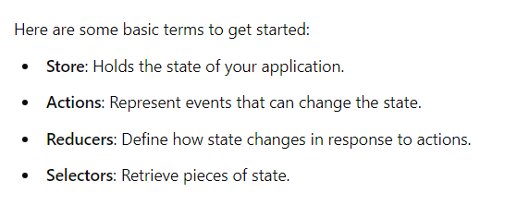
1. What is Redux?
Redux is a predictable state management library for JavaScript apps.

2. What are the core principles of Redux?
Single source of truth, state is read-only, and changes are made with pure functions.

3. What is an action in Redux?
An action is a plain JavaScript object that describes a state change.

4. What is a reducer in Redux?
A reducer is a pure function that takes the current state and an action, and returns a new state.

5. What is the Redux store?
The store holds the state tree of the application.

6. How do you update the state in Redux?
Dispatch an action to the store, and reducers specify how the state changes.

7. What does `dispatch()` do in Redux?
`dispatch()` sends an action to the Redux store to trigger state changes.

8. What are action creators in Redux?
Functions that return an action object.

9. What is middleware in Redux?
Middleware adds extra functionality between the dispatching of an action and the moment it reaches the reducer.

10. What is the `combineReducers` function in Redux?
It merges multiple reducers into a single root reducer.

11. How is the state tree in Redux structured?
The state tree is a single object that represents the app's entire state.

12. What is the role of the `Provider` component in Redux?
It makes the Redux store available to all components in the app.

13. What is the `connect` function in Redux?
It connects a React component to the Redux store.

14. How do you subscribe to changes in the Redux store?
Use the `subscribe()` method to listen for state changes.

15. How is immutability maintained in Redux?
By ensuring state is never mutated, but replaced with a new object.

16. How do you handle side effects in Redux?
Use middleware like Redux Thunk or Redux Saga for handling side effects.

17. What is Redux Thunk?
Redux Thunk is middleware that allows you to write action creators that return functions instead of actions.

18. What is Redux Saga?
Redux Saga is middleware that uses generator functions to handle asynchronous side effects.

19. What are selectors in Redux?
Selectors are functions used to retrieve specific data from the state.

20. How do you debug Redux applications?
Use the Redux DevTools Extension for monitoring and debugging.

21. Can Redux be used with any JavaScript framework?
Yes, Redux can be used with React, Angular, Vue, or any JavaScript framework.

22. What is the purpose of `createStore` in Redux?
It creates the Redux store that holds the state of the app.

23. How do you initialize state in Redux?
Pass an initial state to the reducer or store during initialization.

24. How do you handle asynchronous actions in Redux?
Use middleware like Redux Thunk or Redux Saga to handle async actions.

25. What is a pure function in Redux?
A function that returns the same output for the same input, without side effects.

26. What is the purpose of `mapStateToProps`?
It maps the state from the Redux store to the component's props.

27. What is the purpose of `mapDispatchToProps`?
It maps dispatch functions to props, allowing components to send actions to the store.

28. What is the difference between `Redux` and `context API`?
Redux is more powerful with a built-in dev tool, while the context API is simpler but less feature-rich.

29. What are higher-order components (HOCs) in Redux?
HOCs are functions that take a component and return a new component, often used to inject Redux functionality.

30. What is the use of the `applyMiddleware` function?
It is used to enhance the store with middleware.

31. How do you reset the Redux store?
Return the initial state from the reducers when a reset action is dispatched.

32. How does Redux handle large-scale applications?
By splitting the state and reducers into smaller, manageable pieces using `combineReducers`.

33. What is the purpose of `bindActionCreators`?
It wraps action creators in dispatch calls so they can be invoked directly.

34. How do you optimize performance in Redux?
Use `memoization` for selectors, keep components pure, and reduce unnecessary renders.

35. What are the common use cases for Redux?
Managing application state, handling side effects, and coordinating data between components.

36. How can Redux be used with TypeScript?
By defining types for actions, reducers, and state to ensure type safety.

37. What is the difference between `redux` and `mobx`?
Redux enforces strict unidirectional data flow, while MobX provides a more flexible reactive approach.

38. What are alternatives to Redux?
Context API, MobX, Recoil, and Zustand.

39. How do you handle form state in Redux?
Use libraries like `redux-form` or `Formik` for managing form state in Redux.

40. What are the limitations of Redux?
It requires more boilerplate code and can become complex for small applications.

Java:

1. What is Java 11?
Java 11 is a Long-Term Support (LTS) release of Java with new features and enhancements.

2. How does Java 11 differ from Java 8?
Java 11 includes new APIs, language enhancements, and removal of deprecated modules.

3. What is the `var` keyword in Java 11?
The `var` keyword is used for local variable type inference.

4. What are the key new features of Java 11?
HTTP Client, `var` in lambda, new string methods, and removal of deprecated APIs.

5. How do you create an unmodifiable List in Java 11?
Use `List.of(...)` method.

6. What is the new `String` method `isBlank()` in Java 11?
It checks if a string is empty or contains only white spaces.

7. What does `strip()` do in Java 11's `String` class?
It removes leading and trailing whitespace, supporting Unicode.

8. What is the `repeat()` method in Java 11?
It repeats a string a specified number of times.

9. What is the use of `lines()` in Java 11?
It converts a string into a stream of lines.

10. What is the HTTP Client API in Java 11?
It's an API for sending HTTP requests and handling responses.

11. How do you send an HTTP GET request in Java 11?
Use `HttpRequest.newBuilder()` and `HttpClient.send()`.

12. What is the advantage of using `var` in lambda expressions?
It allows annotations on lambda parameters and simplifies variable declarations.

13. What does `Optional.isEmpty()` do in Java 11?
It checks whether the `Optional` is empty.

14. How is garbage collection improved in Java 11?
Java 11 introduces the Z Garbage Collector (ZGC), a scalable low-latency garbage collector.

15. What is the removal of the Java EE and CORBA modules?
These modules were deprecated in previous versions and removed in Java 11.

16. What is the use of `Files.writeString()` in Java 11?
It writes a string directly to a file.

17. How do you read a file as a string in Java 11?
Use `Files.readString(Path)`.

18. What is `Nest-Based Access Control` in Java 11?
It allows nested classes to access private members of the enclosing class.

19. How is dynamic class-file constants handled in Java 11?
With the new `CONSTANT_Dynamic` constant pool entry.

20. How does Java 11 handle Unicode 10?
It supports the latest Unicode 10 standards.

21. What is `HttpClient.sendAsync()` used for?
It sends asynchronous HTTP requests.

22. What is the new `File.toPath()` method in Java 11?
It converts a file to a `Path` object.

23. How does Java 11 simplify the creation of Collections?
By using factory methods like `List.of()`, `Set.of()`, and `Map.of()`.

24. What is the significance of removing the `javah` tool?
`javah` has been removed since it's no longer necessary to generate JNI headers.

25. How do you create a single-element map in Java 11?
Use `Map.of(key, value)`.

26. What is the purpose of the `Predicate.not()` method in Java 11?
It provides a way to negate a predicate easily.

27. How do you launch a single-file source-code program in Java 11?
You can run `.java` files directly using the `java` command without explicit compilation.

28. What is Flight Recorder in Java 11?
It is a low-overhead performance monitoring and profiling tool.

29. What is the role of Epsilon GC in Java 11?
Epsilon is a no-op garbage collector for testing and benchmarking.

30. How is the security enhanced in Java 11?
Various security improvements including TLS 1.3 and stronger cryptographic algorithms.

31. What is JEP 323 in Java 11?
It allows the use of local `var` in lambda parameters.

32. What is the `InputStream.transferTo()` method in Java 11?
It transfers all bytes from an input stream to an output stream.

33. How is `readAllBytes()` in Java 11 useful?
It reads all bytes from a file or stream at once.

34. How do you write directly to a file using Java 11?
Use `Files.writeString(path, content)`.

35. What is the purpose of the `HttpClient` API in Java 11?
To simplify sending HTTP requests and handling responses.

36. What are the enhancements in `CompletableFuture` in Java 11?
New methods like `delayedExecutor()` and `completeAsync()` have been added.

37. What is `Key Agreement` support in Java 11?
Java 11 adds new Key Agreement algorithms.

38. What is the `String.strip()` method?
It removes all leading and trailing white spaces.

39. What is the advantage of the new Unicode 10 standard in Java 11?
Support for new characters and emojis.

40. How do you create an unmodifiable Set in Java 11?
Use `Set.of(...)`.

41. What is the difference between `String.trim()` and `String.strip()`?
`strip()` supports Unicode, while `trim()` does not.

42. How does Java 11 enhance the garbage collection process?
Through the introduction of ZGC and Epsilon GC for performance tuning.

43. How does `HttpClient` handle asynchronous requests?
By using `sendAsync()` to send non-blocking HTTP requests.

44. What new method allows `InputStream` to write data more efficiently?
`InputStream.transferTo(OutputStream)`.

45. What are `Compact Strings` in Java 11?
A feature to optimize memory usage for strings.

46. How do you convert a file to a `Path` in Java 11?
Use `File.toPath()` method.

47. What is the significance of the `Nestmates` feature in Java 11?
It provides better access between nested classes.

48. How does Java 11 handle new String methods?
New methods like `isBlank()`, `strip()`, and `repeat()` improve string handling.

49. How does Java 11 handle JDK 11 Flight Recorder?
Flight Recorder collects profiling and diagnostic data efficiently.

50. How is the `Stream` API enhanced in Java 11?
New methods like `takeWhile()`, `dropWhile()` simplify stream processing.

51. What is JEP 321 in Java 11?
It is the HTTP Client API that provides an easier way to handle HTTP requests.

52. How is the `Optional` class enhanced in Java 11?
With methods like `isEmpty()` and `orElseThrow()` for better null safety.

53. What does `Predicate.not()` do in Java 11?
It negates the predicate in a simple, readable way.

54. What is the new `Time-Based Release Versioning` in Java 11?
A regular six-month release cadence for Java versions.

55. What is the purpose of `@deprecated(forRemoval=true)`?
It marks APIs that will be removed in future versions.

56. How is the `java.util.concurrent` package enhanced in Java 11?
New methods in `CompletableFuture` and other classes enhance concurrency support.

57. What is the benefit of `Map.ofEntries()` in Java 11?
It allows easier creation of large maps.

58. What is the `pack200` tool, and why is it removed in Java 11?
`pack200` was used for compressing JAR files but is now obsolete.

59. What new constant pool entry is introduced in Java 11?
`CONSTANT_Dynamic` for dynamic constants.

60. What is the purpose of `HttpResponse.BodyHandlers.ofString()`?
It converts HTTP response bodies to strings.

61. What is the `Collectors.toUnmodifiableList()` method in Java 11?
It collects stream elements into an unmodifiable list.

62. How does the `CompletableFuture.delayedExecutor()` work?
It schedules tasks to be executed after a specified delay.

63. What is the significance of ZGC in Java 11?
ZGC is a scalable, low-latency garbage collector for large heaps.

64. How does Java 11 enhance lambda expressions?
Java 11 allows local variable syntax (`var`) for lambda parameters.

65. What does `java.scripting` module removal in Java 11 mean?
The `Nashorn` JavaScript engine and related APIs have been removed.

66. What is the purpose of `HttpClient`'s `Builder` class in Java 11?
It configures the HTTP client for various options like timeouts and redirections.

67. What is `InputStream.readAllBytes()` in Java 11?
It reads all bytes from an input stream at once.

68. How is `Files.writeString()` helpful in Java 11?
It writes strings directly to files more efficiently.

69. What does `repeat()` method in Java 11’s `String` class do?
It repeats the string a specified number of times.

70. What is the impact of `isBlank()` method in `String`?
It returns `true` if the string is empty or contains only white spaces.

71. How does Java 11 simplify launching programs?
Java 11 allows running `.java` files directly without compiling.

72. What does `Predicate.not()` add to Java 11?
It simplifies the negation of a predicate.

73. How is `Optional.orElseThrow()` used in Java 11?
It throws a `NoSuchElementException` if the value is not present.

74. What are the `takeWhile()` and `dropWhile()` methods in Java 11's `Stream` API?
`takeWhile()` takes elements until the condition is false; `dropWhile()` skips them.

75. What does `HttpRequest.Builder.POST()` do in Java 11?
It builds an HTTP POST request.

76. How does Java 11 improve security?
With TLS 1.3 support and enhancements in cryptographic algorithms.

77. What does `HttpClient.version()` specify in Java 11?
It specifies the HTTP version (1.1 or 2) to use.

78. What is `JShell` in Java 11?
`JShell` is a REPL tool for testing small snippets of Java code.

79. How does Java 11 improve `File.toPath()` usage?
It allows seamless conversion between `File` and `Path`.

80. What does `KeyAgreement.getInstance()` do in Java 11?
It supports various cryptographic key agreement protocols.

81. What is the `HttpClient` API's `sendAsync()` method for?
It allows sending HTTP requests asynchronously.

82. How does Java 11 handle `Epsilon GC`?
Epsilon is a no-op GC designed for testing purposes with no memory reclamation.

83. What does `@deprecated(forRemoval = true)` mean in Java 11?
It indicates that the deprecated feature will be removed in a future release.

84. How do you create a stream from a string in Java 11?
Use `String.lines()` to split a string into lines.

85. What is the difference between `strip()` and `trim()` in Java 11?
`strip()` works with Unicode, while `trim()` works with only ASCII.

86. How does Java 11 handle large heaps with ZGC?
ZGC supports heaps up to terabytes in size with low pause times.

87. What is `InputStream.transferTo()` used for in Java 11?
It transfers all bytes from an input stream to an output stream.

88. What is the role of `CompletableFuture.completeAsync()`?
It allows asynchronous task completion in a `CompletableFuture`.

89. How is Java 11’s constant pool enhanced?
The `CONSTANT_Dynamic` entry allows constants to be created at runtime.

90. How does `List.of()` work in Java 11?
It creates an immutable list of elements.

91. What is the function of `Map.ofEntries()` in Java 11?
It creates immutable maps with multiple entries.

92. How is JDK 11's `Flight Recorder` helpful?
It helps collect performance and diagnostic data with low overhead.

93. What is the `HttpResponse.BodyHandlers.ofString()` method?
It converts the HTTP response body into a string.

94. How does Java 11 enhance memory management?
With new GCs like ZGC and Epsilon for better performance and scalability.

95. What is the purpose of `@deprecated` annotation in Java 11?
It marks classes, methods, and fields as deprecated, signaling possible removal.

96. What does `Files.readString()` do in Java 11?
It reads the contents of a file into a string.

97. How is `List.copyOf()` different from `List.of()`?
`List.copyOf()` can take an existing collection and create an unmodifiable copy.

98. What is the role of `CompletableFuture.delayedExecutor()` in Java 11?
It schedules tasks to be executed after a delay.

99. How does the `Stream.takeWhile()` method work?
It takes elements from a stream until the given predicate is false.

100. What is the impact of Java 11 removing the `java.se.ee` module?
It removes deprecated technologies like CORBA, JAX-WS, and JAXB.

Java Collection:

1. What is the `Collection` interface in Java?
It is the root interface for all Java collections.

2. How does `ArrayList` differ from `LinkedList`?
`ArrayList` is based on a dynamic array, `LinkedList` is based on doubly-linked nodes.

3. What is a `HashSet` in Java?
It implements the `Set` interface, backed by a `HashMap`, and does not allow duplicates.

4. What is the difference between `HashSet` and `TreeSet`?
`HashSet` is unordered, while `TreeSet` maintains elements in sorted order.

5. How is `HashMap` implemented internally?
It uses an array of buckets and linked lists or trees for collision handling.

6. What is the `LinkedHashMap` used for?
It preserves the insertion order of keys in the map.

7. Can `List` contain duplicate elements?
Yes, `List` allows duplicate elements.

8. What is the difference between `Queue` and `Deque`?
`Queue` follows FIFO, while `Deque` supports both FIFO and LIFO operations.

9. What is the purpose of the `Collections` class?
It provides static methods for operations on collections, like sorting and searching.

10. How does `TreeMap` work in Java?
It implements the `Map` interface and sorts keys in natural or custom order.

11. What is `PriorityQueue` in Java?
A `Queue` that orders elements based on their natural ordering or a custom comparator.

12. How does `Vector` differ from `ArrayList`?
`Vector` is synchronized and thread-safe, while `ArrayList` is not.

13. What is the `EnumSet` in Java?
A specialized set for enumerated types, highly efficient and compact.

14. What is the `WeakHashMap` used for?
It allows garbage collection of keys when they are no longer referenced.

15. What does `Collections.synchronizedList()` do?
It wraps a `List` to make it thread-safe.

16. Can `HashMap` have null keys or values?
Yes, `HashMap` allows one null key and multiple null values.

17. What is the `IdentityHashMap`?
It uses reference equality (`==`) instead of object equality (`equals()`).

18. How does `ConcurrentHashMap` differ from `HashMap`?
`ConcurrentHashMap` is thread-safe and allows concurrent modifications.

19. What is `NavigableSet` in Java?
A subinterface of `SortedSet` that provides navigation methods like `lower()`, `ceiling()`, etc.

20. What is the difference between `ListIterator` and `Iterator`?
`ListIterator` allows bidirectional traversal, while `Iterator` allows only forward traversal.

21. What is `ArrayDeque` in Java?
A resizable array implementation of the `Deque` interface.

22. What is the default initial capacity of `HashMap`?
The default capacity is 16.

23. What is the load factor in `HashMap`?
It determines how full the map can get before resizing, default is 0.75.

24. How does the `LinkedHashSet` differ from `HashSet`?
`LinkedHashSet` maintains insertion order, while `HashSet` does not.

25. What is the `Comparator` interface used for?
It defines a custom ordering for collections.

26. What is a `CopyOnWriteArrayList` in Java?
A thread-safe variant of `ArrayList` where writes result in copying the list.

27. What is the `BlockingQueue` interface?
A queue that supports operations to wait for elements to become available or space to be free.

28. How does `ArrayList` grow internally?
When capacity is exceeded, it increases its size by 50%.

29. What is a `SortedSet` in Java?
A set that maintains its elements in a sorted order.

30. What does `Collections.reverseOrder()` do?
It returns a comparator that sorts elements in reverse natural order.

31. How is `EnumMap` different from other maps?
It is specifically designed for use with enum keys and is highly efficient.

32. Can a `TreeMap` store null keys?
No, `TreeMap` does not allow null keys.

33. What is `Deque` in Java?
A double-ended queue that allows insertion and removal at both ends.

34. What is the difference between `peek()` and `poll()` in `Queue`?
`peek()` retrieves the head without removing it, `poll()` retrieves and removes it.

35. What is `Collections.emptyList()` used for?
It returns an immutable empty list.

36. What is the `java.util.concurrent` package for?
It provides collections that support high concurrency, like `ConcurrentHashMap`.

37. What is a `Stack` in Java?
A subclass of `Vector` that represents a LIFO stack of elements.

38. What is the difference between `ArrayList` and `LinkedList` performance?
`ArrayList` has faster random access, while `LinkedList` has faster insertions/removals.

39. What is the role of the `Iterable` interface?
It provides a way to iterate over collections using the `for-each` loop.

40. How does `Collections.unmodifiableMap()` work?
It wraps a modifiable map and prevents changes.

41. What is the `Spliterator` in Java?
It is an iterator that supports parallel processing of collections.

42. How does `HashTable` differ from `HashMap`?
`HashTable` is synchronized and does not allow null keys or values.

43. What is the use of `Collections.sort()`?
It sorts elements of a list according to natural order or a custom comparator.

44. What is the purpose of `NavigableMap`?
It extends `SortedMap` with navigation methods like `ceilingEntry()`, `floorKey()`.

45. What is the significance of `ListIterator`'s `previous()` method?
It allows backward traversal in a `List`.

46. What is the `Comparator` chaining in Java?
Combining multiple comparators using `thenComparing()` method.

47. What is the benefit of `TreeSet` over `HashSet`?
`TreeSet` maintains elements in sorted order, while `HashSet` doesn't.

48. What is a `PriorityBlockingQueue`?
A thread-safe priority queue that blocks when elements are unavailable.

49. How does `Collections.shuffle()` work?
It randomly shuffles elements of a list.

50. What is `ConcurrentSkipListSet` in Java?
A thread-safe sorted set that provides scalable concurrent access.

Core Java

1. What is Java?
A high-level, object-oriented programming language designed for portability.

2. What are the main features of Java?
Platform independence, object-oriented, robust, secure, and multithreaded.

3. What is the Java Virtual Machine (JVM)?
It executes Java bytecode and allows Java programs to run on any platform.

4. What is the difference between JDK and JRE?
JDK (Java Development Kit) is for developers, while JRE (Java Runtime Environment) is for running Java applications.

5. What is an object in Java?
An instance of a class containing state and behavior.

6. What is a class in Java?
A blueprint for creating objects, defining properties and methods.

7. What are the access modifiers in Java?
public, private, protected, and default (package-private).

8. What is inheritance in Java?
A mechanism where one class acquires properties and behavior from another class.

9. What is polymorphism?
The ability to perform a single action in different ways, mainly through method overriding and overloading.

10. What is encapsulation?
The bundling of data and methods that operate on that data within one unit, restricting access.

11. What is an interface in Java?
A reference type that can contain only constants, method signatures, default methods, static methods, and nested types.

12. What is an abstract class?
A class that cannot be instantiated and can have abstract methods (without implementation).

13. What is the difference between abstract class and interface?
An abstract class can have implemented methods, while an interface cannot (prior to Java 8).

14. What are constructors in Java?
Special methods used to initialize objects when they are created.

15. What is the `static` keyword used for?
It defines class-level methods and variables that can be accessed without an instance.

16. What is the purpose of the `final` keyword?
It restricts inheritance, method overriding, and variable reassignment.

17. What are Java packages?
A namespace that organizes a set of related classes and interfaces.

18. What is the `main` method in Java?
The entry point of any Java application, defined as `public static void main(String[] args)`.

19. What is exception handling in Java?
A mechanism to handle runtime errors, using `try`, `catch`, and `finally` blocks.

20. What is the difference between checked and unchecked exceptions?
Checked exceptions are checked at compile-time, while unchecked exceptions are checked at runtime.

21. What is the `throw` statement?
It is used to explicitly throw an exception in Java.

22. What is the `throws` keyword?
It declares that a method can throw exceptions, which must be handled by the calling method.

23. What is the purpose of the `String` class in Java?
It represents a sequence of characters and is immutable.

24. What are the differences between `String`, `StringBuilder`, and `StringBuffer`?
`String` is immutable, `StringBuilder` is mutable and not synchronized, while `StringBuffer` is mutable and synchronized.

25. What is the Java Collections Framework?
A set of classes and interfaces for storing and manipulating groups of data.

26. What are the types of loops in Java?
for, while, and do-while loops.

27. What is an `if` statement?
It is used for conditional execution based on a boolean expression.

28. What is a `switch` statement?
It allows multi-way branching based on the value of an expression.

29. What are the data types in Java?
Primitive types (int, float, double, char, boolean) and reference types (arrays, classes, interfaces).

30. What is type casting in Java?
The conversion of a variable from one data type to another.

31. What are Java annotations?
Special metadata added to classes, methods, or fields for configuration or documentation.

32. What is the `this` keyword?
It refers to the current instance of a class.

33. What is the `super` keyword?
It refers to the superclass or parent class of the current object.

34. What is method overloading?
Defining multiple methods in the same class with the same name but different parameters.

35. What is method overriding?
Redefining a superclass method in a subclass with the same signature.

36. What are lambda expressions in Java?
A concise way to represent functional interfaces using an expression.

37. What is a functional interface?
An interface with exactly one abstract method, which can be represented as a lambda expression.

38. What are streams in Java?
A sequence of elements supporting sequential and parallel aggregate operations.

39. What is the purpose of the `volatile` keyword?
It indicates that a variable's value will be modified by different threads.

40. What is multithreading in Java?
The concurrent execution of two or more threads to maximize CPU utilization.

41. What is the `synchronized` keyword?
It is used to control access to a method or block by multiple threads.

42. What are the types of inner classes in Java?
Member inner class, static nested class, local inner class, and anonymous inner class.

43. What is a Singleton class?
A class that restricts instantiation to a single instance and provides a global access point.

44. What is garbage collection in Java?
The automatic memory management process of reclaiming memory by removing unreachable objects.

45. What are Java enums?
A special Java type used to define collections of constants.

46. What is the `instanceof` operator?
It checks whether an object is an instance of a specific class or subclass.

47. What is the `default` method in interfaces?
A method with a default implementation in an interface, introduced in Java 8.

48. What is method reference in Java?
A shorthand notation of a lambda expression to call a method.

49. What is a `try-with-resources` statement?
It automatically closes resources when the try block finishes.

50. How do you create a custom exception in Java?
By extending the `Exception` class or one of its subclasses.

Cloud Computing:
What is cloud computing?
Cloud computing is the delivery of computing services over the internet.
What are the main types of cloud services?
The main types are Infrastructure as a Service (IaaS), Platform as a Service (PaaS), and Software as a Service (SaaS).
What is IaaS?
IaaS provides virtualized computing resources over the internet, such as servers and storage.
What is PaaS?
PaaS offers a platform allowing developers to build, deploy, and manage applications without worrying about infrastructure.
What is SaaS?
SaaS delivers software applications over the internet on a subscription basis.
What are public, private, and hybrid clouds?
Public clouds are shared resources, private clouds are dedicated to one organization, and hybrid clouds combine both.
What is cloud storage?
Cloud storage allows data to be stored on remote servers accessed via the internet.
What is virtualization in cloud computing?
Virtualization creates virtual versions of physical resources to optimize usage and management.
What is a cloud service model?
A cloud service model defines how services are provided, such as IaaS, PaaS, or SaaS.
What is multi-tenancy?
Multi-tenancy allows multiple customers to share the same infrastructure while keeping their data isolated.
What are the benefits of cloud computing?
Benefits include cost savings, scalability, flexibility, and accessibility.
What is serverless computing?
Serverless computing allows developers to build and run applications without managing servers.
What is a cloud provider?
A cloud provider is a company that offers cloud computing services, such as AWS, Azure, or Google Cloud.
What is cloud migration?
Cloud migration is the process of moving data, applications, or services from on-premises to the cloud.
What is a Virtual Private Cloud (VPC)?
A VPC is a private cloud environment hosted within a public cloud.
What is cloud scalability?
Scalability is the ability to increase or decrease resources based on demand.
What is cloud elasticity?
Elasticity is the ability to automatically adjust resources to meet fluctuating workloads.
What are the types of cloud deployment models?
Deployment models include public, private, hybrid, and community clouds.
What is a cloud-native application?
A cloud-native application is designed to leverage cloud computing benefits and scalability.
What are microservices?
Microservices are an architectural style that structures an application as a collection of loosely coupled services.
What is API in cloud computing?
An API (Application Programming Interface) allows different software applications to communicate with each other.
What is a Service Level Agreement (SLA)?
An SLA is a contract that outlines the expected level of service between a provider and a customer.
What is disaster recovery in the cloud?
Disaster recovery in the cloud involves strategies and services to recover data and applications after a disaster.
What is a load balancer?
A load balancer distributes incoming network traffic across multiple servers to ensure reliability.
What is data redundancy?
Data redundancy involves storing duplicate copies of data to ensure availability and reliability.
What are cloud security measures?
Measures include encryption, access controls, and regular security audits.
What is a cloud data center?
A cloud data center is a facility used to house cloud computing resources, including servers and storage.
What is containerization?
Containerization packages applications and their dependencies into containers for consistent deployment.
What is Kubernetes?
Kubernetes is an open-source platform for automating containerized application deployment and management.
What is cloud orchestration?
Cloud orchestration automates the management of cloud resources and services.
What is the difference between a cloud and on-premises computing?
Cloud computing uses remote resources, while on-premises computing relies on local infrastructure.
What is edge computing?
Edge computing processes data closer to the source, reducing latency and bandwidth use.
What is a cloud service catalog?
A cloud service catalog is a curated list of services available to users in a cloud environment.
What is a cloud management platform?
A cloud management platform helps manage cloud resources across different environments.
What are some challenges of cloud computing?
Challenges include security concerns, compliance issues, and data transfer costs.
What is continuous integration/continuous deployment (CI/CD)?
CI/CD automates the software development process, allowing for frequent updates and releases.
What is a CDN (Content Delivery Network)?
A CDN is a network of servers that deliver content to users based on their geographic location.
What is a cloud-based database?
A cloud-based database stores and manages data in the cloud rather than on local servers.
What is the purpose of IAM (Identity and Access Management) in the cloud?
IAM controls user access to resources and services in a cloud environment.
What is a cloud broker?
A cloud broker acts as an intermediary between cloud providers and customers, offering services like integration and management.
What is cloud auditing?
Cloud auditing assesses and verifies compliance and security within cloud environments.
What is a cloud cost management tool?
A tool that helps organizations monitor, manage, and optimize cloud spending.
What are cloud compliance standards?
Compliance standards ensure that cloud services adhere to regulations like GDPR and HIPAA.
What is a cloud readiness assessment?
A cloud readiness assessment evaluates an organization's preparedness for cloud migration.
What is a virtual machine (VM)?
A VM is a software emulation of a physical computer, running an operating system and applications.
What is a server image?
A server image is a snapshot of a server’s state, including the operating system and installed applications.
What is a cloud application?
A cloud application is software that runs on cloud infrastructure and is accessed via the internet.
What is server provisioning?
Server provisioning involves setting up server resources to be used in a cloud environment.
What is a cloud workload?
A workload is a specific task or application running in the cloud.
What is a cloud service provider (CSP)?
A CSP is a company that offers cloud computing services and infrastructure.
What is data sovereignty?
Data sovereignty refers to the concept that data is subject to the laws of the country in which it is stored.
What is the role of a cloud architect?
A cloud architect designs and manages cloud solutions and infrastructure.
What is DevOps in cloud computing?
DevOps integrates development and operations teams to improve collaboration and efficiency.
What is auto-scaling in the cloud?
Auto-scaling automatically adjusts the number of active servers based on demand.
What is a cloud tenant?
A cloud tenant is a unique instance within a cloud service that provides resources to a specific customer.
What is a service mesh?
A service mesh is an infrastructure layer for managing service-to-service communication in microservices.
What is the difference between scaling up and scaling out?
Scaling up adds resources to a single server, while scaling out adds more servers.
What is the function of a cloud router?
A cloud router manages traffic between different networks in a cloud environment.
What is a backup and recovery strategy in cloud computing?
A backup and recovery strategy ensures data is regularly backed up and can be restored in case of loss.
What is a cloud service endpoint?
A cloud service endpoint is a URL that allows access to a cloud service.
What is an API Gateway?
An API Gateway manages and routes API requests to various services in a cloud environment.
What is hybrid cloud storage?
Hybrid cloud storage combines on-premises and cloud storage solutions for flexibility and scalability.
What is a cloud marketplace?
A cloud marketplace is an online store where users can buy and sell cloud services and applications.
What is a cloud firewall?
A cloud firewall protects cloud resources from unauthorized access and threats.
What is cloud performance monitoring?
Cloud performance monitoring tracks the performance of cloud services and applications to ensure efficiency.
What is a network function virtualization (NFV)?
NFV virtualizes network services traditionally run on hardware to improve scalability and flexibility.
What is a service discovery mechanism in microservices?
It allows services to automatically find and communicate with each other in a microservices architecture.
What is a distributed database?
A distributed database is a database that is spread across multiple locations or systems.
What is a cloud compliance audit?
A cloud compliance audit evaluates a cloud service provider's adherence to regulatory requirements.
What is a cloud service usage report?
A usage report provides insights into how cloud services are being utilized within an organization.
What is the significance of encryption in cloud security?
Encryption protects sensitive data from unauthorized access during storage and transmission.
What is a cloud disaster recovery plan?
A plan that outlines how to recover cloud services and data after a disaster or outage.
What is cloud workload automation?
Cloud workload automation streamlines the management of cloud resources to improve efficiency.
What is the role of cloud governance?
Cloud governance establishes policies and controls to ensure effective management and security of cloud resources.
What is a cloud service API?
A cloud service API allows developers to interact with and manage cloud services programmatically.
What is a service blueprint in cloud computing?
A service blueprint visually maps out the components and processes involved in delivering a cloud service.
What is data locality?
Data locality ensures that data processing occurs near the location where data is generated to reduce latency.
What is a cloud performance benchmark?
A performance benchmark evaluates the efficiency and effectiveness of cloud services and infrastructure.
What is cloud usage optimization?
Cloud usage optimization involves improving resource usage and reducing costs in a cloud environment.
What is an external cloud provider?
An external cloud provider offers cloud services to organizations outside their internal infrastructure.
What is a cloud service lifecycle?
The cloud service lifecycle encompasses all stages of a service, from design to decommissioning.
What is a cloud development framework?
A cloud development framework provides tools and libraries to build cloud-based applications.
What is a virtual network in cloud computing?
A virtual network connects cloud resources in a secure and isolated manner.
What is a cloud service incident response plan?
A plan that outlines procedures for responding to incidents affecting cloud services.
What is cloud migration assessment?
An assessment evaluates the feasibility and impact of moving to cloud-based services.
What is the purpose of cloud resource tagging?
Tagging cloud resources helps organize, manage, and track usage and costs.
What is the difference between cloud backup and disaster recovery?
Cloud backup stores copies of data, while disaster recovery focuses on restoring services after an outage.
What is an orchestrator in cloud computing?
An orchestrator automates the deployment and management of cloud resources and services.
What is the role of a cloud security architect?
A cloud security architect designs and implements security measures for cloud services.
What is a cloud resource inventory?
A cloud resource inventory lists all resources and services deployed in a cloud environment.
What is the significance of network latency in cloud computing?
Network latency impacts the speed and performance of cloud applications and services.
What is a cloud data pipeline?
A data pipeline automates the movement and transformation of data between systems in the cloud.
What is a cloud storage gateway?
A cloud storage gateway connects on-premises environments to cloud storage services.
What is a cloud service catalog management?
It involves maintaining and updating the catalog of available cloud services for users.
What is a cloud resource provisioning tool?
A provisioning tool automates the allocation and management of cloud resources.
What is a data lake in cloud computing?
A data lake is a centralized repository for storing structured and unstructured data in the cloud.
What is a cloud API versioning?
API versioning allows multiple versions of an API to coexist for backward compatibility.
What is the role of a cloud engineer?
A cloud engineer designs, builds, and manages cloud infrastructure and services.
What is the significance of cloud service monitoring?
Monitoring ensures that cloud services perform optimally and meet service level agreements (SLAs).
What is the future of cloud computing?
The future includes advancements in AI, automation, and enhanced security measures.

Virtual computing and Load balancing:

Virtual Cloud Environment
- What is a virtual cloud environment?
A virtual cloud environment uses virtualization technologies to create and manage multiple virtual resources on physical servers.
- How does virtualization enhance cloud computing?
Virtualization allows for better resource utilization, scalability, and flexibility in managing cloud resources.
- What is Infrastructure as a Service (IaaS)?
IaaS is a cloud computing model that provides virtualized computing resources over the internet.
- What are the benefits of using a Virtual Private Cloud (VPC)?
A VPC offers enhanced security, control, and isolation for resources within a cloud environment.
- Describe the differences between public, private, and hybrid clouds.
Public clouds are shared, private clouds are dedicated to one organization, and hybrid clouds combine both for flexibility.
- What are the main characteristics of cloud computing?
Cloud computing features on-demand self-service, broad network access, resource pooling, rapid elasticity, and measured service.
- How do hypervisors work in a virtualized environment?
Hypervisors create and manage virtual machines by abstracting the underlying hardware.
- What are the types of hypervisors, and how do they differ?
Type 1 hypervisors run directly on hardware, while Type 2 hypervisors run on a host operating system.
- What is resource pooling in cloud computing?
Resource pooling refers to the provider's ability to serve multiple customers from a shared pool of resources.
- Explain the role of a cloud service provider (CSP).
A CSP offers various cloud services such as storage, computing power, and software applications.
- How does elasticity in cloud computing work?
Elasticity allows for automatic scaling of resources based on demand, enabling efficient resource usage.
- What are the key components of a virtualized infrastructure?
Key components include hypervisors, virtual machines, storage systems, and networking.
- How do you ensure data security in a virtual cloud environment?
Data security can be ensured through encryption, access control, and regular security audits.
- What is a cloud deployment model?
A cloud deployment model defines how cloud services are deployed, such as public, private, or hybrid.
- How does multi-tenancy affect performance in cloud environments?
Multi-tenancy can lead to resource contention but allows for efficient resource sharing among users.
- What tools do you use for cloud management?
Common tools include AWS Management Console, Azure Portal, and Google Cloud Console.
- What are the challenges of managing a virtual cloud environment?
Challenges include resource allocation, security, compliance, and monitoring.
- Explain the concept of cloud orchestration.
Cloud orchestration automates the management of complex tasks and workflows in cloud environments.
- How do you monitor resource usage in a cloud environment?
Resource usage can be monitored using cloud provider dashboards and third-party monitoring tools.
- What are the best practices for cloud security?
Best practices include implementing strong access controls, encryption, and regular audits.
- How can you achieve high availability in a virtual cloud environment?
High availability can be achieved through redundancy, load balancing, and failover strategies.
- What are service-level agreements (SLAs) in cloud computing?
SLAs define the expected level of service, including uptime and performance metrics.
- Explain how billing works in cloud services.
Billing is typically based on usage metrics such as compute hours, data transfer, and storage.
- What is the difference between horizontal and vertical scaling?
Horizontal scaling adds more instances, while vertical scaling increases resources for existing instances.
- How does data redundancy work in a cloud environment?
Data redundancy ensures copies of data are stored across multiple locations for reliability.
- What are the advantages of using a cloud database?
Cloud databases offer scalability, automatic backups, and reduced management overhead.
- How do you handle backups and disaster recovery in the cloud?
Backups are managed through automated services, and disaster recovery plans include failover strategies.
- What is the role of API in cloud services?
APIs enable interaction and integration with cloud services for automation and management.
- How do you optimize performance in a virtualized environment?
Performance optimization can be achieved through resource allocation, load balancing, and caching.
- What is the difference between bare metal and virtual servers?
Bare metal servers are physical servers, while virtual servers are created using virtualization technology.
- How do you implement network security in a cloud environment?
Network security can be implemented using firewalls, VPNs, and intrusion detection systems.
- What is containerization, and how does it relate to virtualization?
Containerization packages applications and their dependencies, offering lightweight alternatives to full virtual machines.
- What are the common storage options in a cloud environment?
Common storage options include block storage, object storage, and file storage.
- How do you handle compliance in a cloud setup?
Compliance is managed by adhering to regulations and conducting regular audits.
- What is the role of cloud gateways in hybrid cloud architectures?
Cloud gateways facilitate communication between on-premises infrastructure and cloud services.

Load Balancer for Webservers
- What is a load balancer, and why is it used?
A load balancer distributes network traffic across multiple servers to ensure high availability and performance.
- What are the different types of load balancers?
Types include hardware, software, application, and network load balancers.
- How does a load balancer improve application availability?
It prevents server overload by distributing traffic, ensuring no single server fails due to excessive requests.
- Explain the concept of round-robin load balancing.
Round-robin distributes requests sequentially to each server in a pool.
- What is least connections load balancing?
This method directs traffic to the server with the fewest active connections.
- How does SSL termination work in a load balancer?
SSL termination offloads the decryption process from web servers, reducing their load.
- What are health checks, and why are they important for load balancers?
Health checks verify server availability to route traffic only to healthy servers.
- How do you configure a load balancer in a cloud environment?
Load balancers are configured through cloud provider dashboards or command-line interfaces.
- What is the difference between Layer 4 and Layer 7 load balancing?
Layer 4 operates at the transport layer, while Layer 7 operates at the application layer for content-based routing.
- How does a reverse proxy relate to load balancing?
A reverse proxy routes client requests to servers and can also perform load balancing.
- What is sticky session management, and why is it useful?
Sticky sessions bind a user to a specific server, maintaining session state across requests.
- How can you achieve session persistence in a load-balanced environment?
Session persistence can be achieved using cookies or IP address affinity.
- What role does DNS play in load balancing?
DNS can distribute traffic across multiple servers by resolving domain names to different IP addresses.
- How do you secure a load balancer?
Security measures include encryption, access controls, and regular security updates.
- What are the common challenges faced in load balancing?
Challenges include session management, server health monitoring, and performance tuning.
- How does auto-scaling work with load balancers?
Auto-scaling adjusts the number of servers in response to traffic loads, working seamlessly with load balancers.
- Explain the concept of application delivery controllers (ADCs).
ADCs manage and optimize application traffic, providing load balancing, security, and acceleration.
- What metrics do you monitor for load balancer performance?
Key metrics include response time, throughput, error rates, and server health.
- How does geographic load balancing work?
Geographic load balancing directs traffic to the nearest server based on user location for improved performance.
- What is the difference between active-active and active-passive load balancing?
Active-active uses multiple servers simultaneously, while active-passive has one server on standby.
- How do you handle traffic spikes in a load-balanced environment?
Traffic spikes are managed by auto-scaling and distributing traffic efficiently across servers.
- What are some best practices for configuring load balancers?
Best practices include regular health checks, using SSL, and monitoring performance metrics.
- How does a cloud load balancer differ from an on-premises load balancer?
Cloud load balancers offer scalability and managed services, while on-premises require hardware management.
- What is IP hashing in load balancing?
IP hashing routes traffic based on the client's IP address, ensuring consistent server selection.
- How can you implement failover strategies with load balancers?
Failover strategies involve monitoring server health and rerouting traffic in case of failure.
- What is the role of load balancing in microservices architectures?
Load balancing distributes requests among microservices, ensuring resilience and scalability.
- How do you test the performance of a load balancer?
Performance testing can be conducted using load testing tools to simulate traffic and measure response times.
- What are the security implications of load balancers?
Load balancers can be targets for attacks; hence, securing them is crucial to protect backend resources.
- How do you handle logging and analytics for load balancers?
Logging and analytics can be managed through monitoring tools that aggregate and analyze traffic data.
- What is a CDN, and how does it relate to load balancing?
A Content Delivery Network (CDN) distributes content across multiple locations, working with load balancers to optimize delivery.
- What strategies can you use for load balancing stateful applications?
Stateful applications can use sticky sessions or external session stores for effective load balancing.
- How do you handle non-HTTP traffic with load balancers?
Non-HTTP traffic can be managed using TCP or UDP load balancers.
- What role does caching play in load balancing?
Caching reduces server load by serving frequently requested content quickly, improving performance.
- How can you implement a global load balancing strategy?
Global load balancing can be achieved using DNS-based routing or geo-routing techniques.
- What is the role of service discovery in load balancing?
Service discovery enables load balancers to dynamically find available services for routing traffic.
- How do you manage and update configurations for load balancers?
Configurations can be managed through automation tools and version control systems.
- What is the importance of network latency in load balancing?
Network latency affects user experience, so minimizing it is crucial for efficient load balancing.
- How do you implement access control for load-balanced applications?
Access control can be implemented at the load balancer level, ensuring only authorized traffic is allowed.
- What are some common use cases for load balancing?
Common use cases include web application hosting, API traffic management, and microservices communication.
- How does a load balancer handle SSL offloading?
The load balancer terminates SSL connections, decrypting traffic before forwarding it to backend servers.
- What is the difference between layer 4 and layer 7 health checks?
Layer 4 checks connectivity, while Layer 7 checks the application's response and behavior.
- How do you integrate a load balancer with a monitoring solution?
Load balancers can be integrated with monitoring tools that track performance and alert on issues.
- What is an external vs. internal load balancer?
External load balancers manage traffic from outside the network, while internal load balancers distribute traffic within the network.
- How do you achieve zero-downtime deployments with load balancing?
Zero-downtime deployments can be achieved using rolling updates and canary releases with load balancers.
- What are some common load balancing algorithms?
Common algorithms include round-robin, least connections, and IP hashing.
- How do you handle application versioning in a load-balanced environment?
Application versioning can be managed using routing rules to direct traffic to specific versions.
- What is a service mesh, and how does it relate to load balancing?
A service mesh manages microservices communication and provides advanced load balancing capabilities.
- How do you set up a load balancer for an e-commerce application?
Set up involves configuring traffic distribution, SSL termination, and monitoring for peak traffic times.
- What tools can you use to visualize load balancer traffic?
Tools like Grafana, Kibana, and cloud provider dashboards can be used for traffic visualization.
- How does a load balancer handle DDoS attacks?
Load balancers can mitigate DDoS attacks by distributing traffic and using rate limiting techniques.
- What is server affinity, and when is it useful?
Server affinity binds a user to a specific server, useful for maintaining session state.
- How do you perform capacity planning for a load balancer?
Capacity planning involves analyzing traffic patterns and resource usage to ensure sufficient server capacity.
- What are some pitfalls to avoid when configuring a load balancer?
Pitfalls include neglecting health checks, overloading servers, and failing to secure the load balancer.
- How does a load balancer support high throughput applications?
It distributes requests efficiently, ensuring no single server becomes a bottleneck.
- What considerations should you make for mobile app traffic with load balancing?
Considerations include session management, performance optimization, and handling varying traffic loads.
- How do you manage traffic from microservices to legacy systems?
Use API gateways and load balancers to route traffic appropriately between microservices and legacy systems.
- What role does CDN play in enhancing load balancer performance?
A CDN caches content closer to users, reducing load on the origin servers and enhancing performance.
- How do you maintain logs for troubleshooting in load-balanced applications?
Maintain centralized logs from all servers to enable effective troubleshooting.
- What is a load balancer’s role in maintaining user sessions?
It ensures session persistence, directing users to the appropriate server for their session state.
- How do you perform stress testing on a load balancer?
Use load testing tools to simulate heavy traffic and measure the load balancer's performance.
- What are the implications of using a cloud-native load balancer?
Cloud-native load balancers offer scalability and seamless integration with cloud services.
- How do you troubleshoot performance issues in a load-balanced environment?
Troubleshoot by analyzing logs, monitoring metrics, and checking server health.
- What is the significance of load balancer configuration management?
Configuration management ensures consistency and allows for easy rollback in case of issues.
- How can you improve the security of a load balancer?
Improve security by using firewalls, intrusion detection systems, and regular updates.
- What strategies can you use to prevent bottlenecks in a load-balanced environment?
Strategies include load distribution, resource scaling, and monitoring for performance issues.

Moneris financial technology

1. What is Moneris?
A leading payment processor in Canada, providing transaction processing services for businesses.

2. What types of payment solutions does Moneris offer?
Moneris offers point-of-sale systems, online payment solutions, and mobile payment options.

3. What is a payment gateway?
A service that authorizes credit card payments for e-businesses and online retailers.

4. How does Moneris support e-commerce?
By providing secure online payment processing and integrations with various shopping carts.

5. What is PCI compliance?
A set of security standards designed to ensure that all companies process, store, or transmit credit card information securely.

6. What is the role of a payment processor?
To facilitate the transfer of funds between the customer and the merchant's bank account.

7. How does Moneris ensure transaction security?
By implementing encryption, tokenization, and fraud detection measures.

8. What is tokenization in payment processing?
A security process that replaces sensitive card information with a unique identifier called a token.

9. What are Moneris' customer support options?
They offer phone, email, and live chat support for their clients.

10. What is the importance of chargeback management?
It helps businesses mitigate losses from disputed transactions and improve customer satisfaction.

11. How can merchants access their transaction data?
Through the Moneris online portal or mobile app, providing insights into sales and transaction history.

12. What is a merchant account?
A type of bank account that allows businesses to accept payments by debit or credit cards.

13. How does Moneris handle international transactions?
By providing multi-currency processing options for businesses operating globally.

14. What is the difference between a credit card and a debit card transaction?
Credit cards allow borrowing money, while debit cards withdraw directly from the linked bank account.

15. What is an ACH transaction?
An Automated Clearing House transaction is an electronic transfer of funds between bank accounts.

16. How does Moneris support mobile payments?
Through integrations with mobile wallets like Apple Pay and Google Pay, facilitating contactless transactions.

17. What is fraud detection and prevention?
Measures and technologies implemented to identify and prevent fraudulent transactions.

18. How does Moneris process refunds?
Refunds can be initiated through the merchant's account portal or point-of-sale system.

19. What are the benefits of using Moneris for small businesses?
Competitive transaction rates, reliable support, and flexible payment solutions.

20. How does Moneris integrate with POS systems?
Through APIs that allow seamless data transfer and payment processing.

21. What is the significance of recurring payments?
They automate the billing process for subscription-based businesses, improving cash flow.

22. How does Moneris ensure data privacy?
By adhering to strict data protection regulations and implementing robust security measures.

23. What are value-added services offered by Moneris?
Analytics tools, loyalty programs, and marketing solutions to enhance customer engagement.

24. What is a virtual terminal?
A web-based application that allows merchants to process card payments without a physical card reader.

25. How can businesses customize their payment solutions with Moneris?
By choosing from various products, integrations, and features tailored to their specific needs.

26. What is EMV technology?
Europay, MasterCard, and Visa technology that enhances card security through chip-enabled cards.

27. How does Moneris support omnichannel payment solutions?
By providing consistent payment processing across online, in-store, and mobile channels.

28. What are the typical fees associated with Moneris services?
Transaction fees, monthly fees, and equipment costs, varying based on the service level.

29. How does Moneris handle customer disputes?
By providing tools and support to help merchants resolve disputes efficiently.

30. What is the importance of transaction analytics?
It helps businesses understand customer behavior and improve sales strategies.

31. What features does the Moneris app provide for merchants?
Transaction tracking, sales reporting, and inventory management capabilities.

32. How does Moneris handle technical issues during transactions?
They provide 24/7 technical support and troubleshooting assistance.

33. What are the benefits of contactless payments?
Faster transactions, enhanced customer experience, and reduced physical contact.

34. How does Moneris support gift cards?
By offering customizable gift card programs for businesses to increase sales.

35. What is the role of a payment facilitator?
To simplify the onboarding process for merchants by managing payment processing on their behalf.

36. How can businesses integrate Moneris with their existing systems?
Through various APIs and SDKs provided by Moneris for developers.

37. What is the process for getting started with Moneris?
Applying for a merchant account and choosing the preferred payment solutions.

38. How does Moneris address the needs of enterprise clients?
By offering scalable solutions, dedicated support, and customized pricing plans.

39. What is the significance of customer loyalty programs?
They encourage repeat business and enhance customer retention.

40. How can businesses manage their Moneris account?
Through an online portal that provides access to account settings, transaction history, and reporting tools.

41. What are the advantages of using a payment processor like Moneris?
Streamlined payment processing, enhanced security, and comprehensive support services.

42. How does Moneris support compliance with payment regulations?
By adhering to PCI DSS standards and other relevant financial regulations.

43. What is dynamic currency conversion (DCC)?
A service that allows international customers to pay in their home currency at the point of sale.

44. How does Moneris facilitate transaction settlements?
By processing and transferring funds to merchants' accounts typically within 1-3 business days.

45. What are the key components of a payment transaction lifecycle?
Authorization, capture, settlement, and reconciliation.

46. How does Moneris support fraud alerts?
By providing real-time monitoring and alerts for suspicious activities.

47. What is a payment link?
A URL generated by Moneris that enables merchants to accept payments online easily.

48. How can businesses access Moneris’ reporting tools?
Through the online dashboard, providing insights into sales performance and trends.

49. What is a self-service checkout?
A system that allows customers to scan and pay for their items independently.

50. How does Moneris contribute to the growth of e-commerce in Canada?
By providing secure, reliable, and innovative payment solutions tailored for online businesses.

troubleshooting UI issues in 10 lines:
- Reproduce the Issue: Try to replicate the problem to identify the conditions under which it occurs.
- Check the Console: Use developer tools to inspect for JavaScript errors or warnings in the console.
- Inspect Elements: Examine the HTML and CSS to identify misalignments or missing styles.
- Cross-Browser Testing: Verify the UI across different browsers and devices for compatibility.
- Review Recent Changes: Look at recent code modifications that might have caused the issue.
- Monitor Network Requests: Use the network tab to check if all resources are loading correctly.
- Debugging Tools: Implement debugging tools or breakpoints to step through your code logic.
- Consult Documentation: Refer to official documentation for frameworks and libraries in use.
- Seek Input from Others: Collaborate with team members or community forums for fresh perspectives.
- Utilize Feedback Tools: Gather insights from user feedback tools to identify potential UI problems.
Here’s a concise guide on troubleshooting an AWS Fargate application in 10 lines:
- Check Task Status: Use the AWS Management Console or CLI to verify the status of your Fargate tasks and identify any that are stopped or failed.
- Review CloudWatch Logs: Access logs through CloudWatch to find errors or warnings that may indicate what went wrong during task execution.
- Inspect Task Definitions: Ensure that your task definitions have the correct configurations, including resource limits and environment variables.
- Monitor Container Health: Set up health checks for containers and review their health status to ensure they are responding as expected.
- Check Networking Configuration: Validate the VPC, subnets, and security groups to ensure that network configurations allow proper communication.
- Evaluate IAM Roles: Ensure that the IAM roles associated with your tasks have the necessary permissions to access required AWS resources.
- Use AWS X-Ray: Implement AWS X-Ray to trace requests and analyze performance bottlenecks in your application.
- Examine Application Logic: Debug application code locally if possible, focusing on areas where failures are logged or issues arise.
- Test with Minimal Load: Scale down to a minimal load to isolate issues and gradually increase load while monitoring performance.
- Consult AWS Documentation: Refer to AWS troubleshooting guides and best practices for Fargate for specific error codes or common issues.
Here’s a concise guide on troubleshooting AWS Lambda applications in 10 lines:
- Check CloudWatch Logs: Access the logs for your Lambda function in CloudWatch to find error messages and stack traces.
- Set Up Custom Metrics: Use custom CloudWatch metrics to monitor performance and failure rates to identify patterns.
- Review Lambda Execution Role: Ensure that the execution role has the necessary permissions to access other AWS services.
- Inspect Function Configuration: Verify settings like timeout, memory allocation, and environment variables to ensure they are correctly configured.
- Test with Sample Events: Use the AWS Lambda console to test your function with different input events to simulate various scenarios.
- Enable X-Ray Tracing: Activate AWS X-Ray to trace requests and visualize the function's performance and potential bottlenecks.
- Use AWS SAM CLI: For local debugging, use the AWS Serverless Application Model (SAM) CLI to test your functions locally.
- Handle Errors Gracefully: Implement error handling and retries in your code to manage failures more effectively.
- Examine VPC Configuration: If your function is in a VPC, check security groups and subnet settings to ensure they allow necessary traffic.
- Consult AWS Documentation: Refer to AWS troubleshooting guides for specific error codes and common issues with Lambda functions.

DSA Interview Question:
What is a data structure?
A way to store and organize data to enable efficient access and modification.
What is an algorithm?
A step-by-step procedure to solve a problem or perform a computation.
What is a stack?
A LIFO (Last In, First Out) data structure.
What is a queue?
A FIFO (First In, First Out) data structure.
What is the difference between stack and queue?
Stack is LIFO; Queue is FIFO.
What is a linked list?
A sequence of nodes where each node points to the next node.
What is the difference between an array and a linked list?
Arrays are fixed-size and indexed; linked lists are dynamic and sequential.
What is a binary tree?
A tree data structure where each node has at most two children.
What is a binary search tree (BST)?
A binary tree where left children are smaller and right children are larger than the parent node.
What is tree traversal?
The process of visiting all the nodes in a tree.
What are the types of tree traversal?
In-order, Pre-order, Post-order, and Level-order traversal.
What is a heap?
A complete binary tree that satisfies the heap property (max-heap or min-heap).
What is a hash table?
A data structure that maps keys to values using a hash function.
What is a graph?
A collection of vertices (nodes) and edges connecting them.
What is a directed graph?
A graph where edges have a direction.
What is an undirected graph?
A graph where edges have no direction.
What is a cyclic graph?
A graph that contains at least one cycle.
What is an acyclic graph?
A graph with no cycles.
What is Dijkstra’s Algorithm?
An algorithm to find the shortest path from a source to all vertices in a weighted graph.
What is a breadth-first search (BFS)?
A graph traversal algorithm that explores neighbors level by level.
What is a depth-first search (DFS)?
A graph traversal algorithm that explores as far as possible along each branch.
What is a recursion?
A function that calls itself to solve a smaller version of a problem.
What is dynamic programming (DP)?
An optimization technique that breaks problems into overlapping subproblems.
What is memoization?
A technique to store results of expensive function calls to avoid repeated calculations.
What is a greedy algorithm?
An algorithm that makes the locally optimal choice at each step.
What is a divide and conquer algorithm?
An algorithm that divides the problem into subproblems, solves them, and combines their results.
What is time complexity?
The amount of time an algorithm takes as a function of input size.
What is space complexity?
The amount of memory an algorithm uses as a function of input size.
What is Big O notation?
A mathematical representation of an algorithm's worst-case time complexity.
What is the time complexity of binary search?
O(log n).
What is the time complexity of linear search?
O(n).
What is the time complexity of bubble sort?
O(n²).
What is the time complexity of merge sort?
O(n log n).
What is the time complexity of quicksort?
O(n log n) on average, O(n²) worst case.
What is the time complexity of heap sort?
O(n log n).
What is a priority queue?
A queue where each element has a priority, and the highest priority is dequeued first.
What is a circular queue?
A queue where the last position is connected back to the first position.
What is a deque?
A double-ended queue that allows insertion and deletion from both ends.
What is a balanced binary tree?
A tree where the height difference between left and right subtrees is at most one.
What is AVL tree?
A self-balancing binary search tree.
What is a red-black tree?
A balanced binary search tree with specific color-coding rules for balancing.
What is a splay tree?
A self-adjusting binary search tree where recently accessed elements are moved to the root.
What is a B-tree?
A self-balancing tree commonly used in databases and file systems.
What is hashing?
A technique to map data to a fixed-size table using a hash function.
What is collision in hashing?
When two keys hash to the same index.
What is open addressing in hashing?
A collision resolution strategy that finds the next open slot in the hash table.
What is separate chaining in hashing?
A collision resolution technique that uses linked lists at each hash table index.
What is linear probing?
A collision resolution technique that searches linearly for the next available slot.
What is quadratic probing?
A collision resolution technique that searches using quadratic intervals for the next available slot.
What is double hashing?
A technique that uses a second hash function to resolve collisions.
What is a Trie?
A tree-like data structure used to store strings, with each node representing a character.
What is a Fibonacci heap?
A data structure for priority queues that supports better amortized time complexity.
What is a disjoint-set (union-find)?
A data structure that tracks a set of elements partitioned into disjoint subsets.
What is path compression in disjoint-set?
An optimization that flattens the structure of the tree whenever Find is called.
What is union by rank?
An optimization in the disjoint-set that attaches the smaller tree under the larger one.
What is a minimum spanning tree (MST)?
A spanning tree with the minimum possible total edge weight.
What is Kruskal’s algorithm?
An algorithm to find the MST using edge sorting and the union-find structure.
What is Prim’s algorithm?
An algorithm to find the MST starting from a vertex and expanding the tree.
What is a backtracking algorithm?
A search algorithm that explores possible solutions and abandons paths that fail.
What is a sliding window algorithm?
A technique used to solve problems involving a subset of data that slides over a sequence.
What is topological sorting?
A linear ordering of vertices in a directed acyclic graph (DAG) where for each edge (u, v), u comes before v.
What is a strongly connected component?
A maximal subgraph in which any two vertices are reachable from each other.
What is Floyd-Warshall algorithm?
An algorithm to find the shortest paths between all pairs of vertices in a graph.
What is Bellman-Ford algorithm?
An algorithm to find the shortest path from a single source to all vertices in a graph, handling negative weights.
What is KMP algorithm?
A string matching algorithm that preprocesses the pattern to avoid redundant comparisons.
What is Rabin-Karp algorithm?
A string matching algorithm that uses hashing to find any one of a set of pattern strings in a text.
What is an adjacency matrix?
A 2D array representation of a graph where matrix[i][j] is 1 if there is an edge between vertices i and j.
What is an adjacency list?
A list where each vertex has a list of all the vertices it is connected to.
What is amortized analysis?
A method to average the time complexity over a sequence of operations, rather than for a single operation.
What is the master theorem?
A formula to determine the time complexity of divide-and-conquer algorithms.
What is a segment tree?
A tree used for storing intervals or segments and answering range queries efficiently.
What is a Fenwick tree (Binary Indexed Tree)?
A data structure that provides efficient methods for cumulative frequency tables.
What is a bit manipulation?
The act of algorithmically manipulating bits or binary digits.
What is the two-pointer technique?
A common technique used to solve problems by using two indices to iterate over data.
What is the Dutch National Flag problem?
A problem of sorting an array of three colors (or numbers) in linear time.
What is an LRU cache?
A cache eviction policy where the least recently used items are removed first.
What is tail recursion?
A recursive function where the recursive call is the last operation in the function.
What is an iterator?
An object that allows traversal of a container, particularly lists.
What is memoization vs. tabulation?
Memoization stores results of expensive function calls; tabulation builds solutions bottom-up.
What is Kadane’s algorithm?
An algorithm to find the maximum subarray sum in O(n) time.
What is a Turing machine?
A mathematical model of computation that defines an abstract machine.
What is the Knuth-Morris-Pratt (KMP) algorithm used for?
For string pattern matching.
What is Moore's voting algorithm?
A linear time algorithm to find the majority element in an array.
What is Boyer-Moore algorithm?
A pattern matching algorithm that skips sections of the text to improve efficiency.
What is Floyd’s cycle detection algorithm?
An algorithm to detect cycles in a linked list using two pointers (slow and fast).
What is the difference between BFS and DFS?
BFS explores neighbors level by level; DFS explores as far as possible along each branch.
What is a Hamiltonian path?
A path in a graph that visits each vertex exactly once.
What is a Eulerian path?
A path that visits every edge of a graph exactly once.
What is the pigeonhole principle?
If n items are put into m containers, and n > m, at least one container must contain more than one item.
What is a monotonic stack?
A stack that maintains elements in a sorted order (increasing or decreasing).
What is a max-flow problem?
A problem that involves finding the maximum possible flow in a flow network.
What is a suffix tree?
A compressed trie for all suffixes of a given string.
What is binary search?
An algorithm that searches a sorted array by repeatedly dividing the search interval in half.
What is exponential search?
An algorithm that searches an unbounded or infinite array using binary search combined with exponential steps.
What is interpolation search?
A search algorithm for uniformly distributed sorted data that improves on binary search by guessing a better position to start the search.
What is merge sort?
A divide-and-conquer algorithm that divides the array into halves, sorts them, and then merges them.
What is quicksort?
A divide-and-conquer algorithm that selects a pivot, partitions the array, and recursively sorts the subarrays.
What is insertion sort?
A sorting algorithm that builds the sorted array one item at a time.
What is selection sort?
A sorting algorithm that repeatedly selects the smallest element and swaps it with the first unsorted element.
What is bucket sort?
A sorting algorithm that distributes elements into buckets, sorts them, and then concatenates them.

Design Pattern Interview Question:
Here are 50 common Design Pattern interview questions with one-line answers:
- What is a design pattern?
A reusable solution to a common problem in software design.
- What are the types of design patterns?
Creational, Structural, and Behavioral.
- What is the Singleton pattern?
Ensures only one instance of a class exists globally.
- What is the Factory Method pattern?
A method that creates objects without exposing the instantiation logic.
- What is the Abstract Factory pattern?
A pattern that provides an interface to create families of related objects.
- What is the Builder pattern?
Separates object construction from its representation for complex objects.
- What is the Prototype pattern?
Creates new objects by copying an existing object (prototype).
- What is the Adapter pattern?
Allows incompatible interfaces to work together by acting as a bridge.
- What is the Decorator pattern?
Adds behavior to objects dynamically without affecting other objects.
- What is the Proxy pattern?
Provides a surrogate or placeholder for another object to control access.
- What is the Bridge pattern?
Separates abstraction from implementation, allowing them to vary independently.
- What is the Composite pattern?
Composes objects into tree structures to represent part-whole hierarchies.
- What is the Facade pattern?
Provides a simplified interface to a complex subsystem.
- What is the Flyweight pattern?
Reduces memory usage by sharing common parts of objects.
- What is the Chain of Responsibility pattern?
Passes requests along a chain of handlers, where each handler can process the request or pass it on.
- What is the Command pattern?
Encapsulates a request as an object, allowing parameterization of clients with different requests.
- What is the Iterator pattern?
Provides a way to access elements of a collection sequentially without exposing its underlying structure.
- What is the Observer pattern?
Defines a one-to-many dependency, so when one object changes, all its dependents are notified.
- What is the Mediator pattern?
Encapsulates how objects interact, promoting loose coupling by keeping objects from referring to each other directly.
- What is the Memento pattern?
Captures and restores an object's internal state without violating encapsulation.
- What is the State pattern?
Allows an object to change its behavior when its internal state changes.
- What is the Strategy pattern?
Defines a family of algorithms and makes them interchangeable within an object.
- What is the Template Method pattern?
Defines the skeleton of an algorithm, letting subclasses override steps without changing the algorithm's structure.
- What is the Visitor pattern?
Allows adding new operations to a class hierarchy without changing the classes.
- What is the Interpreter pattern?
Defines a representation for a language's grammar and provides an interpreter to evaluate expressions.
- What is the difference between the Factory Method and Abstract Factory?
Factory Method creates one object, while Abstract Factory creates families of related objects.
- What is the difference between the Adapter and Facade patterns?
Adapter changes the interface to match, while Facade simplifies the interface.
- When would you use the Singleton pattern?
When exactly one instance of a class is needed globally.
- When would you use the Prototype pattern?
When creating a new object by copying an existing one is cheaper than creating it from scratch.
- When would you use the Composite pattern?
When working with tree-like structures or when individual objects and compositions of objects should be treated uniformly.
- What is lazy initialization in Singleton?
Delays object creation until it's needed, to save resources.
- What is double-checked locking in Singleton?
Reduces the overhead of acquiring a lock by first checking the condition without synchronization.
- What is the main drawback of the Singleton pattern?
It can lead to tightly coupled code and global state.
- What is the difference between the Proxy and Decorator patterns?
Proxy controls access to an object, while Decorator adds behavior to an object.
- What is a real-world example of the Facade pattern?
A home theater system's universal remote that simplifies multiple subsystems.
- What is a real-world example of the Observer pattern?
A news application where users are notified when new articles are published.
- When would you use the Strategy pattern?
When you need to choose an algorithm at runtime without altering the client code.
- What is the difference between the State and Strategy patterns?
State changes behavior based on state, while Strategy changes behavior by swapping algorithms.
- What is the advantage of the Command pattern?
It decouples the sender and receiver, making it easier to implement undo/redo functionality.
- What is the difference between the Iterator and Composite patterns?
Iterator traverses collections, while Composite treats individual objects and compositions uniformly.
- When would you use the Flyweight pattern?
When many instances of similar objects are created, and memory usage needs to be optimized.
- What is the difference between the Chain of Responsibility and Command patterns?
Chain of Responsibility passes requests through a chain of handlers, while Command encapsulates requests as objects.
- What is a real-world example of the Chain of Responsibility pattern?
Technical support where calls are escalated through different levels until resolved.
- When would you use the Builder pattern?
When creating complex objects that require multiple steps to construct.
- What is the difference between the Builder and Factory patterns?
Builder focuses on step-by-step construction, while Factory focuses on creating an object in one go.
- What is the main benefit of the Mediator pattern?
It promotes loose coupling by centralizing complex interactions between objects.
- What problem does the Visitor pattern solve?
It allows adding new operations to classes without modifying them.
- What is the difference between Memento and Prototype patterns?
Memento restores an object’s state, while Prototype creates a new object by copying an existing one.
- When would you use the Interpreter pattern?
When you need to parse and evaluate expressions or sentences in a simple language.
- What is a real-world example of the Template Method pattern?
A framework that defines a general algorithm for data processing, allowing customizations for specific steps.

TOGAF:
What is TOGAF?
A framework for developing enterprise architecture.
What are the key components of TOGAF?
Architecture Development Method (ADM), Enterprise Continuum, and Reference Models.
What is the TOGAF ADM?
A step-by-step approach to developing enterprise architecture.
What are the phases of ADM?
Preliminary, Vision, Business Architecture, IS Architecture, Technology Architecture, Opportunities and Solutions, Migration Planning, Implementation Governance, Change Management.
What is the purpose of the Preliminary Phase in ADM?
To establish the architecture capability and define scope.
What is the Architecture Vision?
High-level view of the target architecture to align stakeholders.
What is the Business Architecture?
Describes business processes, organization, and strategies.
What is the Information Systems Architecture?
Includes both data and application architectures.
What is Technology Architecture in TOGAF?
Defines the IT infrastructure needed to support the business and IS architectures.
What is the Enterprise Continuum?
A classification system for organizing architecture artifacts.
What is the Architecture Repository?
Central repository for storing all enterprise architecture artifacts.
What is Gap Analysis in TOGAF?
Identifies differences between the current (baseline) and target architectures.
What is a Building Block in TOGAF?
Components of the architecture, categorized into Architecture Building Blocks (ABB) and Solution Building Blocks (SBB).
What is the difference between ABB and SBB?
ABBs define architecture requirements, SBBs provide the solution implementation.
What is the Enterprise Architecture Capability?
The organization's ability to develop, manage, and sustain enterprise architecture.
What is Architecture Governance?
The process of overseeing architecture to ensure compliance and alignment with business goals.
What are Architecture Principles?
General rules and guidelines to ensure that architectures meet business objectives.
What is a Statement of Architecture Work?
A formal document defining the scope, objectives, and deliverables of an architecture project.
What is the Architecture Content Framework?
Provides a structured approach to describe and organize architecture artifacts.
What is the Architecture Landscape?
A view of all architectures within an organization, categorized as baseline, transition, and target.
What is the Purpose of the Requirements Management phase?
To manage changing requirements and ensure alignment with architecture.
What is the Technology Reference Model (TRM)?
A foundation for technology architecture development, describing generic platform services.
What is the Integrated Information Infrastructure Reference Model (III-RM)?
A model to support boundaryless information flow.
What is a View in TOGAF?
A representation of a system from a specific perspective.
What is a Viewpoint in TOGAF?
A template for creating a view, defining rules, and guidelines.
What is a Roadmap in TOGAF?
A visual representation of the planned changes from the baseline to the target architecture.
What is a Transition Architecture?
Intermediate architectures that guide an organization from baseline to target architecture.
What is the Migration Planning phase?
Focuses on developing a roadmap to move from the current to the target architecture.
What is a Work Package in TOGAF?
A set of activities needed to implement parts of the architecture.
What is a Business Scenario?
A technique to capture business requirements by understanding business processes.
What is Architecture Vision's purpose?
Secures early agreement on the high-level architecture to guide the project.
What is the Enterprise Continuum?
A framework that categorizes architecture artifacts across the spectrum from generic to specific.
What is Architecture Maturity?
The level of competency in enterprise architecture practices within an organization.
What is Boundaryless Information Flow?
A key objective of TOGAF, enabling information to flow freely across systems and organizations.
What is an Architecture Board?
A group responsible for architecture governance and decision-making.
What is the difference between TOGAF and Zachman Framework?
TOGAF provides a method (ADM), while Zachman is more of a taxonomy.
What is Architecture Contract?
A document that ensures alignment between architecture development and the organization’s goals.
What is the Stakeholder Map in TOGAF?
A tool to identify stakeholders and their interests.
What is Risk Management in TOGAF?
The process of identifying, assessing, and managing risks related to architecture.
What is the Conceptual Architecture in TOGAF?
A high-level description of the system's main components.
What is the purpose of the Opportunity and Solutions phase?
To identify potential solutions and opportunities and create a high-level plan.
What is a Capability Increment in TOGAF?
A measurable improvement delivered by an architecture project.
What is a Target Architecture?
The desired future state of the enterprise architecture.
What is a Baseline Architecture?
The current state of the enterprise architecture.
What is Business Transformation Readiness Assessment?
Measures the organization’s ability to change in response to business needs.
What is the purpose of Implementation Governance?
To ensure the architecture is implemented as designed and meets business needs.
What is Architecture Change Management?
Manages the architecture lifecycle and ensures it evolves as needed.
What is a Reference Architecture?
A template architecture based on industry best practices.
What is a Deliverable in TOGAF?
A formal output from a phase in the ADM.
What is the TOGAF Content Metamodel?
A framework to structure architecture content into defined categories and relationships.
What is Architecture Definition Document?
Describes the baseline, target, and transition architectures in detail.
What is a Capability-Based Planning?
An approach that focuses on delivering business capabilities.
What is the difference between Architecture Building Block (ABB) and Solution Building Block (SBB)?
ABB focuses on functionality, SBB on the implementation of that functionality.
What is the purpose of the Implementation and Migration Plan?
Defines how the architecture will be implemented and transitioned.
What is the purpose of the Preliminary Phase?
Sets the context and objectives for enterprise architecture efforts.
What is the main goal of the Technology Architecture phase?
To define the technical infrastructure required to support business and application architectures.
What is the Enterprise Security Architecture in TOGAF?
A framework that integrates security into the enterprise architecture.
What is Architecture Vision phase's output?
Architecture Vision document that secures approval and direction for the project.
What is TOGAF Capability Framework?
Provides guidance for building enterprise architecture capability within an organization.
What is the purpose of Gap Analysis?
To identify what is missing or incomplete in moving from baseline to target architecture.
What is the Business Capability Map?
Visualizes business functions and how they relate to architecture.
What is Business Architecture in TOGAF?
Describes the structure and interaction of business processes and strategies.
What is the ADM Guidelines and Techniques?
Helps adapt the ADM to specific scenarios and industries.
What is the Standards Information Base (SIB)?
A repository of standards and guidelines used in architecture.
What is the TRM’s role in TOGAF?
Provides a foundation for developing technical architectures across domains.
What is the purpose of the Data Architecture?
Defines how data is structured, stored, and managed across the enterprise.
What is the Application Architecture?
Defines the structure and behavior of applications used in the enterprise.
What is the purpose of Requirements Management?
To track and manage architecture requirements throughout the lifecycle.
What is Architecture Capability Maturity Model (ACMM)?
A tool to assess the maturity of an organization's architecture capability.
What is Architecture Patterns in TOGAF?
Best practices and templates for common architectural problems.
What is the Implementation Factor Assessment and Deduction Matrix?
A tool used in Migration Planning to assess risks and constraints.
What is ADM's output in the Opportunities and Solutions phase?
The draft implementation and migration plan.
What is the purpose of Architecture Roadmap?
To outline the steps to move from baseline to target architecture.
What is Business Function in TOGAF?
Represents the higher-level business processes and their interactions.
What is Service-Oriented Architecture (SOA)?
An approach where components communicate via services.
What is a Stakeholder in TOGAF?
Anyone with an interest in the architecture’s outcomes or processes.
What is a Business Transformation?
The process of making major changes to the structure or strategy of a business.
What is TOGAF's Continuous Improvement?
The practice of continuously improving architecture and processes.
What is the Information Architecture in TOGAF?
Describes the data and information flow within an organization.
What is a Reference Model?
A template for creating architecture models based on best practices.
What is the Governance Framework in TOGAF?
Provides processes and structures for managing architecture governance.
What is the Performance Architecture in TOGAF?
Ensures the architecture meets performance, scalability, and reliability requirements.
What is TOGAF's Boundaryless Information Flow?
Seamless exchange of information across systems and business units.
What is Capability-Based Planning?
A focus on achieving business goals by delivering key capabilities.
What is Architecture Compliance?
Ensures architecture conforms to defined standards and principles.
What is a Capability Increment?
A planned improvement in business capability.
What is TOGAF’s purpose?
To provide a comprehensive approach for designing, implementing, and governing enterprise architecture.
What is an Enterprise Architect's role?
To align IT strategy with business goals by developing and implementing architecture frameworks.
What is TOGAF’s Content Framework?
Defines the structure of architecture deliverables and how they relate.
What is a Business Goal?
A high-level outcome that a business aims to achieve.
What is Architecture Building Block (ABB)?
A component that defines what products or services are needed for an architecture.
What is a Migration Strategy?
A plan for moving from the current (baseline) to the target architecture.
What is Data Management in TOGAF?
Focuses on how data is stored, accessed, and used across the enterprise.
What is a Capability-Based Approach?
Focuses on delivering business outcomes by developing required capabilities.
What is the Technical Reference Model (TRM)?
Provides a foundation for technology architecture and services.
What is a Business Service in TOGAF?
A service that supports business processes and outcomes.
What is TOGAF Certification?
A qualification that validates knowledge of the TOGAF framework.
What is the Architecture Governance Framework?
Ensures accountability and alignment between enterprise architecture and business strategy.
What is the TOGAF Capability Framework?
Provides best practices for building and maintaining an enterprise architecture.
What is a Solution Building Block (SBB)?
Represents the actual implementation of an architecture requirement.

SpringBoot Tech Arch:

Here are more advanced Spring Boot interview questions tailored for a Technology Architect role:
- How do you design a microservices architecture with Spring Boot?
By using Spring Boot for individual services, Spring Cloud for coordination, and considering scalability, resilience, and independent deployment.
- How would you handle eventual consistency in a Spring Boot microservice architecture?
Through asynchronous communication with messaging queues like RabbitMQ, Kafka, or implementing the Saga pattern.
- What is the Circuit Breaker pattern, and how do you implement it in Spring Boot?
It prevents cascading failures using Spring Cloud Circuit Breaker or Resilience4j.
- How would you scale a Spring Boot application horizontally?
By using containerization (Docker), Kubernetes for orchestration, and Spring Boot’s stateless design for scalability.
- Explain how you would manage distributed transactions in Spring Boot microservices.
By using patterns like Saga or event-driven approaches to coordinate transactions across services.
- What are the different communication mechanisms in Spring Boot for microservices?
REST APIs (HTTP), messaging systems (e.g., Kafka, RabbitMQ), or gRPC for inter-service communication.
- How do you implement service discovery in Spring Boot?
Using Spring Cloud Netflix Eureka or Consul for dynamic registration and discovery of services.
- How would you handle configuration management across multiple environments in Spring Boot?
By using Spring Cloud Config Server for externalized configuration and version control.
- How do you ensure high availability in a Spring Boot microservices architecture?
By using load balancing, service discovery, circuit breakers, and clustering.
- What is reactive programming, and how does Spring Boot support it?
Spring WebFlux provides non-blocking reactive streams support, suitable for handling a large number of concurrent requests.
- How would you design a robust logging system in a Spring Boot microservices environment?
By using centralized logging systems like ELK (Elasticsearch, Logstash, Kibana) or using Spring Cloud Sleuth and Zipkin for distributed tracing.
- How do you secure a distributed Spring Boot microservices application?
Through OAuth2, JWT for token-based authentication, and Spring Security for access control.
- How do you handle large datasets efficiently in a Spring Boot application?
By using pagination, batching, and leveraging database optimization techniques such as indexing.
- How would you integrate Spring Boot with NoSQL databases like MongoDB or DynamoDB?
Using Spring Data MongoDB or Spring Data DynamoDB for seamless integration with NoSQL databases.
- What considerations would you take for designing a multi-tenant Spring Boot application?
Database sharding, schema separation, and tenant context management for data isolation.
- How would you design a distributed caching mechanism in a Spring Boot application?
Using Redis or Memcached with Spring Boot’s caching abstraction, and considering cache eviction strategies.
- What are the key factors in designing fault-tolerant Spring Boot applications?
Circuit breakers, retries, bulkheads, and fallback mechanisms with tools like Resilience4j.
- How do you design for scalability in a cloud-native Spring Boot application?
By leveraging containerization, cloud-native services like AWS Lambda, and autoscaling policies.
- What is the difference between monolithic and microservice architectures in Spring Boot?
Monoliths are single, unified systems, while microservices break functionality into independently deployable services.
- How do you optimize performance in a Spring Boot application?
By using caching, lazy loading, optimizing database queries, and asynchronous processing.
- How do you manage state in a stateless Spring Boot microservices architecture?
Using external systems like Redis or a database to maintain state information.
- How do you handle request throttling in Spring Boot?
By implementing rate-limiting filters using APIs like Bucket4j or custom throttling logic.
- How would you implement API versioning in a Spring Boot microservice?
Through URI versioning, query parameters, or header-based versioning.
- How do you implement observability in Spring Boot microservices?
By integrating with monitoring tools like Prometheus, Grafana, and Micrometer for metrics.
- How do you handle database sharding in Spring Boot?
Through database partitioning strategies and managing sharded databases with Spring Data abstractions.
- How would you implement blue-green deployment in Spring Boot?
By deploying a new version alongside the existing one and switching traffic to the new version gradually.
- How do you design for zero-downtime deployments in Spring Boot applications?
Using container orchestration (Kubernetes), rolling updates, and database migrations with Flyway or Liquibase.
- How do you secure Spring Boot applications at the API gateway level?
By implementing authentication and authorization mechanisms at the gateway, using OAuth2 or API keys.
- How do you configure distributed tracing in Spring Boot microservices?
Using Spring Cloud Sleuth and Zipkin for tracing calls across microservices.
- How do you implement continuous integration/continuous deployment (CI/CD) for Spring Boot applications?
By using Jenkins, GitHub Actions, or AWS CodePipeline with containerized environments and automated testing.
- How do you mitigate latency issues in a distributed Spring Boot system?
By using caching, asynchronous calls, and reducing cross-service communication where possible.
- How would you design a resilient Spring Boot application that handles sudden traffic spikes?
By using auto-scaling, load balancing, and implementing backpressure techniques in reactive systems.
- How do you handle batch processing in Spring Boot?
By using Spring Batch for managing large-volume batch jobs with retry and scheduling mechanisms.
- How do you secure inter-service communication in Spring Boot microservices?
By using mutual TLS or OAuth2 tokens for service-to-service authentication.
- How would you design an event-driven architecture using Spring Boot?
By leveraging Spring Cloud Stream with message brokers like Kafka or RabbitMQ for decoupled, asynchronous communication.
- How do you handle concurrency in a Spring Boot application?
By using synchronized blocks, optimistic/pessimistic locking, and thread management techniques.
- What is a service mesh, and how would you implement it in a Spring Boot application?
A service mesh (e.g., Istio) manages service-to-service communication, providing observability and security.
- How do you manage schema evolution in Spring Boot applications?
By using Flyway or Liquibase for database versioning and schema migrations.
- How would you implement request aggregation in Spring Boot?
By using API Gateway patterns to aggregate multiple microservice responses into a single result.
- How would you handle long-running tasks in a Spring Boot application?
By offloading tasks to background jobs using queues (RabbitMQ, Kafka) or scheduling frameworks like Quartz.
- How do you integrate cloud services (e.g., AWS, GCP) with Spring Boot?
By using Spring Cloud AWS, Spring Cloud GCP, or native cloud SDKs for integrating services like S3, EC2, and BigQuery.
- What is the role of a Circuit Breaker in a distributed system, and how do you implement it in Spring Boot?
A Circuit Breaker protects services from cascading failures; implemented using Resilience4j.
- How do you handle distributed sessions in a Spring Boot microservice architecture?
Using Spring Session with external session storage like Redis.
- How do you implement API Gateway in a Spring Boot microservices architecture?
By using Spring Cloud Gateway or Netflix Zuul for routing and filtering.
- How would you design a scalable, fault-tolerant messaging system with Spring Boot?
By leveraging message brokers like Kafka or RabbitMQ, ensuring persistence and retry mechanisms.
- What is the role of a service registry in microservices, and how do you implement it in Spring Boot?
It tracks service instances; implemented using Spring Cloud Netflix Eureka or Consul.
- How do you handle failover in Spring Boot microservices?
By setting up multiple instances with load balancing and ensuring that critical services have replicas.
- How do you implement request validation in a Spring Boot REST API?
Using @Valid and custom validators with exception handling for input validation.
- How would you design a multi-region Spring Boot application deployment?
By replicating the application across regions with load balancers, handling data synchronization and failover.
- What is canary deployment, and how do you implement it in Spring Boot applications?
A gradual release technique, where new versions are deployed to a subset of users before full rollout.

Angular architect question and answer:
To help you prepare for Angular interview questions at the Technology Architect level, I'll provide more advanced, architect-specific questions that focus on system design, performance, scalability, and strategic decision-making with Angular. These questions will go deeper into architectural principles and their implementation.

Advanced Angular Architect Questions and Answers
- How do you architect an Angular application for large-scale enterprise use? Break the application into feature modules with lazy loading, and use state management libraries like NgRx.
- How do you handle complex state management in Angular applications? Use NgRx for a Redux-like store and side effects management for handling large-scale state.
- How do you optimize Angular applications for high performance? Implement lazy loading, change detection strategy OnPush, and Ahead-of-Time (AOT) compilation.
- Explain the role of OnPush change detection and how it improves performance. It optimizes performance by limiting change detection to only when input properties change.
- What is server-side rendering (SSR), and how does Angular Universal support it? SSR improves performance and SEO by rendering pages on the server; Angular Universal enables this.
- What is the importance of Dependency Injection in an Angular architecture? DI ensures modularity, reusability, and testability by injecting dependencies at runtime.
- How do you design a shared module for reusable components across an application? Encapsulate reusable components, directives, and pipes in a shared module and import them across feature modules.
- What are best practices for handling API communication in Angular applications? Use services with HttpClient, interceptors for common logic, and observables for real-time data handling.
- How do you ensure efficient routing in a large Angular application? Use lazy loading, preloading strategies, and fine-grained route guards for route management.
- Explain the purpose of APP_INITIALIZER in Angular. It allows you to perform tasks like configuration fetching before Angular initializes the app.
- How would you implement multi-tenancy in an Angular application? Use dynamic module loading based on tenant configurations and manage different themes and configurations per tenant.
- What strategies would you employ for optimizing bundle size in Angular? Use Angular’s AOT compilation, lazy loading, and tree shaking to reduce bundle size.
- What is the role of service workers in Angular, and how do you implement them? Service workers cache assets and API responses for offline usage, enhancing PWA capabilities.
- How do you handle authentication and authorization in Angular at an enterprise scale? Implement route guards, token-based authentication (JWT), and role-based access control (RBAC).
- How do you handle form validation in complex forms in Angular? Use reactive forms with custom validators for complex business logic validation.
- How do you design an Angular application to handle SEO effectively? Use Angular Universal for server-side rendering and implement meta tags using Meta service.
- What are Angular’s rendering engines, and how do they differ (ViewEngine vs. Ivy)? Ivy is the more recent, smaller, faster, and more efficient rendering engine compared to ViewEngine.
- How do you integrate third-party libraries into an Angular application? Install via npm, declare them in angular.json or import them directly in components or modules.
- What considerations do you make when designing a multi-language Angular app? Use Angular’s i18n or ngx-translate libraries for internationalization and localization, and manage lazy-loaded translations.
- How do you handle error logging and monitoring in Angular applications? Use a global error handler and external services like Sentry or LogRocket for error logging.
- How would you improve the scalability of an Angular app with a microservices backend? Use API gateways for communication, lazy load features, and state management for decoupled services.
- How do you implement route resolvers, and when are they useful? Resolvers pre-fetch data before navigation, ensuring that the view has the necessary data before being rendered.
- What is the purpose of Angular CLI in large projects? CLI helps with scaffolding, building, and optimizing code, ensuring consistency across teams.
- How do you ensure type safety in large Angular applications? Enforce strict TypeScript rules and type annotations across services, components, and interfaces.
- What is the role of decorators in Angular, and how do they support metadata-driven architecture? Decorators like @Component, @Injectable, and @Directive provide metadata that Angular uses to handle DI, views, and routing.
- How do you manage asynchronous data streams in Angular applications? Use RxJS observables, operators like map, switchMap, and forkJoin to handle complex asynchronous logic.
- How would you implement advanced caching strategies in Angular? Use service workers for offline caching, memory caching with RxJS ReplaySubject, or HTTP interceptors for API caching.
- What are the major differences between Angular reactive forms and template-driven forms? Reactive forms provide a more programmatic approach with better scalability for large forms, while template-driven forms are easier for simple forms.
- How do you design an Angular application for reusability? Break down features into modular components, use dependency injection, and design feature modules.
- How do you manage third-party API interactions in Angular? Encapsulate API calls within service layers and use HttpInterceptor for token management and error handling.
- What is Content Projection, and when would you use it? Content Projection allows components to reuse templates by passing external content into the component.
- How do you handle state synchronization between components in Angular? Use shared services, RxJS subjects, or a centralized state management system like NgRx.
- What is the purpose of Webpack in Angular applications? Webpack bundles application code and assets, optimizing for production with features like tree shaking.
- What is the difference between eager and lazy loading in Angular? Eager loading loads all modules upfront, while lazy loading defers module loading until required, optimizing performance.
- What is a hybrid Angular application, and how do you build one? A hybrid Angular application combines AngularJS (1.x) and Angular (2+), allowing a gradual migration using the UpgradeModule.
- How do you design a progressive web app (PWA) with Angular? Use Angular’s built-in PWA support with service workers for offline capabilities, app-like experience, and caching.
- How do you implement role-based access control (RBAC) in Angular? Use route guards and directives for controlling access based on user roles and permissions.
- How do you set up automated unit tests in Angular applications? Use Jasmine/Karma with Angular CLI’s built-in testing utilities to write and run unit tests for components, services, and pipes.
- How do you handle memory leaks in Angular applications? Clean up subscriptions, event listeners, and use ngOnDestroy lifecycle hook to avoid memory leaks.
- What is the importance of NgZone in Angular? NgZone helps manage asynchronous tasks and ensures that change detection runs outside of Angular’s zone for better performance.
- How do you implement accessibility (A11Y) in Angular applications? Use Angular’s @angular/cdk/a11y package and follow best practices like ARIA roles, semantic HTML, and keyboard navigation.
- What is Tree Shaking, and how does it work in Angular? Tree shaking is a feature of Webpack that removes unused code during the build process, reducing bundle size.
- How do you optimize an Angular app’s initial load time? Implement lazy loading, tree shaking, AOT compilation, and optimize asset delivery using content delivery networks (CDNs).
- How do you handle security in Angular forms? Use Angular's built-in sanitization for form inputs and implement CSRF protection for server communication.
- How do you scale Angular applications for high concurrency? Use server-side rendering (SSR), lazy loading, micro-frontends, and efficient API design to handle large-scale traffic.

- What is micro-frontend architecture, and how does Angular fit in? Micro-frontends break an application into smaller, independently deployable units, which can be achieved with Angular modules.
- How do you handle authorization across multiple Angular apps in a microservices architecture? Implement a shared authentication service using JWTs or OAuth tokens to handle authorization across apps.
- How do you ensure reusable styles across Angular applications? Use Angular’s component encapsulation, SCSS variables, and shared style modules.
- What are the advantages of using Angular in an enterprise environment? Angular provides maintainability, scalability, strong typing with TypeScript, and a structured application architecture.
- How do you deploy Angular applications in a cloud environment? Use CI/CD pipelines, such as GitHub Actions, AWS CodePipeline, or Jenkins, to automate testing and deployment to platforms like AWS S3, CloudFront, or Firebase Hosting.

AWS Architect-Level Interview Questions & Answers
Here are 100 architect-level interview questions and answers focused on AWS for distributed web application system development:
- What is AWS, and how does it differ from traditional hosting?
AWS is a cloud computing platform providing on-demand resources and services, allowing for scalable and cost-effective solutions compared to traditional hosting.
- What are the key benefits of using AWS for distributed applications?
Scalability, high availability, global reach, and a wide range of services enable quick deployment and management of distributed applications.
- How do you ensure high availability in an AWS architecture?
Utilize multiple Availability Zones (AZs) and services like Elastic Load Balancing (ELB) and Auto Scaling to distribute traffic and handle failures.
- What are the differences between EC2 and Lambda, and when would you use each?
EC2 provides full control of virtual servers, while Lambda is serverless and event-driven, ideal for microservices or short-lived tasks.
- How do you design an AWS architecture for fault tolerance?
Implement redundancy across multiple AZs, use health checks, and design for automatic failover with services like RDS Multi-AZ.
- What is the role of Amazon S3 in a web application architecture?
S3 provides scalable and durable object storage for static assets, backups, and data lakes, enabling efficient content delivery.
- How do you secure data in transit and at rest in AWS?
Use TLS for data in transit and enable server-side encryption for data at rest in services like S3 and RDS.
- What is AWS CloudFormation, and how is it used in architecture design?
CloudFormation is an infrastructure as code (IaC) service that allows you to define and provision AWS resources using templates.
- How do you implement CI/CD in an AWS environment?
Use AWS CodePipeline, CodeBuild, and CodeDeploy to automate build, test, and deployment processes for applications.
- What are AWS Availability Zones, and why are they important?
AZs are isolated data centers within a region that provide high availability and fault tolerance for cloud applications.
- How do you manage AWS resource permissions and access control?
Use AWS Identity and Access Management (IAM) to define roles, policies, and permissions for fine-grained access control.
- What is Amazon VPC, and how does it contribute to security?
VPC allows you to create isolated networks within AWS, providing control over IP address ranges, subnets, and security settings.
- How do you optimize cost in AWS architecture?
Utilize Reserved Instances, Spot Instances, and monitor usage with AWS Cost Explorer to manage and optimize expenses.
- What are AWS Lambda’s limits, and how do you work within them?
Lambda has limits on execution time (15 minutes), memory (up to 10 GB), and package size (50 MB), so design functions to fit these constraints.
- How can you implement a microservices architecture using AWS?
Use services like AWS Lambda, API Gateway, and ECS to deploy and manage microservices in a decoupled manner.
- What strategies do you recommend for monitoring and logging in AWS?
Use AWS CloudWatch for monitoring and AWS CloudTrail for logging API calls, combined with centralized logging solutions like ELK stack.
- How do you handle data migration to AWS?
Use AWS Database Migration Service (DMS) for database migration and AWS Snowball for large-scale data transfer to S3.
- What is the purpose of AWS Elastic Load Balancing (ELB)?
ELB distributes incoming traffic across multiple instances, ensuring availability and improving fault tolerance.
- How do you architect for scalability in an AWS application?
Design with stateless components, use Auto Scaling groups, and implement load balancing to handle varying loads.
- What are the different types of AWS storage services, and when should you use each?
Use S3 for object storage, EBS for block storage with EC2, and EFS for shared file storage across multiple instances.
- How do you implement a serverless architecture in AWS?
Combine AWS Lambda, API Gateway, and DynamoDB to create a fully serverless application without managing servers.
- What is AWS Direct Connect, and when would you use it?
Direct Connect provides a dedicated network connection from on-premises to AWS, suitable for high-throughput applications needing low latency.
- How do you set up a CDN with AWS?
Use Amazon CloudFront to cache content at edge locations globally, improving latency and performance for users.
- What is Amazon RDS, and how does it simplify database management?
RDS is a managed database service that automates backups, patching, and scaling, allowing you to focus on application development.
- How can you ensure compliance with regulations in an AWS environment?
Implement IAM policies, enable logging with CloudTrail, and use services like AWS Config for compliance monitoring.
- What are AWS Global Accelerator and its benefits?
Global Accelerator improves availability and performance by directing traffic to optimal endpoints based on health and latency.
- How do you architect for disaster recovery in AWS?
Implement multi-region backups, use Amazon S3 for data replication, and design failover processes to minimize downtime.
- What is the AWS Well-Architected Framework, and why is it important?
The Well-Architected Framework provides best practices for building secure, high-performing, resilient, and efficient infrastructure for applications.
- How do you manage secrets and sensitive information in AWS?
Use AWS Secrets Manager or AWS Systems Manager Parameter Store to securely store and manage sensitive information.
- What are the best practices for using Amazon API Gateway?
Enable caching, throttle requests, and use custom domain names for better performance and security in API management.
- How do you implement cross-account access in AWS?
Use IAM roles with trust relationships to allow resources in one AWS account to access resources in another account securely.
- What is Amazon Aurora, and how does it differ from traditional RDS?
Aurora is a MySQL and PostgreSQL-compatible relational database designed for high performance and availability, with automatic replication across AZs.
- How do you handle data consistency in distributed AWS applications?
Implement eventual consistency models, use DynamoDB transactions, and design for conflict resolution strategies.
- What is AWS Step Functions, and how is it used?
Step Functions is a serverless orchestration service that allows you to coordinate multiple AWS services into complex workflows.
- How do you set up monitoring alerts for AWS resources?
Create CloudWatch Alarms based on metrics, setting thresholds to notify you of changes in performance or usage.
- What are the different types of Amazon EC2 instances, and how do you choose one?
EC2 offers various instance types optimized for different workloads, such as compute, memory, and storage; choose based on application requirements.
- How do you implement multi-region architecture in AWS?
Deploy resources in multiple AWS regions, configure cross-region replication, and use Route 53 for DNS failover.
- What is AWS Lambda@Edge, and how does it extend Lambda's capabilities?
Lambda@Edge allows you to run Lambda functions in response to CloudFront events, enabling customization of content delivery.
- How do you secure an application deployed on AWS?
Implement security groups, network ACLs, IAM roles, and conduct regular security assessments and audits.
- What are the challenges of deploying applications in a multi-cloud environment?
Challenges include data integration, management complexity, security concerns, and varying service availability across providers.
- How do you leverage AWS Glue for data integration?
AWS Glue is a managed ETL service that automates data preparation and integration, enabling seamless data movement between services.
- What is Amazon EKS, and when would you use it?
Amazon EKS is a managed Kubernetes service for deploying containerized applications, providing scalability and ease of management.
- How can you optimize a serverless application for performance?
Minimize cold starts by keeping functions warm, optimize function code size, and use efficient data access patterns.
- What is the purpose of AWS Organizations?
AWS Organizations allows you to manage multiple AWS accounts centrally, applying policies and consolidating billing.
- How do you set up cross-region replication in S3?
Enable cross-region replication in the S3 bucket settings, specifying the destination bucket in another region.
- What are the differences between AWS CloudTrail and AWS CloudWatch?
CloudTrail records API calls for auditing, while CloudWatch monitors resource metrics and application logs in real-time.
- How do you implement blue-green deployments in AWS?
Use Elastic Beanstalk or EC2 with load balancers to switch traffic between two environments, reducing downtime during deployments.
- What is Amazon CloudFormation StackSet?
StackSets allow you to create, update, or delete CloudFormation stacks across multiple accounts and regions in a single operation.
- How do you handle versioning for AWS Lambda functions?
Use aliases to point to different versions of a Lambda function, allowing for safe rollbacks and staged deployments.
- What are the security implications of using public subnets in VPC?
Public subnets expose resources to the internet, requiring strict security group rules and careful management of inbound traffic.
- How can you use Amazon Elastic File System (EFS) in a distributed application?
EFS provides a scalable file storage solution for multiple EC2 instances, facilitating shared access to data across instances.
- What is AWS Systems Manager, and how does it improve operations?
Systems Manager provides a unified interface for managing AWS resources, automating tasks, and ensuring compliance.
- How do you configure a secure VPC endpoint for S3 access?
Create a VPC endpoint for S3 and update the bucket policy to allow access from the VPC, ensuring traffic does not go over the public internet.
- What is Amazon Route 53, and how does it support DNS management?
Route 53 is a scalable DNS web service that offers domain registration, DNS routing, and health checking for high availability.
- How do you use Amazon Kinesis for real-time data processing?
Kinesis streams collect and process real-time data, enabling applications to respond quickly to events and changes.
- What are the advantages of using AWS Transit Gateway?
Transit Gateway simplifies network architecture by connecting multiple VPCs and on-premises networks, providing a centralized routing hub.
- How do you set up an Amazon Redshift cluster for data analytics?
Launch a Redshift cluster, configure nodes and security settings, and use SQL queries to analyze data stored in Redshift.
- What are the implications of using ephemeral storage in EC2?
Ephemeral storage is temporary and data is lost when instances are stopped or terminated; use it for transient data.
- How do you optimize the performance of a DynamoDB table?
Design tables with appropriate partition keys, use Global Secondary Indexes (GSIs), and optimize read/write capacity settings.
- What is Amazon EBS, and what types of volumes does it provide?
EBS is block storage for EC2, offering SSD and HDD volumes for various performance needs, including general-purpose and provisioned IOPS.
- How can you enforce compliance and governance in AWS?
Use AWS Config to track resource configurations, enable CloudTrail for auditing, and apply policies through AWS Organizations.
- What are AWS service limits, and how can they affect architecture design?
AWS service limits define the maximum resources you can provision; design architectures considering these limits and plan for scaling.
- How do you implement server-side encryption in S3?
Enable server-side encryption in the S3 bucket settings, choosing options like SSE-S3, SSE-KMS, or SSE-C.
- What is AWS CodeArtifact, and how does it benefit development teams?
CodeArtifact is a fully managed artifact repository for storing and sharing software packages, streamlining dependency management.
- How do you set up Amazon CloudFront to serve static assets?
Create a CloudFront distribution with the origin set to an S3 bucket, configure caching behaviors, and specify SSL settings.
- What are the challenges of managing state in a serverless architecture?
Serverless applications need external services like DynamoDB or S3 for state management, increasing complexity and potential latency.
- How do you secure API endpoints in AWS?
Use API Gateway with AWS IAM or Lambda authorizers, implement throttling, and enable logging for monitoring.
- What is AWS AppSync, and how does it support GraphQL APIs?
AppSync is a managed service that simplifies the development of GraphQL APIs, integrating with various data sources like DynamoDB and Lambda.
- How do you implement caching strategies in AWS applications?
Use Amazon ElastiCache for in-memory caching and implement CloudFront for caching static assets to reduce latency.
- What is AWS Backup, and how does it support data protection?
AWS Backup centralizes and automates backup processes for AWS resources, simplifying compliance and recovery management.
- How do you monitor the performance of a web application on AWS?
Utilize CloudWatch for metrics, set up dashboards, and enable X-Ray for tracing requests to diagnose performance issues.
- What are AWS Lambda layers, and how do they enhance functions?
Lambda layers allow you to package libraries and dependencies separately from function code, promoting code reuse and simplifying management.
- How do you implement multi-tenancy in an AWS architecture?
Design with resource isolation, use IAM for tenant-specific access, and apply network segmentation for data security.
- What is Amazon QuickSight, and how does it support data visualization?
QuickSight is a scalable BI service that provides data visualization and business intelligence capabilities for AWS data sources.
- How can you use AWS Secrets Manager to manage credentials?
Secrets Manager securely stores, manages, and rotates secrets like database credentials and API keys.
- What are AWS CloudFormation drift detection capabilities?
Drift detection identifies differences between the deployed resources and the CloudFormation template, helping maintain compliance.
- How do you handle data access and identity management in AWS?
Use IAM for fine-grained access control, enforce policies, and regularly review permissions to maintain security.
- What is AWS Glue Data Catalog, and how is it used?
Glue Data Catalog is a metadata repository for managing data assets, enabling efficient data discovery and ETL processes.
- How do you implement logging for a microservices architecture on AWS?
Centralize logs using Amazon CloudWatch Logs or a logging service like ELK to aggregate and analyze logs from multiple services.
- What are the best practices for deploying applications with AWS Elastic Beanstalk?
Configure environment settings, use versioning for deployments, and enable monitoring for application health.
- How do you optimize AWS RDS for performance?
Use read replicas, optimize queries, and monitor performance metrics to identify and resolve bottlenecks.
- What is AWS WAF, and how does it protect web applications?
AWS WAF is a web application firewall that helps protect applications from common web exploits and allows custom rule creation.
- How can you implement VPC peering, and what are its limitations?
VPC peering connects two VPCs to route traffic between them; limitations include not being able to transitive peering.
- What is the purpose of AWS IAM policies?
IAM policies define permissions for AWS resources, allowing you to specify what actions users and roles can perform.
- How do you use Amazon Elastic Kubernetes Service (EKS) to manage containers?
EKS simplifies Kubernetes management, automating tasks like scaling and upgrades, while integrating with other AWS services.
- What are the benefits of using AWS Service Catalog?
Service Catalog enables organizations to create and manage approved catalogs of IT services for consistent resource provisioning.
- How do you configure security groups for AWS resources?
Security groups act as virtual firewalls, allowing you to define inbound and outbound traffic rules for resources.
- What are the advantages of using AWS Cloud9 for development?
Cloud9 provides a cloud-based IDE with collaboration features, enabling development without local environment setup.
- How can you implement a CI/CD pipeline with AWS CodePipeline?
CodePipeline automates build, test, and deploy phases, integrating with services like CodeBuild and CodeDeploy for a seamless workflow.
- What is AWS Inspector, and how does it enhance security?
AWS Inspector is an automated security assessment service that helps identify vulnerabilities in applications deployed on AWS.
- How do you use AWS Auto Scaling to manage application load?
Configure Auto Scaling groups based on demand, allowing EC2 instances to scale in and out automatically.
- What are Amazon EBS snapshots, and how do they work?
EBS snapshots are backups of EBS volumes stored in S3, enabling point-in-time recovery of data.
- How do you ensure compliance with AWS shared responsibility model?
Understand your responsibilities for securing applications and data while leveraging AWS's security measures for infrastructure.
- What are the best practices for network design in AWS?
Use VPCs, subnets, NAT gateways, and security groups to create a secure and scalable network architecture.
- How do you monitor user activity in AWS?
Enable CloudTrail for logging API calls and use AWS Config to track changes in resource configurations.
- What is AWS Outposts, and how does it extend AWS services on-premises?
AWS Outposts brings native AWS services to on-premises environments, enabling hybrid cloud architectures.
- How do you implement a data lake in AWS?
Use Amazon S3 for storage, AWS Glue for data cataloging and ETL, and Amazon Athena for querying the data.
- What are the differences between S3 and EFS?
S3 is object storage for unstructured data, while EFS is a file system for shared access across instances.
- How can you set up multi-factor authentication (MFA) in AWS?
Enable MFA in IAM settings for users and roles to add an additional layer of security during sign-in.
- What is the significance of AWS Well-Architected Tool?
The Well-Architected Tool helps you evaluate your architecture against best practices, providing insights for improvement.
These questions and answers should help prepare for an architect-level interview focused on AWS and distributed web application development. Let me know if you need further details or any specific areas covered!

DynamoDB Architect-Level Interview Questions & Answers
Here are 100 architect-level interview questions and answers focused on DynamoDB for distributed web application system development:
- What is DynamoDB, and how does it differ from relational databases?
DynamoDB is a fully managed NoSQL database service that provides high availability and scalability without predefined schemas.
- How do you choose the right partition key for optimal performance in DynamoDB?
Choose a partition key that ensures even data distribution to avoid hot partitions and throttling.
- What strategies can you implement to optimize read performance in a high-traffic application using DynamoDB?
Use Global Secondary Indexes (GSIs), caching strategies with DAX, and optimize partition keys for access patterns.
- How do you handle data modeling in DynamoDB for a multi-tenant application?
Use composite keys and segregate tenant data with partition keys to ensure data isolation and access control.
- What are the best practices for designing a DynamoDB schema for a distributed web application?
Analyze access patterns, denormalize data where appropriate, and limit item size to improve performance.
- How does DynamoDB support transactions, and what are its limitations?
DynamoDB supports ACID transactions across multiple items and tables, but it has a limit of 25 items per transaction.
- What are the implications of using DynamoDB Streams in an event-driven architecture?
Streams allow real-time processing of changes, enabling integration with AWS Lambda for immediate reactions to data modifications.
- How do you implement access control and security in DynamoDB?
Use AWS Identity and Access Management (IAM) policies to enforce granular access control on resources.
- What are the trade-offs between strong and eventual consistency in DynamoDB?
Strong consistency ensures the latest data but may increase latency, while eventual consistency offers higher availability but may return stale data.
- How do you architect a solution for large-scale write operations in DynamoDB?
Use batching for writes, monitor capacity usage, and consider adaptive capacity to handle sudden increases in traffic.
- What role does AWS Lambda play in conjunction with DynamoDB?
AWS Lambda can process DynamoDB Streams and perform serverless data processing, allowing for dynamic application architectures.
- How can you ensure data durability and availability in DynamoDB?
DynamoDB automatically replicates data across multiple Availability Zones to ensure durability and high availability.
- What are the benefits and drawbacks of using a single-table design in DynamoDB?
Benefits include reduced complexity and improved query performance, while drawbacks may include increased difficulty in managing relationships.
- How do you implement versioning in items stored in DynamoDB?
Include a version attribute in each item to track changes and implement conflict resolution strategies.
- What techniques can you use to mitigate the impact of read/write capacity limits in DynamoDB?
Use autoscaling, monitor metrics for read/write usage, and implement exponential backoff for retries on throttled requests.
- How does DynamoDB handle data retention and archiving?
Utilize Time to Live (TTL) to automatically delete outdated data, and consider exporting old data to S3 for archiving.
- What considerations should you have when integrating DynamoDB with microservices?
Ensure that each service has its own data model, manage inter-service communication, and implement data independence.
- How do you design for global distribution in DynamoDB?
Use Global Tables to replicate data across multiple regions, ensuring low-latency access for global applications.
- What patterns do you recommend for handling large item sizes in DynamoDB?
Split large items into smaller chunks, store binary data in S3, and reference it in DynamoDB items.
- How do you implement caching strategies with DynamoDB?
Use Amazon DynamoDB Accelerator (DAX) for in-memory caching to reduce read latency and increase throughput.
- What role does data modeling play in optimizing DynamoDB performance?
Effective data modeling aligns with application access patterns, which can drastically improve query performance and reduce costs.
- How do you manage schema evolution in DynamoDB?
Design your schema to accommodate changes without downtime, using version attributes and conditional updates.
- What are the architectural considerations for high-throughput applications using DynamoDB?
Implement efficient partition key strategies, monitor capacity, and leverage DynamoDB's adaptive capacity for scaling.
- How do you handle backup and restore processes in a DynamoDB architecture?
Utilize on-demand backups and point-in-time recovery features to safeguard against data loss.
- What is the significance of DynamoDB’s adaptive capacity feature?
Adaptive capacity helps optimize resource allocation by automatically adjusting the partitioning of data based on traffic patterns.
- How can you ensure high availability for a web application using DynamoDB?
Leverage automatic replication across multiple Availability Zones and configure read replicas for failover scenarios.
- What is the impact of using JSON in DynamoDB for data storage?
JSON allows for flexible schema design but may complicate querying and indexing, requiring careful consideration of data access patterns.
- How do you monitor the health and performance of a DynamoDB instance?
Utilize AWS CloudWatch metrics to track read/write capacity, latency, and error rates, setting alarms for anomalies.
- What strategies can be employed to optimize DynamoDB costs for a distributed application?
Implement on-demand capacity mode, analyze access patterns for efficient table design, and use TTL for data expiration.
- How do you integrate DynamoDB with a data lake architecture?
Use AWS Glue to transform and load data from DynamoDB into Amazon S3 for analytics and reporting.
- What considerations are there for using DynamoDB with GraphQL APIs?
Design data structures to support nested queries and implement resolvers to manage complex data access efficiently.
- How does DynamoDB handle fault tolerance?
By replicating data across multiple Availability Zones, DynamoDB provides high fault tolerance and availability.
- What is the role of partitioning in DynamoDB’s architecture?
Partitioning enables horizontal scaling and performance optimization by distributing data across multiple storage nodes.
- How do you ensure compliance and data governance in DynamoDB?
Implement IAM policies, encryption, and auditing mechanisms to maintain compliance with regulatory requirements.
- What are the implications of using DynamoDB with containerized applications?
Provides a scalable and managed data store that integrates seamlessly with microservices and container orchestration platforms.
- How do you implement automated testing for a DynamoDB application?
Use AWS SAM or LocalStack to test serverless applications locally, including interactions with DynamoDB.
- What patterns can help improve write throughput in a DynamoDB design?
Use partition keys that encourage even distribution, implement batch writes, and consider using FIFO queues for write-heavy applications.
- How can you leverage DynamoDB for real-time analytics?
Integrate with Kinesis Data Streams to process real-time data and store results back into DynamoDB for further analysis.
- What is the role of DynamoDB’s conditional writes?
Conditional writes enable you to enforce data integrity and implement optimistic locking strategies.
- How do you handle data migrations to DynamoDB?
Use AWS Database Migration Service (DMS) to facilitate migration and ensure minimal downtime during the process.
- What are the differences between on-demand and provisioned capacity modes in DynamoDB?
On-demand capacity automatically scales to accommodate traffic, while provisioned capacity requires manual scaling and monitoring.
- How do you implement health checks for applications using DynamoDB?
Monitor key metrics in CloudWatch and implement custom health checks that validate data availability and consistency.
- What strategies can you use for optimizing write operations to DynamoDB?
Batch write operations, use adaptive capacity, and monitor write patterns to minimize throttling and improve throughput.
- How do you manage data relationships in a NoSQL database like DynamoDB?
Use embedded documents for one-to-one relationships and denormalize data for many-to-many relationships.
- What are the implications of eventual consistency for application design?
Requires designing for staleness, implementing retry logic, and ensuring conflict resolution mechanisms are in place.
- How can you effectively handle database schema changes in a live DynamoDB application?
Use versioning, apply non-breaking changes, and implement feature flags to manage schema evolution without downtime.
- What are the best practices for indexing in DynamoDB?
Carefully design partition and sort keys, minimize the number of GSIs, and monitor index usage to ensure efficient queries.
- How do you architect for data access patterns in DynamoDB?
Design tables based on specific access patterns, using GSIs and LSIs to accommodate various query requirements.
- What considerations should you have for using DynamoDB in regulated industries?
Ensure encryption at rest and in transit, implement IAM policies for access control, and maintain audit logs.
- How do you ensure that your DynamoDB architecture can handle sudden spikes in traffic?
Implement auto-scaling, use on-demand capacity mode, and design for burst capacity to manage traffic spikes effectively.
- What is the significance of using Time to Live (TTL) in DynamoDB?
TTL automates the deletion of expired items, helping to reduce storage costs and improve performance.
- How does DynamoDB handle large item sizes, and what are the best practices?
Store large items in S3 and reference them in DynamoDB, or split them into smaller items to

Postgress sql:
Here is a comprehensive list of 100 PostgreSQL SQL interview questions and their one-line answers:
- Select all rows
Q: How do you select all rows from the employees table?
A: SELECT * FROM employees;
- Select specific columns
Q: How do you select only the name and salary columns from employees?
A: SELECT name, salary FROM employees;
- Filter with WHERE
Q: How do you get employees with salary over 50000?
A: SELECT * FROM employees WHERE salary > 50000;
- ORDER BY ascending
Q: How do you sort employees by name in ascending order?
A: SELECT * FROM employees ORDER BY name ASC;
- ORDER BY descending
Q: How do you sort employees by salary in descending order?
A: SELECT * FROM employees ORDER BY salary DESC;
- Count rows
Q: How do you count the number of employees?
A: SELECT COUNT(*) FROM employees;
- Find maximum value
Q: How do you find the highest salary in employees?
A: SELECT MAX(salary) FROM employees;
- Find minimum value
Q: How do you find the lowest salary in employees?
A: SELECT MIN(salary) FROM employees;
- Calculate average
Q: How do you calculate the average salary?
A: SELECT AVG(salary) FROM employees;
- Calculate sum
Q: How do you calculate the total salary expense?
A: SELECT SUM(salary) FROM employees;
- Filter with BETWEEN
Q: How do you find employees with salaries between 30000 and 70000?
A: SELECT * FROM employees WHERE salary BETWEEN 30000 AND 70000;
- Filter with LIKE
Q: How do you find employees whose name starts with 'A'?
A: SELECT * FROM employees WHERE name LIKE 'A%';
- IN condition
Q: How do you find employees in departments 1, 2, or 3?
A: SELECT * FROM employees WHERE department_id IN (1, 2, 3);
- Exclude with NOT IN
Q: How do you find employees not in departments 4 or 5?
A: SELECT * FROM employees WHERE department_id NOT IN (4, 5);
- IS NULL condition
Q: How do you find employees without a department?
A: SELECT * FROM employees WHERE department_id IS NULL;
- IS NOT NULL
Q: How do you find employees assigned to a department?
A: SELECT * FROM employees WHERE department_id IS NOT NULL;
- Limit rows
Q: How do you get the top 5 employees by salary?
A: SELECT * FROM employees ORDER BY salary DESC LIMIT 5;
- Offset rows
Q: How do you skip the first 10 rows and get the next 5?
A: SELECT * FROM employees OFFSET 10 LIMIT 5;
- Inner join
Q: How do you join employees and departments on department_id?
A: SELECT * FROM employees INNER JOIN departments ON employees.department_id = departments.id;
- Left join
Q: How do you get all employees and their departments, if any?
A: SELECT * FROM employees LEFT JOIN departments ON employees.department_id = departments.id;
- Right join
Q: How do you get all departments and their employees, if any?
A: SELECT * FROM employees RIGHT JOIN departments ON employees.department_id = departments.id;
- Full outer join
Q: How do you get all employees and all departments, even without a match?
A: SELECT * FROM employees FULL OUTER JOIN departments ON employees.department_id = departments.id;
- Cross join
Q: How do you get the Cartesian product of employees and projects?
A: SELECT * FROM employees CROSS JOIN projects;
- Self join
Q: How do you join employees with itself on manager ID?
A: SELECT e1.*, e2.name AS manager_name FROM employees e1 JOIN employees e2 ON e1.manager_id = e2.id;
- Group by
Q: How do you group employees by department and get the average salary?
A: SELECT department_id, AVG(salary) FROM employees GROUP BY department_id;
- Group by with HAVING
Q: How do you find departments with an average salary above 50000?
A: SELECT department_id FROM employees GROUP BY department_id HAVING AVG(salary) > 50000;
- Update a column
Q: How do you set all employee salaries to 60000?
A: UPDATE employees SET salary = 60000;
- Update with condition
Q: How do you increase salary by 10% for employees in department 2?
A: UPDATE employees SET salary = salary * 1.1 WHERE department_id = 2;
- Delete with condition
Q: How do you delete employees with a salary below 30000?
A: DELETE FROM employees WHERE salary < 30000;
- Delete all rows
Q: How do you delete all records from employees?
A: DELETE FROM employees;
- Create table
Q: How do you create a new table departments with id and name?
A: CREATE TABLE departments (id SERIAL PRIMARY KEY, name VARCHAR(50));
- Add column
Q: How do you add a birth_date column to employees?
A: ALTER TABLE employees ADD COLUMN birth_date DATE;
- Drop column
Q: How do you remove the birth_date column from employees?
A: ALTER TABLE employees DROP COLUMN birth_date;
- Rename table
Q: How do you rename the employees table to staff?
A: ALTER TABLE employees RENAME TO staff;
- Create index
Q: How do you create an index on salary in employees?
A: CREATE INDEX idx_salary ON employees(salary);
- Drop index
Q: How do you remove the idx_salary index?
A: DROP INDEX idx_salary;
- Unique constraint
Q: How do you ensure email in employees is unique?
A: ALTER TABLE employees ADD CONSTRAINT unique_email UNIQUE(email);
- Foreign key
Q: How do you add a foreign key from employees.department_id to departments.id?
A: ALTER TABLE employees ADD CONSTRAINT fk_department FOREIGN KEY (department_id) REFERENCES departments(id);
- Check constraint
Q: How do you ensure salary in employees is always above 0?
A: ALTER TABLE employees ADD CONSTRAINT check_salary_positive CHECK(salary > 0);
- Default value
Q: How do you set default status to 'active' in employees?
A: ALTER TABLE employees ALTER COLUMN status SET DEFAULT 'active';
- Subquery
Q: How do you find employees in the same city as department_id 1?
A: SELECT * FROM employees WHERE city IN (SELECT city FROM departments WHERE id = 1);
- Exists clause
Q: How do you find employees in departments with id 1, 2, or 3?
A: SELECT * FROM employees WHERE EXISTS (SELECT 1 FROM departments WHERE department_id IN (1,2,3));

Dynamodb sql Querys interview Questions:

DynamoDB doesn’t use SQL directly; it relies on a NoSQL model with specific APIs for querying and updating items. Here’s a list of essential DynamoDB interview-style questions with answers using DynamoDB syntax. These cover various core operations, query formats, conditions, and advanced functionalities with DynamoDB.

---

### **Basic Operations**

1. **Get Single Item**
**Q:** How do you retrieve an item with `id = 1`?
**A:**
```javascript
dynamodb.get({ TableName: "Table", Key: { id: 1 } }, callback);
```

2. **Get All Items**
**Q:** How do you retrieve all items in a table?
**A:**
```javascript
dynamodb.scan({ TableName: "Table" }, callback);
```

3. **Conditional Insert**
**Q:** Insert if item with `id = 2` doesn’t exist.
**A:**
```javascript
dynamodb.put({
TableName: "Table",
Item: { id: 2, name: "Alice" },
ConditionExpression: "attribute_not_exists(id)"
}, callback);
```

4. **Update an Item**
**Q:** How do you update `age` to 30 for `id = 1`?
**A:**
```javascript
dynamodb.update({
TableName: "Table",
Key: { id: 1 },
UpdateExpression: "SET age = :age",
ExpressionAttributeValues: { ":age": 30 }
}, callback);
```

5. **Delete an Item**
**Q:** How do you delete an item with `id = 1`?
**A:**
```javascript
dynamodb.delete({ TableName: "Table", Key: { id: 1 } }, callback);
```

---

### **Filtering & Querying**

6. **Filter by Attribute**
**Q:** Filter items with `age > 25`.
**A:**
```javascript
dynamodb.scan({
TableName: "Table",
FilterExpression: "age > :age",
ExpressionAttributeValues: { ":age": 25 }
}, callback);
```

7. **Query by Partition Key**
**Q:** Retrieve items with `department = "Sales"`.
**A:**
```javascript
dynamodb.query({
TableName: "Table",
KeyConditionExpression: "department = :dept",
ExpressionAttributeValues: { ":dept": "Sales" }
}, callback);
```

8. **Query with Sort Key Condition**
**Q:** Get items with `department = "Sales"` and `joined_date >= "2023-01-01"`.
**A:**
```javascript
dynamodb.query({
TableName: "Table",
KeyConditionExpression: "department = :dept AND joined_date >= :date",
ExpressionAttributeValues: { ":dept": "Sales", ":date": "2023-01-01" }
}, callback);
```

---

### **Conditional Updates**

9. **Update with Condition**
**Q:** Update `age` only if `age < 50` for `id = 3`.
**A:**
```javascript
dynamodb.update({
TableName: "Table",
Key: { id: 3 },
UpdateExpression: "SET age = :age",
ConditionExpression: "age < :check_age",
ExpressionAttributeValues: { ":age": 50, ":check_age": 50 }
}, callback);
```

10. **Increment Attribute Value**
**Q:** Increment `visits` by 1 for `id = 4`.
**A:**
```javascript
dynamodb.update({
TableName: "Table",
Key: { id: 4 },
UpdateExpression: "SET visits = visits + :inc",
ExpressionAttributeValues: { ":inc": 1 }
}, callback);
```

---

### **Batch Operations**

11. **Batch Get**
**Q:** Retrieve multiple items with `id` in `[1, 2, 3]`.
**A:**
```javascript
dynamodb.batchGet({
RequestItems: { "Table": { Keys: [{ id: 1 }, { id: 2 }, { id: 3 }] } }
}, callback);
```

12. **Batch Write (Put)**
**Q:** Add multiple items at once.
**A:**
```javascript
dynamodb.batchWrite({
RequestItems: {
"Table": [
{ PutRequest: { Item: { id: 1, name: "John" } } },
{ PutRequest: { Item: { id: 2, name: "Alice" } } }
]
}
}, callback);
```

13. **Batch Write (Delete)**
**Q:** Delete multiple items with `id` in `[1, 2]`.
**A:**
```javascript
dynamodb.batchWrite({
RequestItems: {
"Table": [
{ DeleteRequest: { Key: { id: 1 } } },
{ DeleteRequest: { Key: { id: 2 } } }
]
}
}, callback);
```

---

### **Indexing and Querying with Indexes**

14. **Create Global Secondary Index**
**Q:** How do you create a GSI on `department`?
**A:**
```json
{
"AttributeDefinitions": [{ "AttributeName": "department", "AttributeType": "S" }],
"GlobalSecondaryIndexes": [
{
"IndexName": "DepartmentIndex",
"KeySchema": [{ "AttributeName": "department", "KeyType": "HASH" }],
"Projection": { "ProjectionType": "ALL" }
}
]
}
```

15. **Query Using GSI**
**Q:** Query employees in `HR` department using `DepartmentIndex`.
**A:**
```javascript
dynamodb.query({
TableName: "Table",
IndexName: "DepartmentIndex",
KeyConditionExpression: "department = :dept",
ExpressionAttributeValues: { ":dept": "HR" }
}, callback);
```

---

### **Advanced Techniques**

16. **Atomic Counter Update**
**Q:** Increment `views` count atomically by 1 for `id = 5`.
**A:**
```javascript
dynamodb.update({
TableName: "Table",
Key: { id: 5 },
UpdateExpression: "SET views = views + :val",
ExpressionAttributeValues: { ":val": 1 }
}, callback);
```

17. **TTL (Time-to-Live) Setup**
**Q:** Set TTL on an item to auto-delete after a given time.
**A:**
```javascript
dynamodb.update({
TableName: "Table",
Key: { id: 6 },
UpdateExpression: "SET expires_at = :expire_time",
ExpressionAttributeValues: { ":expire_time": Math.floor(Date.now() / 1000) + 3600 } // 1 hour
}, callback);
```

18. **Conditional Delete**
**Q:** Delete item with `id = 7` if `status = "inactive"`.
**A:**
```javascript
dynamodb.delete({
TableName: "Table",
Key: { id: 7 },
ConditionExpression: "status = :stat",
ExpressionAttributeValues: { ":stat": "inactive" }
}, callback);
```

---

### **More Complex Scans and Queries**

19. **Scan with Begins With**
**Q:** Get items where `name` begins with `A`.
**A:**
```javascript
dynamodb.scan({
TableName: "Table",
FilterExpression: "begins_with(name, :prefix)",
ExpressionAttributeValues: { ":prefix": "A" }
}, callback);
```

20. **Query with BETWEEN Condition**
**Q:** Get items where `date` is between two values.
**A:**
```javascript
dynamodb.query({
TableName: "Table",
KeyConditionExpression: "date BETWEEN :start AND :end",
ExpressionAttributeValues: { ":start": "2023-01-01", ":end": "2023-12-31" }
}, callback);
```

21. **Query with NOT NULL Condition**
**Q:** Retrieve items where `email` is not null.
**A:**
```javascript
dynamodb.scan({
TableName: "Table",
FilterExpression: "attribute_exists(email)"
}, callback);
```

22. **Paginated Scan**
**Q:** Get first 10 items in a paginated scan.
**A:**
```javascript
dynamodb.scan({
TableName: "Table",
Limit: 10
}, callback);
```

23. **Querying a Sorted GSI**
**Q:** Query `DepartmentIndex` ordered by `joined_date`.
**A:**
```javascript
dynamodb.query({
TableName: "Table",
IndexName: "DepartmentIndex",
KeyConditionExpression: "department = :dept",
ExpressionAttributeValues: { ":dept": "HR" },
ScanIndexForward:

false // Descending order
}, callback);
```

---

These examples showcase DynamoDB’s querying capabilities, indexing, batch operations, conditional checks, and atomic updates. For the complete list, DynamoDB documentation offers deeper examples with a variety of complex filters and pagination controls. Let me know if you want to dive deeper into any specific area!

Here’s a list of interview questions covering Java 17, including the Stream API, concurrency API, and lambda expressions, with a focus on both conceptual and practical knowledge areas. These questions are commonly asked in interviews to assess experience with Java 17 features, especially in real-world applications.

---

### **Core Java and Java 17 Features**

1. **What are new features introduced in Java 17?**
- Java 17 includes sealed classes, pattern matching for `instanceof`, and enhanced random number generators.

2. **What is a sealed class, and how do you define it?**
- Sealed classes restrict which other classes can extend them. Use the `sealed`, `non-sealed`, and `permits` keywords.

3. **How does pattern matching work with `instanceof` in Java 17?**
- It allows a variable to be directly assigned and cast within an `instanceof` check.

4. **Explain text blocks and their use case.**
- Text blocks simplify multi-line strings and support cleaner syntax for SQL, JSON, etc.

5. **What are the new random number generators in Java 17?**
- Java 17 adds `RandomGeneratorFactory` to create custom RNGs and use new algorithms like `Xoshiro`.

---

### **Java Stream API**

6. **How do you use `filter` and `map` in streams?**
- `filter` selects elements matching a predicate; `map` transforms elements.

7. **What’s the difference between `map` and `flatMap`?**
- `map` transforms elements one-to-one, `flatMap` flattens nested elements.

8. **What is a `Collector` in streams?**
- A `Collector` accumulates elements from a stream into a collection.

9. **How do you perform parallel processing with streams?**
- Use `.parallelStream()` on a collection or `.parallel()` on an existing stream.

10. **Explain `Optional` with streams.**
- `Optional` handles potential null values and provides chaining methods like `map`, `filter`.

11. **How do you calculate the sum of integers in a stream?**
- Use `mapToInt()` with `sum()`.

12. **What is the use of `collect(Collectors.toList())`?**
- It collects stream elements into a list.

13. **Explain the difference between `findFirst()` and `findAny()`.**
- `findFirst()` returns the first element; `findAny()` returns any element in parallel streams.

14. **How does `reduce` work in streams?**
- `reduce` combines elements into a single result using an accumulator.

15. **What is a terminal operation in streams?**
- It produces a result and ends the stream processing, e.g., `collect()`, `forEach()`.

16. **Explain lazy evaluation in streams.**
- Streams delay execution until a terminal operation is invoked.

17. **How does short-circuiting work in streams?**
- Operations like `limit` and `findFirst` stop further processing once the result is found.

18. **How do you use `groupingBy` in streams?**
- It groups elements by a classifier function, resulting in a map.

19. **Explain `partitioningBy` with streams.**
- It divides elements into two groups based on a predicate.

20. **What’s the purpose of `Collectors.joining`?**
- It concatenates stream elements into a single `String`.

---

### **Concurrency API**

21. **What’s new in the Java 17 concurrency API?**
- Improvements in the `ForkJoinPool` and thread-local random.

22. **Explain `CompletableFuture`.**
- It enables asynchronous programming without manually handling threads.

23. **What is the purpose of `ExecutorService`?**
- It manages thread pools and schedules asynchronous tasks.

24. **How do you create a single-threaded executor?**
- Use `Executors.newSingleThreadExecutor()`.

25. **What is `ForkJoinPool`?**
- It’s a pool designed for divide-and-conquer tasks, like recursive tasks.

26. **Explain the difference between `Callable` and `Runnable`.**
- `Callable` returns a result or throws exceptions; `Runnable` does not.

27. **How does `invokeAll` work?**
- It executes all tasks in a collection and returns results as futures.

28. **What is `CountDownLatch`?**
- It allows a thread to wait until other threads complete their tasks.

29. **How does `CyclicBarrier` differ from `CountDownLatch`?**
- `CyclicBarrier` lets threads wait at a barrier until all arrive, then resets.

30. **Explain `Semaphore` in concurrency.**
- Controls access to a resource by limiting the number of concurrent threads.

31. **What’s the purpose of `ReentrantLock`?**
- Provides a lock with manual control, supporting reentrant locking.

32. **How does `ReadWriteLock` work?**
- Allows multiple readers or one writer, optimizing read-heavy operations.

33. **How do you handle deadlock in Java?**
- Use timeouts, order locking carefully, or try concurrent structures.

34. **Explain `Phaser` in Java concurrency.**
- It allows phased synchronization of threads.

35. **What is an atomic operation?**
- An operation that executes without interruption, using `Atomic` classes.

36. **Explain `volatile` keyword in Java.**
- It ensures visibility of changes to a variable across threads.

37. **How does `synchronized` block work?**
- Locks the specified object, ensuring thread safety within the block.

38. **What is a `ThreadLocal` variable?**
- A variable with separate values for each thread.

39. **How do you schedule tasks at fixed rates?**
- Use `ScheduledExecutorService` for periodic tasks.

40. **What is `ForkJoinTask`?**
- A lightweight task used within a `ForkJoinPool`.

---

### **Lambda Expressions**

41. **What is a lambda expression in Java?**
- A concise way to express an anonymous function.

42. **How do lambdas improve performance?**
- They reduce boilerplate and enable functional-style programming.

43. **Explain the syntax of lambda expressions.**
- `(parameters) -> expression/body`

44. **How do you create a comparator using lambdas?**
- `(a, b) -> a.compareTo(b)`

45. **What is a functional interface?**
- An interface with a single abstract method.

46. **What are method references?**
- A shorthand for calling a method via `::` syntax.

47. **How do you use lambdas with collections?**
- Use `forEach`, `filter`, `map`, etc., on collections.

48. **Explain `BiFunction` functional interface.**
- Represents a function with two inputs and a result.

49. **What is the use of `Consumer` in lambdas?**
- Consumes input but does not return a result.

50. **What is the `Predicate` interface?**
- Represents a boolean-valued function, used in filtering.

51. **Explain `Supplier` in Java.**
- Provides an output without input, used for lazy initialization.

52. **How does `Function` work in Java?**
- Takes one input, returns a result; useful in transformation.

53. **What is the difference between `andThen` and `compose`?**
- `andThen` executes another function after; `compose` before.

54. **What is `UnaryOperator` in Java?**
- A function that takes a single argument and returns the same type.

55. **Explain `BinaryOperator` in Java.**
- Takes two arguments of the same type and returns the same type.

---

### **Advanced Stream and Concurrency Questions**

56. **How do you handle exceptions in streams?**
- Use `try-catch` in lambdas or custom exception-handling collectors.

57. **How does `parallelStream` manage threads?**
- Uses the common `ForkJoinPool` by default.

58. **Can you modify elements in a stream?**
- No; streams are meant for stateless, immutable processing.

59. **How does `CompletableFuture.anyOf` work?**
- Returns a result from any of the completed futures.

60. **What is `CompletableFuture.allOf`?**
- Awaits completion of multiple futures.

61. **Explain the difference between `join()` and `get()` in `CompletableFuture`.**
- `join` does not throw checked exceptions, while `get` does.

62. **How does `ExecutorService` shut down gracefully?**
- Use `shutdown` and `awaitTermination` methods.

63. **Explain the use of `mapMulti` in streams.**
- It enables flexible, flat-mapping by handling multiple values per element.

64. **What’s the difference between `mapToInt` and `map`?**
- `mapToInt` converts elements to `IntStream`.

65. **How do you use a custom `Collector`?**
- Implement `Collector` interface or use `Collector.of`.

---

Reactive Programming:
Certainly! Here is a comprehensive list of 100 interview questions focused on reactive programming, covering core concepts, popular libraries like Project Reactor and RxJava, and practical scenarios. These questions target essential skills and knowledge in reactive programming, with a focus on handling asynchronous and event-driven applications.

---

### **Core Concepts of Reactive Programming**

1. **What is reactive programming?**
- It’s an asynchronous programming paradigm focused on data streams and change propagation.

2. **How does reactive programming differ from imperative programming?**
- Reactive is non-blocking and ]event-driven, while imperative is blocking and sequential.

3. **What are the key principles of reactive programming?**
- Responsive, resilient, elastic, and message-driven (from the Reactive Manifesto).

4. **What is backpressure, and why is it important in reactive systems?**
- It’s the mechanism for managing the rate of data flow, preventing data overload.

5. **Explain the concept of observables in reactive programming.**
- Observables emit a sequence of items over time, enabling event-driven handling.

6. **What is a reactive stream?**
- A reactive stream is an asynchronous data stream with mechanisms for backpressure.

7. **How does reactive programming handle data flow?**
- Through streams that emit data events, errors, and completion signals.

8. **What are publishers and subscribers in reactive programming?**
- Publishers emit data, while subscribers consume and process it.

9. **Describe a use case where reactive programming is beneficial.**
- Real-time updates in UI applications, like stock market tracking.

10. **What’s the role of non-blocking I/O in reactive programming?**
- Non-blocking I/O enables handling of more requests without waiting for resource availability.

11. **What is event-driven programming, and how is it related to reactive programming?**
- Event-driven programming triggers actions on specific events, central to reactive systems.

12. **How does reactive programming enable responsive applications?**
- By processing events asynchronously, it ensures a continuous and timely response.

13. **What’s the difference between reactive and functional programming?**
- Functional programming focuses on pure functions and immutability, while reactive programming focuses on asynchronous data flows.

14. **How are reactive streams imgplemented in Java?**
- Via interfaces like `Publisher`, `Subscriber`, `Subscription`, and `Processor`.

15. **Explain the difference between hot and cold observables.**
- Hot observables emit data regardless of subscribers, while cold observables emit data only when subscribed.

---

### **Project Reactor and RxJava**

16. **What is Project Reactor?**
- Project Reactor is a reactive library for building non-blocking applications on the JVM.

17. **What are Mono and Flux in Project Reactor?**
- `Mono` represents 0-1 items, while `Flux` represents 0-N items in a stream.

18. **What is RxJava?**
- RxJava is a Java library for composing asynchronous and event-based programs using observable sequences.

19. **How do you create a Mono in Project Reactor?**
- Use `Mono.just()`, `Mono.empty()`, or `Mono.fromCallable()`.

20. **How does `Flux` differ from `Observable` in RxJava?**
- `Flux` handles backpressure, while `Observable` does not by default.

21. **What’s the purpose of `Schedulers` in RxJava?**
- `Schedulers` define thread pools and concurrency in RxJava.

22. **How do you handle errors in a Flux stream?**
- Use `onErrorReturn`, `onErrorResume`, or `onErrorMap`.

23. **What is the purpose of `subscribeOn` and `publishOn` in Project Reactor?**
- `subscribeOn` controls where the subscription happens, `publishOn` changes the thread of execution for subsequent operations.

24. **How does `retry` work in RxJava?**
- `retry` restarts the sequence on failure, useful for transient failures.

25. **Explain the `zip` operator in reactive programming.**
- Combines elements from multiple sources, emitting them as pairs or tuples.

26. **How do you handle conditional logic in reactive streams?**
- Use operators like `filter`, `switchIfEmpty`, and `flatMap`.

27. **What’s the difference between `concat` and `merge` in Project Reactor?**
- `concat` preserves order, waiting for each stream to finish; `merge` interleaves elements as they arrive.

28. **What is the purpose of `delayElements` in Project Reactor?**
- Introduces a delay between emitted items, useful for simulating time gaps.

29. **How does `collectList` work in a Flux stream?**
- It aggregates emitted items into a list, returning a `Mono<List<T>>`.

30. **How does `switchMap` work in RxJava?**
- Cancels the previous subscription and switches to a new observable.

---

### **Concurrency and Asynchronous Processing**

31. **How does reactive programming handle concurrency?**
- Through asynchronous data streams, schedulers, and non-blocking operators.

32. **What is a Scheduler in reactive programming?**
- A Scheduler controls the threading policy for reactive pipelines.

33. **How do you implement parallel processing in reactive streams?**
- Use `.parallel()` on Flux and a rgelevant scheduler.

34. **What are the pros and cons of using `.subscribeOn`?**
- Pros: flexible thread management; Cons: can complicate stream understanding.

35. **Explain how to merge two async data sources in Project Reactor.**
- Use `merge` or `concat` to combine data from different sources.

36. **How does `.buffer()` work in a reactive stream?**
- It groups emitted items into lists ]or time-based batches.

37. **How can you control backpressure in RxJava?**
- Use `Flowable` with strategies like `drop`, `latest`, or `buffer`.

38. **What is the use of `.flatMap()` in reactive programming?**
- It transforms each emitted item into a new stream, allowing asynchronous processing.

39. **How do you schedule a reactive stream to run on a single thread?**
- Use `.subscribeOn(Schedulers.single())`.

40. **What’s the use of `.retryBackoff` in Project Reactor?**
- Retries failed operations with increasing delay between retries.

---

### **Error Handling and Debugging**

41. **What are some common error-handling strategies in reactive programming?**
- Use `onErrorReturn`, `onErrorResume`, and `retry`.

42. **Explain the `onErrorContinue` operator.**
- Allows skipping erroneous items without terminating the stream.

43. **How does `doOnError` work in reactive programming?**
- Executes a side effect on error but does not modify the error flow.

44. **What is `onErrorResume`?**
- A fallback mechanism that switches to an alternative stream on error.

45. **How can you debug reactive streams?**
- Use `.log()`, `.doOnNext()`, or `.doOnSubscribe()` for logging events.

46. **What is the purpose of `.doFinally()` in Project Reactor?**
- Executes cleanup code after the stream terminates, regardless of success or error.

47. **Explain `.onErrorMap` in Project Reactor.**
- Transforms one error type into another, useful for wrapping exceptions.

48. **What’s the difference between `onErrorReturn` and `onErrorResume`?**
- `onErrorReturn` provides a default value; `onErrorResume` switches to an alternative sequence.

49. **How does `.log()` work in Project Reactor?**
- Logs events in the stream’s lifecycle for debugging purposes.

50. **What are some common causes of errors in reactive systems?**
- Overload, incorrect backpressure handling, and improper thread management.

---

### **Testing Reactive Streams**

51. **How do you test reactive streams in Project Reactor?**
- Use `StepVerifier` to verify emitted items, errors, and completion.

52. **What is StepVerifier, and how is it used?**
- A testing utility in Reactor to assert step-by-step behavior of a reactive stream.

53. **How do you simulate errors in a reactive test?**
- Use `Mono.error()` or `Flux.error()` for error scenarios.

54. **Explain the use of `VirtualTimeScheduler` in tests.**
- It allows controlling the passage of time in tests for time-sensitive streams.

55. **How do you test backpressure handling in reactive streams?**
- Use `StepVerifier.withVirtualTime()` to manage item requests.

56. **What is the purpose of `thenAwait` in StepVerifier?**
- Pauses verification until time passes, for testing delayed elements.

57. **How do you test the completion of a Mono?**
- Use `expectComplete()` in StepVerifier.

58. **What does `expectError` do in StepVerifier?**
- Asserts that an error occurs at the specified step.

59. **How can you verify an empty stream?**
- Use `expectComplete()` and ensure no items are emitted.

60. **What is a `TestPublisher` in Reactor?**
- A publisher for controlled, manual emissions in tests.

---

### **Advanced Topics**

61. **Explain `parallel()` in Project Reactor.**
62. **What’s the use of `Processor` in reactive streams?**
63. **How do `window` and `buffer` differ?**
64. **What’s the difference between `.just` and `.fromCallable`?**
65. **Explain `Schedulers.parallel()`.

**
66. **When to use `.reduce` in streams?**
67. **Why use `.concatWith`?**
68. **What is `Interval`?**
69. **Explain `.take` vs. `.takeWhile`.**
70. **What is `ZipWith` for combining streams?**
71. **How does `combineLatest` work?**
72. **How does `Mono.fromSupplier` differ?**
73. **Explain use of `.doOnSubscribe`.**
74. **How does `.scan` aggregate data?**
75. **Purpose of `.switchIfEmpty`.**
76. **Use of `.onErrorContinue`.**
77. **Explain `.defer` for lazy data.**
78. **How to chain `.flatMap`?**
79. **What’s a `ConnectableFlux`?**
80. **When to use `.refCount()`?**
81. **Explain `.publish().autoConnect()`.**
82. **How does `.groupBy` work?**
83. **What’s a hot sequence?**
84. **How do you `.block` in reactive?**
85. **Difference of `.switchMap`?**
86. **What’s `.distinctUntilChanged`?**
87. **Explain `Mono.empty()` use.**
88. **How to `.repeat` streams?**
89. **Purpose of `.delaySubscription`.**
90. **Use of `SubscriberContext`.**
91. **Explain `Mono.defer`.**
92. **When is `.cache` needed?**
93. **How to handle race conditions?**
94. **Use of `.replay()` in streams?**
95. **Explain `doOnSuccess` and `doOnError`.**
96. **Purpose of `.expandDeep`.**
97. **Difference of `.retryBackoff`.**
98. **Explain `.concatMap` order.**
99. **When to use `.bufferTimeout`?**
100. **What’s a `BoundedElastic` Scheduler?**

---

These questions cover concepts and implementations with Project Reactor, RxJava, concurrency, testing, and advanced usage in real-life applications. Let me know if you want more focus on any specific area.
Type Script and React:
Here’s a list of 100 interview questions with answers, covering essential concepts, advanced topics, and best practices in UI development using TypeScript and React. These questions range from foundational to advanced, to help with technical interview preparation in this area.

---

### **TypeScript Basics**

1. **What is TypeScript, and why use it with React?**
- TypeScript is a typed superset of JavaScript that adds static typing, making it easier to catch errors early, improving code quality.

2. **How do you declare a variable in TypeScript?**
- Use `let`, `const`, or `var` followed by `: type` (e.g., `let age: number = 30;`).

3. **What are TypeScript interfaces, and how do you use them in React?**
- Interfaces define object shapes and can be used for prop validation in React components.

4. **How do you create a TypeScript React component?**
- Define it as a function or class with a `React.FC` or `React.Component` type (e.g., `const MyComponent: React.FC = () => {}`).

5. **What’s the difference between `type` and `interface` in TypeScript?**
- `type` can define unions and intersections, while `interface` is better for extending objects.

6. **How do you enforce prop types with TypeScript?**
- Use interfaces or types to define prop types and add them to `React.FC<Props>` or function arguments.

7. **What is a generic type in TypeScript?**
- A generic type allows components or functions to be type-agnostic (e.g., `function identity<T>(arg: T): T { return arg; }`).

8. **Explain `never` type in TypeScript.**
- `never` represents values that never occur, like functions that throw errors or infinite loops.

9. **What are `type guards` in TypeScript?**
- Type guards are functions or expressions that narrow down types within conditional blocks.

10. **How do you create a type-safe array in TypeScript?**
- Declare it with a type (e.g., `let list: string[] = ['apple', 'banana'];`).

---

### **Advanced TypeScript Concepts**

11. **What is `Partial` in TypeScript?**
- `Partial<T>` makes all properties of a type optional.

12. **How do you use `Readonly` in TypeScript?**
- `Readonly<T>` makes all properties immutable.

13. **Explain the `Pick` utility in TypeScript.**
- `Pick<T, K>` creates a type with selected properties from another type.

14. **What does `Record` do in TypeScript?**
- `Record<K, T>` creates an object type with properties of type `K` with values of type `T`.

15. **What are `Union` and `Intersection` types?**
- Union represents multiple possible types, while Intersection combines multiple types.

16. **How do you define optional properties in TypeScript?**
- Use the `?` symbol after the property name (e.g., `age?: number;`).

17. **What are TypeScript enums?**
- Enums are a way to define named constants, making code more readable.

18. **What’s `unknown` in TypeScript?**
- `unknown` is a type-safe counterpart to `any`, requiring a type check before use.

19. **How do you declare a function return type in TypeScript?**
- Specify it after the parameters (e.g., `function add(a: number): number { return a + a; }`).

20. **Explain module augmentation in TypeScript.**
- Module augmentation allows extending modules or interfaces, especially useful for library customization.

---

### **React Basics**

21. **What is React, and what problem does it solve?**
- React is a UI library for building interactive UIs by efficiently updating and rendering components.

22. **Explain the virtual DOM in React.**
- A lightweight representation of the DOM that allows fast re-rendering by diffing and updating only changed elements.

23. **What are React components?**
- Components are building blocks of a React application, encapsulating UI and logic.

24. **How do you create a React function component?**
- `const MyComponent: React.FC = () => { return <div>Hello</div>; }`.

25. **What is JSX?**
- JSX is a syntax extension for JavaScript, allowing HTML-like code within JavaScript.

26. **What are props in React?**
- Props are data passed from parent to child components for customization.

27. **How do you use state in a React function component?**
- Use the `useState` hook, e.g., `const [count, setCount] = useState(0);`.

28. **What’s the difference between controlled and uncontrolled components?**
- Controlled components have state managed by React; uncontrolled rely on the DOM.

29. **What’s the role of keys in lists?**
- Keys help React identify and efficiently update elements in a list.

30. **Explain `useEffect` in React.**
- `useEffect` manages side effects, like data fetching, within components.

---

### **React with TypeScript**

31. **How do you type a React component’s props?**
- Define an interface and assign it to `React.FC<Props>`.

32. **How do you type state in a functional component?**
- Use `useState<Type>()` to define the state type explicitly.

33. **What’s the best way to type child components in props?**
- Use `React.ReactNode` for flexible children typing.

34. **Explain `React.FC` and its benefits.**
- `React.FC` includes typing for props and children by default.

35. **How to handle default props in TypeScript?**
- Define optional props in the interface and set default values directly.

36. **What’s the difference between `ReactNode` and `JSX.Element`?**
- `ReactNode` is broader, allowing any renderable elements; `JSX.Element` is specifically a JSX element.

37. **How do you type `ref` in TypeScript?**
- Use `React.RefObject` or `React.Ref`, e.g., `useRef<HTMLInputElement>(null);`.

38. **How do you handle events in React with TypeScript?**
- Use `React.ChangeEvent` or similar event types.

39. **How to type a functional component that returns `null`?**
- Set return type to `React.FC | null`.

40. **What is the use of `as` in TypeScript with React components?**
- `as` is used for type assertion, to tell TypeScript about a specific type.

---

### **Hooks and Advanced React**

41. **Explain `useState` with TypeScript.**
- Define state with an initial type, e.g., `useState<string>('Hello');`.

42. **How to type `useReducer` in TypeScript?**
- Define state and action interfaces, then use `useReducer<State, Action>()`.

43. **What’s the difference between `useEffect` and `useLayoutEffect`?**
- `useEffect` runs after paint; `useLayoutEffect` runs before.

44. **How do you prevent re-renders in React?**
- Use `React.memo` or `useCallback` for stable functions.

45. **Explain `useCallback` in React.**
- `useCallback` memoizes a function, preventing it from recreating on each render.

46. **What does `useMemo` do?**
- `useMemo` caches computed values for performance optimization.

47. **What’s `context` in React?**
- `Context` is a way to share state across components without prop drilling.

48. **How to create a context with TypeScript?**
- Use `React.createContext<Type | null>(null)` and a provider.

49. **Explain `useRef` and its use cases.**
- `useRef` is for persistent values across renders, like DOM manipulation.

50. **How to create a custom hook in React?**
- Define a function starting with `use`, implementing logic with hooks.

---

### **React Performance and Optimization**

51. **How to avoid prop drilling in React?**
- Use `React.Context` to share state across components.

52. **Explain code-splitting in React.**
- Splits code into smaller chunks, improving load time.

53. **What is lazy loading in React?**
- It’s deferring component loading until necessary, via `React.lazy()`.

54. **How does `React.memo` work?**
- `React.memo` caches a component to prevent unnecessary re-renders.

55. **How to use `React.Suspense`?**
- Wrap lazy-loaded components in `Suspense` to show fallback content.

56. **What is a higher-order component (HOC)?**
- A function that takes a component and returns a new component with added functionality.

57. **What’s the purpose of React Fragments?**
- `<>...</>` groups elements without adding a DOM node.

58. **How does server-side rendering (SSR) work in React?**
- Renders React components on the server, sending HTML to the client.

59. **Explain the React profiler.**
- A tool to measure components’ performance in React DevTools.

60. **What is React hydration?**
- Merging client-side React code with server-rendered HTML.

---

### **

Testing in React with TypeScript**

61. **How do you test React components with TypeScript?**
- Use Jest and React Testing Library with typed assertions.

62. **Explain `shallow` rendering in testing.**
- Renders components without child components for isolated tests.

63. **How to mock props in React tests?**
- Use Jest or `jest.fn()` to mock functions and props.

64. **What’s `fireEvent` in React Testing Library?**
- Triggers events on elements to simulate user interactions.

65. **How to test async functions in React?**
- Use `waitFor` and async assertions with React Testing Library.

---

Let me know if you need more specific questions or a particular focus area like hooks, testing, or advanced optimizations!
Certainly! Here’s a set of more complex interview questions for experienced UI developers working with TypeScript and React. These questions cover advanced TypeScript types, complex React hooks usage, performance optimization, and architecture best practices for scalable applications.

---

### **Advanced TypeScript Questions**

1. **How would you type a React component that can accept multiple sets of props, with some required only in specific combinations?**
- Use `Union` types or overloads, ensuring TypeScript enforces which props are valid combinations.

2. **Explain conditional types in TypeScript and how they can be applied in React components.**
- Conditional types allow types to be determined based on other types. They’re useful for adapting components based on varying props.

3. **How do mapped types work in TypeScript, and when would you use them in a React project?**
- Mapped types create types by iterating over keys in another type. Useful for dynamically defining shape based on props.

4. **What is `keyof` in TypeScript, and how would you use it with React props?**
- `keyof` is an operator that extracts keys of a type, useful in enforcing strict typing based on existing properties.

5. **How do you handle complex types in TypeScript like deeply nested objects or arrays within a React project?**
- Use recursive types and utility types like `Partial` and `Required` to manage deeply nested structures.

6. **Explain the `infer` keyword in TypeScript and its application in React projects.**
- `infer` can be used in conditional types to infer a type within the scope of a conditional type.

7. **How do you handle typing for higher-order components (HOCs) in TypeScript?**
- Type the HOC as a function returning a component, using generics to carry props from the original component.

8. **When would you use `Omit` in TypeScript, and how can it be helpful in UI components?**
- `Omit<T, K>` removes specified properties from a type, which is useful for avoiding unnecessary props in reused components.

9. **How do you type asynchronous functions with `Promise` types in TypeScript?**
- Define the return type as `Promise<Type>`, ensuring that it accurately represents the async function output.

10. **How do you manage dynamic component prop types based on the presence of certain flags in TypeScript?**
- Use discriminated unions or conditional types based on flag props to enforce conditional props.

---

### **Complex React and TypeScript Integrations**

11. **How would you implement and type a reusable `useFetch` hook in TypeScript that fetches data and manages loading and error states?**
- Define a generic `useFetch<T>` hook with `data`, `loading`, and `error` states to ensure type safety across different fetch calls.

12. **Explain how you’d type a `useReducer` hook in TypeScript for managing complex state and actions in a component.**
- Define separate `State` and `Action` interfaces and use them in the `useReducer<State, Action>()` function.

13. **How do you type forwardRefs in TypeScript for passing refs to children components in React?**
- Use `React.forwardRef` and `React.Ref<T>` to handle typing for ref-passing accurately.

14. **Explain the difference between `useRef` for mutable refs and `useState` for persistent state. When would you use each?**
- `useRef` doesn’t trigger re-renders and is used for direct DOM access or persisting data across renders without re-rendering, while `useState` is for state that affects UI.

15. **How would you type a custom hook that returns multiple types of state (e.g., `data`, `loading`, `error`) in TypeScript?**
- Define a type or interface for each state and return them as a tuple or object from the custom hook.

---

### **Advanced React Component Architecture**

16. **Explain the purpose of React Portals, and how would you use them in a TypeScript project?**
- Portals allow rendering children outside of their parent component’s DOM hierarchy, useful for modals and notifications.

17. **How do you optimize context usage in a large application to avoid excessive re-renders?**
- Use context only for truly global state, split context into smaller pieces, and leverage `React.memo` and `useMemo` as appropriate.

18. **What is a controlled versus uncontrolled component, and how would you implement a controlled form component in TypeScript?**
- Controlled components use React state to manage input values; define form fields’ values and handlers with specific types in TypeScript.

19. **Describe how you’d implement a compound component pattern in React, and when it would be useful.**
- Create a main component that provides context for subcomponents, useful for designing component libraries or complex forms.

20. **How would you implement a render prop pattern in a TypeScript project?**
- Define a prop with a function type that returns JSX and pass it as a render prop for reusable UI logic.

---

### **Performance and Optimization in React**

21. **What is the purpose of `React.memo`, and when should you avoid using it?**
- `React.memo` prevents unnecessary re-renders, but it may cause overhead if not used with care in small or dynamic components.

22. **How would you implement a complex caching mechanism in a React app to avoid redundant API calls?**
- Use `useMemo` or `useContext` with a caching layer (like a custom hook) to store and retrieve API data based on parameters.

23. **How do you implement debouncing and throttling in React components?**
- Use libraries like `lodash` or write custom hooks with `setTimeout` or `requestAnimationFrame` for debouncing/throttling behavior.

24. **What are concurrent features in React, and how do they help with performance?**
- Concurrent features enable React to work on multiple tasks simultaneously, improving responsiveness.

25. **Explain code-splitting and dynamic imports. How would you set up lazy loading in a React app?**
- Use `React.lazy` with `Suspense` for dynamic imports, loading only when needed for better performance.

---

### **Testing Complex React Components**

26. **How do you mock context data when testing components that rely on React Context?**
- Use a mocked provider or override context values with a testing-specific provider.

27. **Explain snapshot testing and when it might be inappropriate to use for React components.**
- Snapshot testing ensures the output structure remains unchanged, but it's unsuitable for highly dynamic components.

28. **How do you test asynchronous actions in React components, such as API calls?**
- Use `waitFor` and `findBy` methods in React Testing Library to handle async states.

29. **How would you write tests for custom hooks in React?**
- Use the `renderHook` utility from React Testing Library to simulate and validate custom hook behaviors.

30. **Explain the process of writing integration tests for React components with dependencies on multiple APIs.**
- Mock API responses and test components through their full workflow, validating interaction between components and APIs.

---

### **Reactive State Management**

31. **Explain how to manage state in React with `Redux` or `Recoil` in complex applications.**
- Use `Redux` for centralized, predictable state or `Recoil` for fine-grained, component-scoped state management.

32. **How would you structure a large Redux store for scalable state management in TypeScript?**
- Break the store into modules with typed reducers, actions, and selectors, leveraging `createSlice` for clarity.

33. **How do you handle side effects in Redux using middleware like `redux-thunk` or `redux-saga`?**
- Use `redux-thunk` for async actions or `redux-saga` to orchestrate complex side effects in a predictable manner.

34. **What are selectors in Redux, and how would you use `reselect` for memoized selectors?**
- Selectors extract specific data from the store; `reselect` optimizes them by memoizing.

35. **Explain the difference between `useSelector` and `useDispatch` in React-Redux.**
- `useSelector` accesses state, while `useDispatch` triggers actions in the Redux store.

---

### **Complex State Patterns**

36. **How do you use the Observer pattern with React and TypeScript?**
- Implement with `useEffect` or a custom hook, observing changes in data and updating components.

37. **Explain how you would implement the MVC architecture in a large-scale React app.**
- Separate concerns into components (View), state management (Model), and controllers (custom hooks or services).

38. **How do you design a React application to be resilient against unexpected UI state failures?**
- Use error boundaries, component testing, and centralized error logging.

39. **What are the advantages of using `Immer` for immutable state management?**
- `Immer` simplifies state updates by making immutability automatic, reducing errors in complex state management.

40. **Explain how you would implement a Redux middleware to log actions and their payloads in a TypeScript project.**
- Create middleware using TypeScript types for `store`, `next`, and `action` parameters, logging each dispatched action.

---

These questions delve into advanced topics that demonstrate expertise with TypeScript, complex component architecture, efficient state management, performance tuning, and testing practices. They can help guide preparation for experienced-level interviews in UI development with TypeScript and React. Let me know if you need any further explanations on specific topics!

C#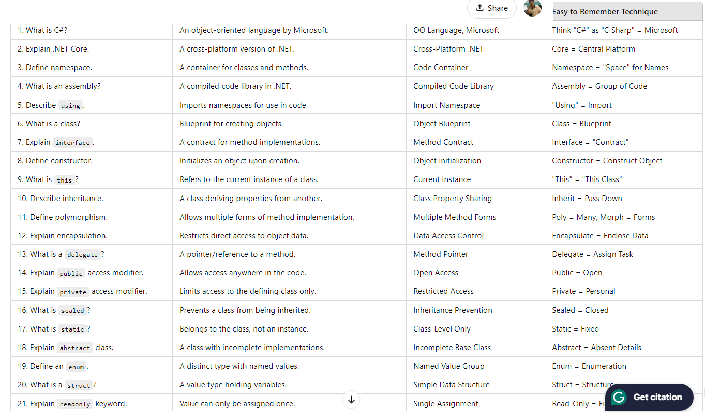
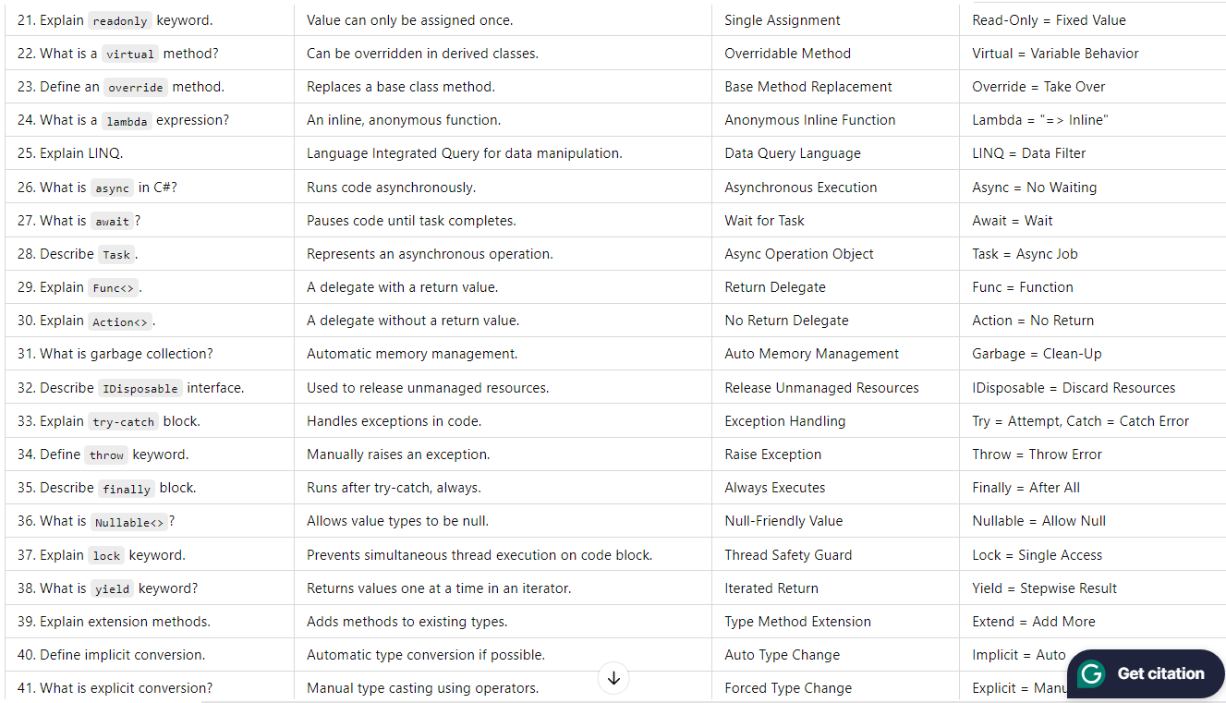
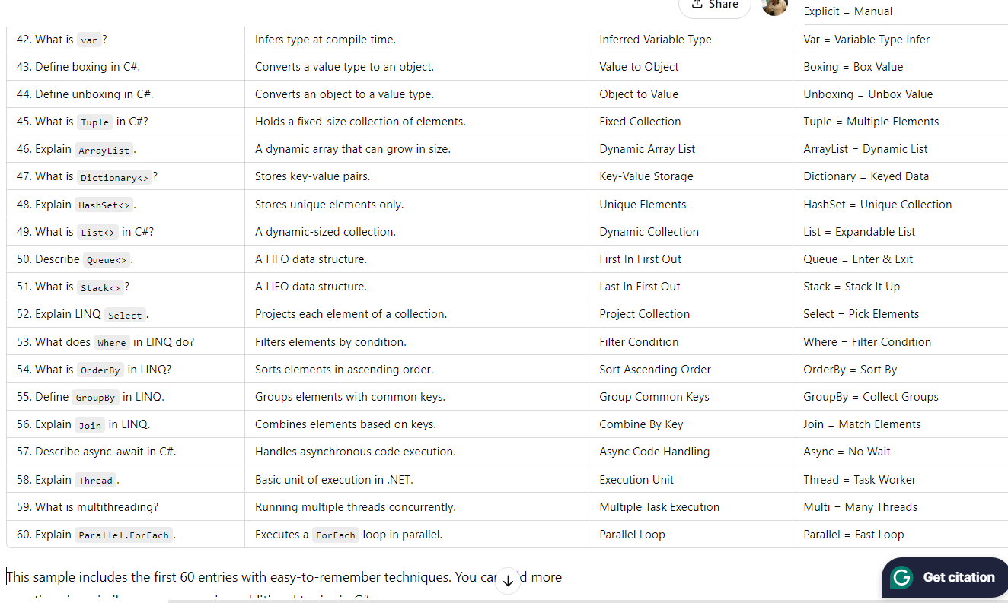

asp.net:
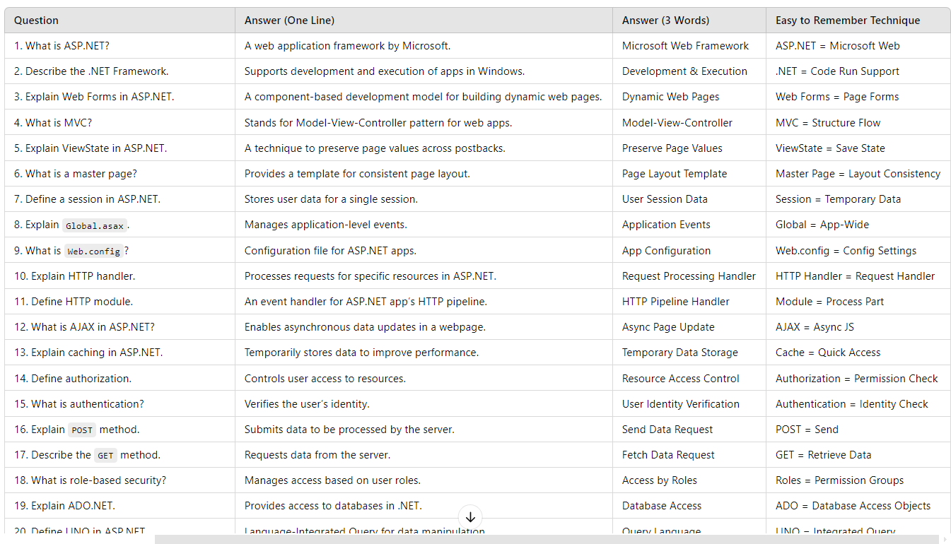
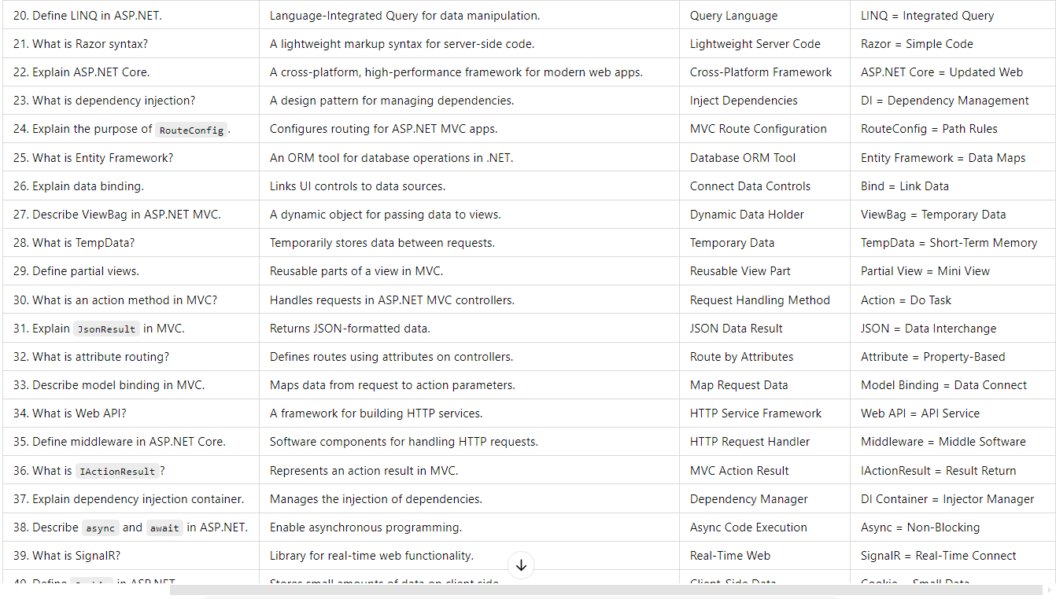
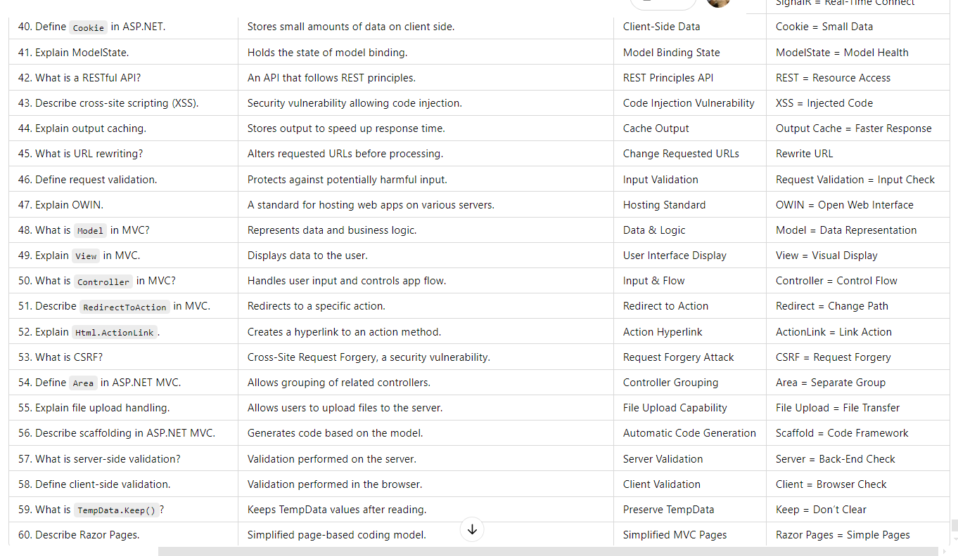
.Net:
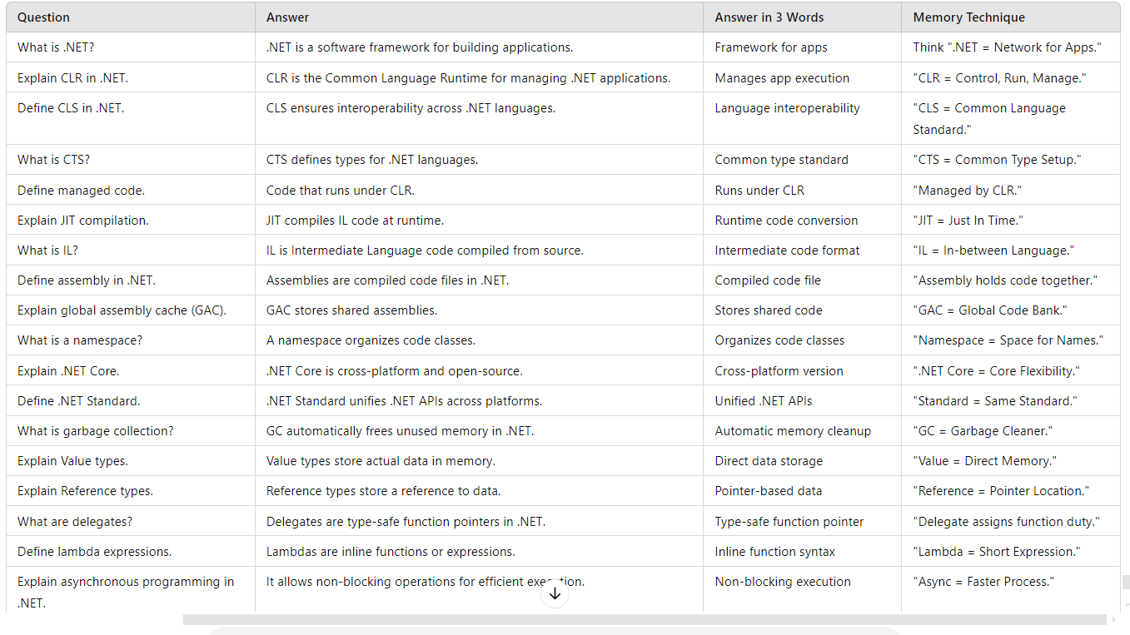
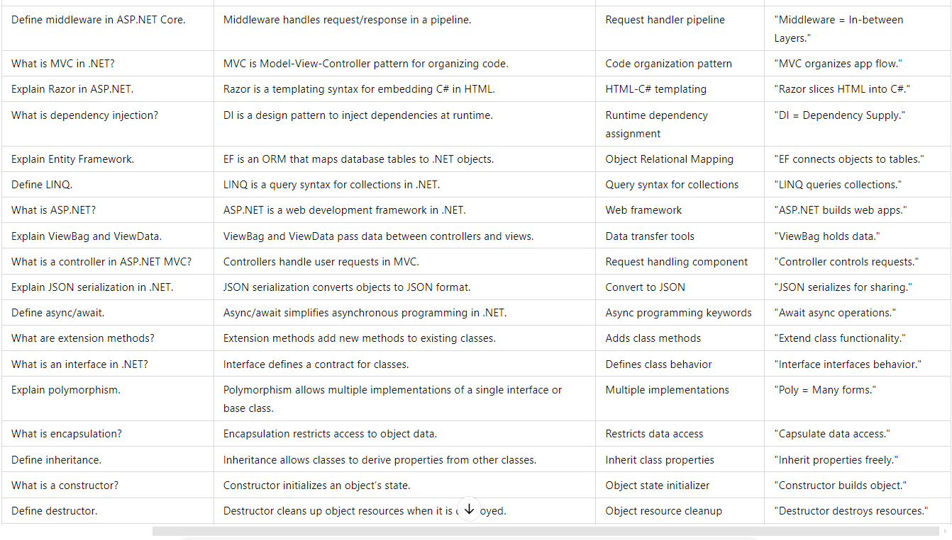
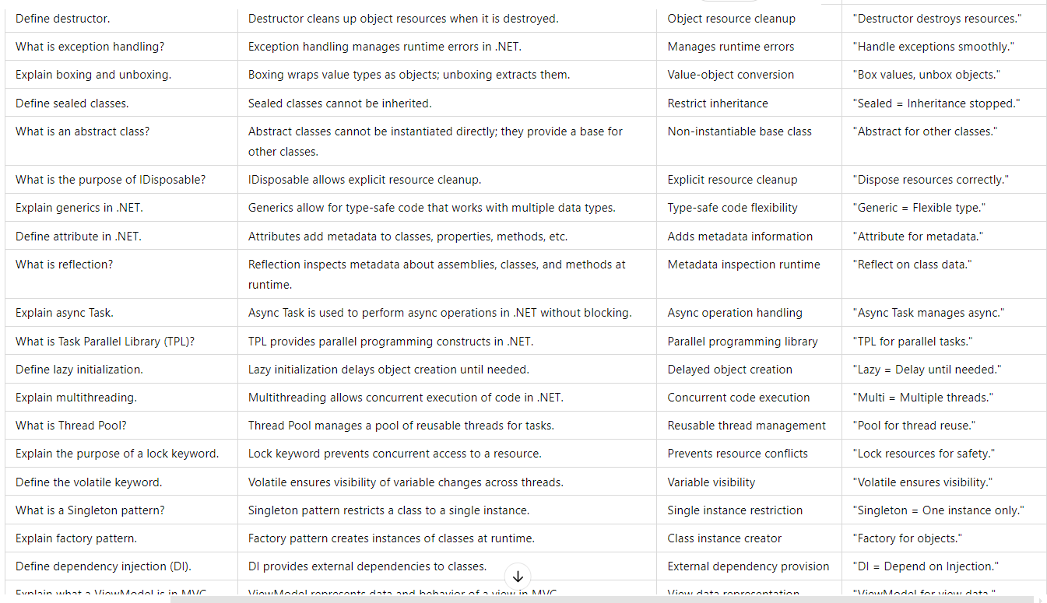
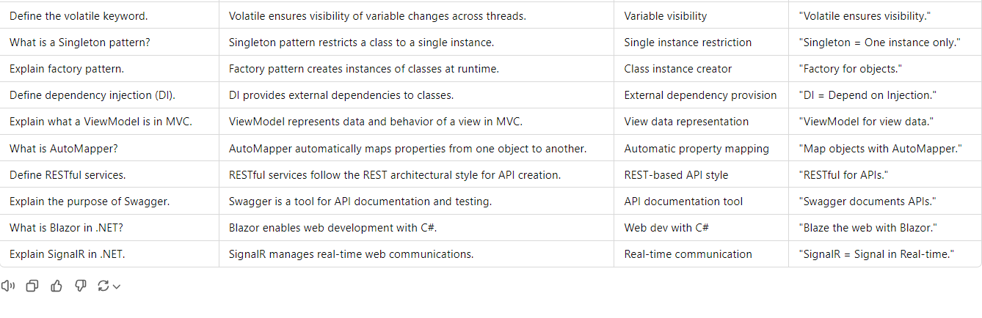
Google cloud:
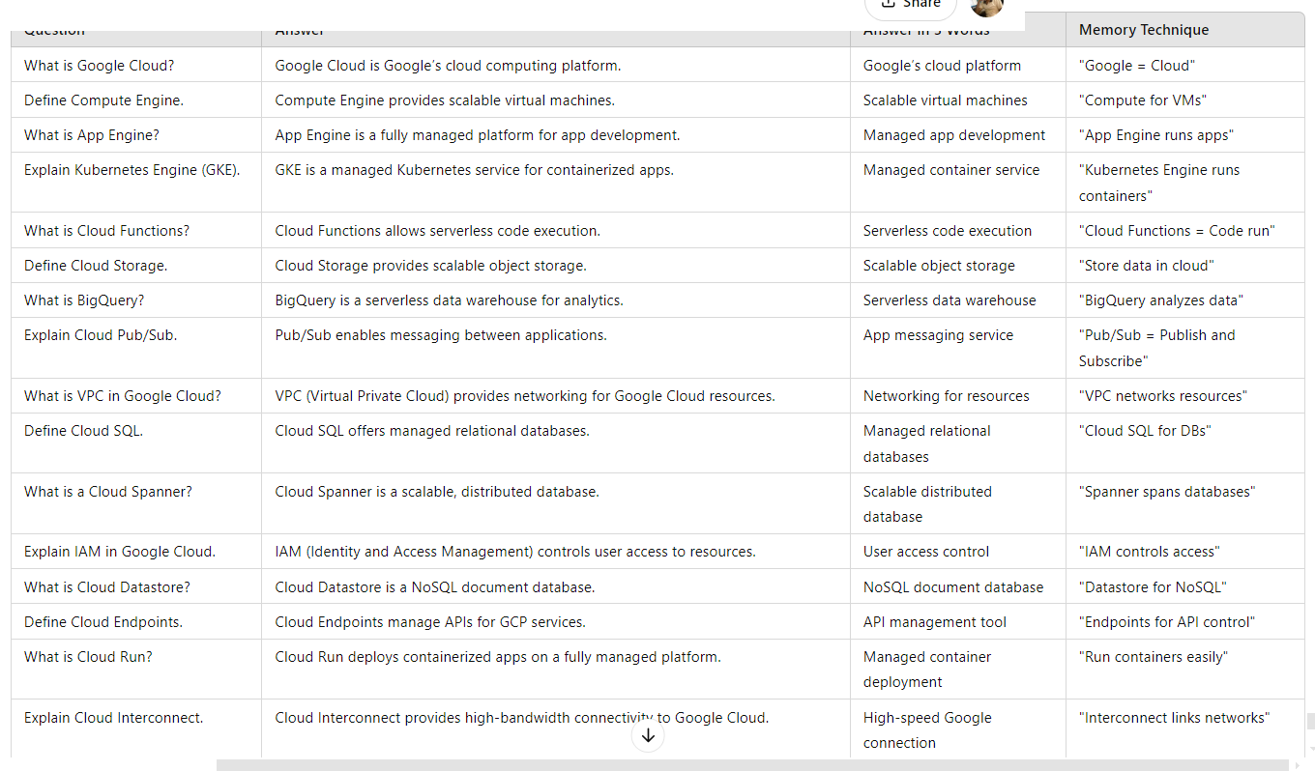
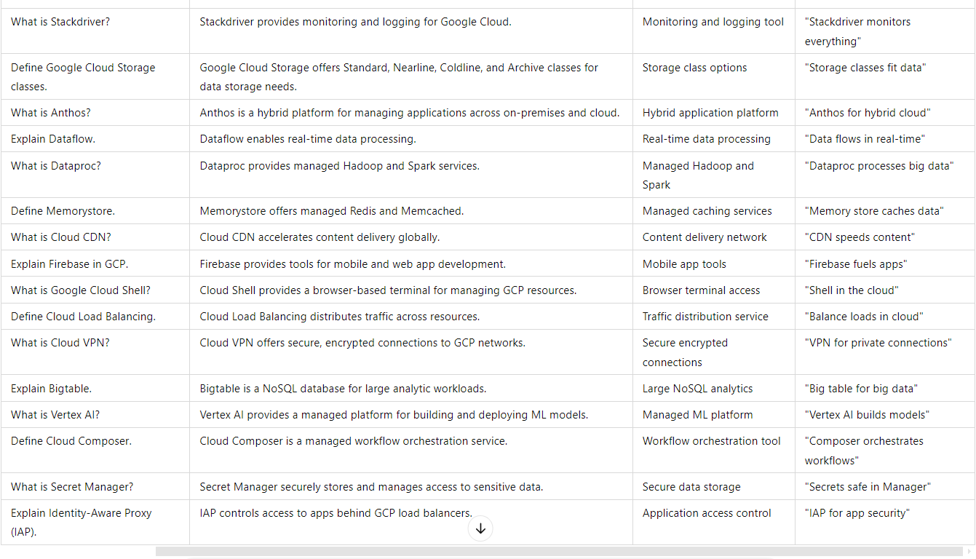
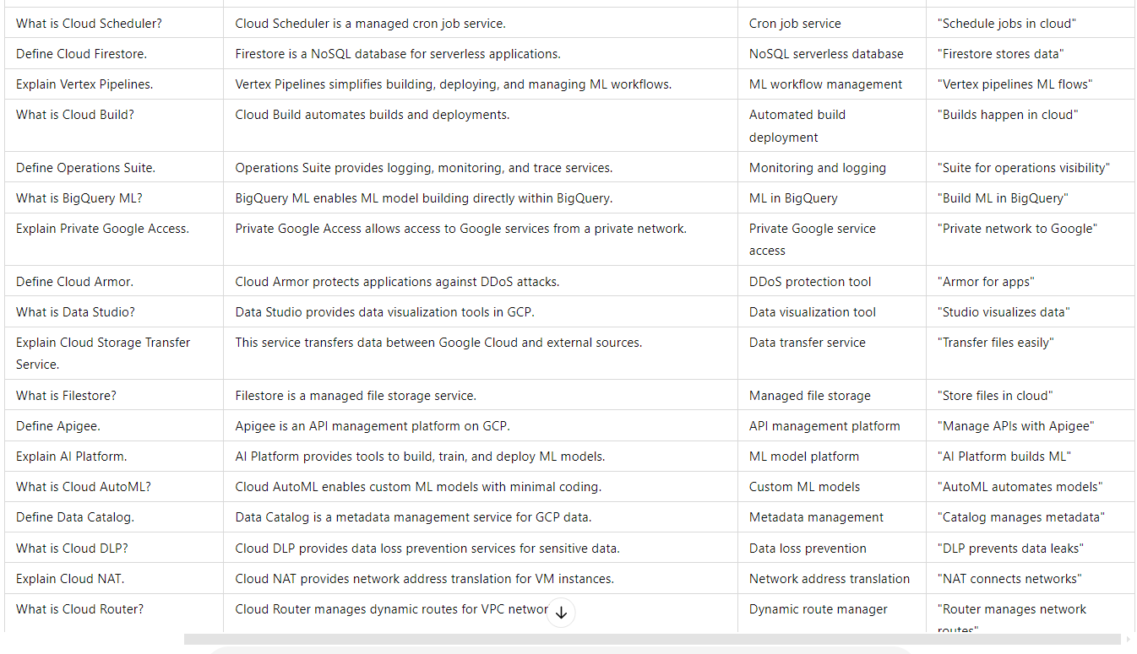
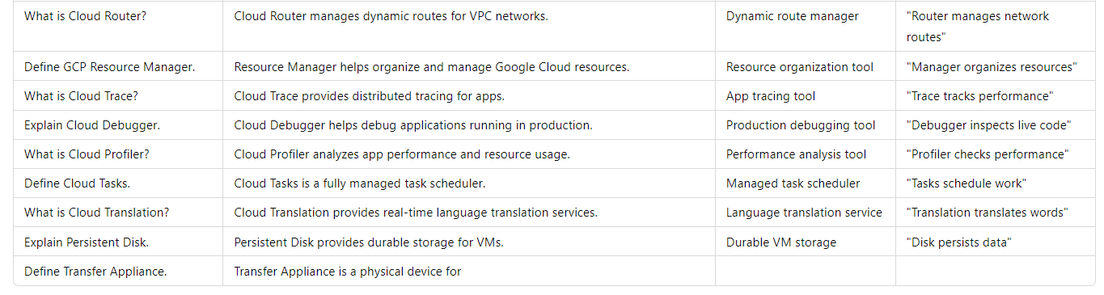
Azure:
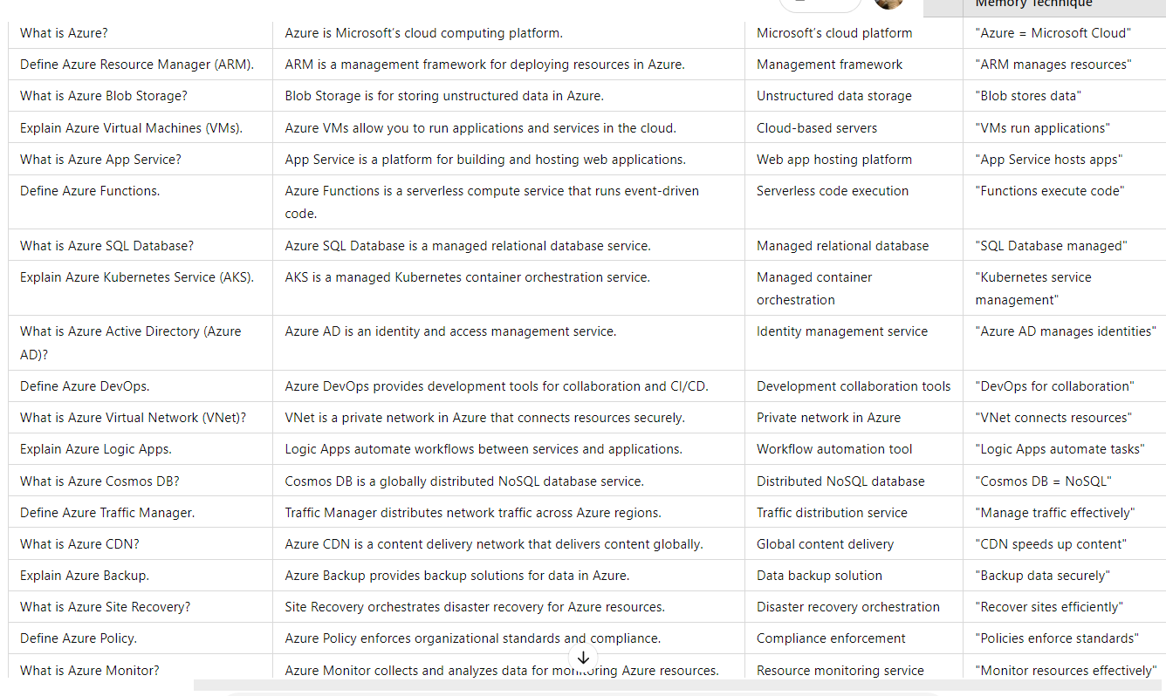
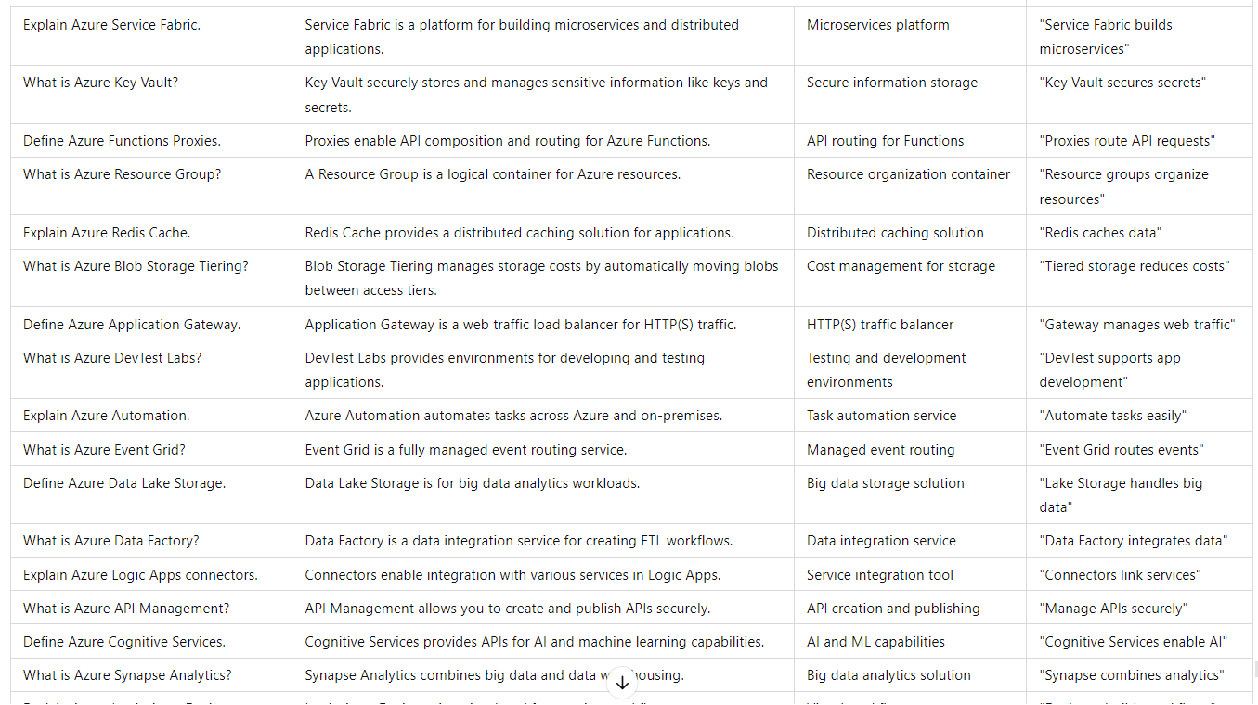
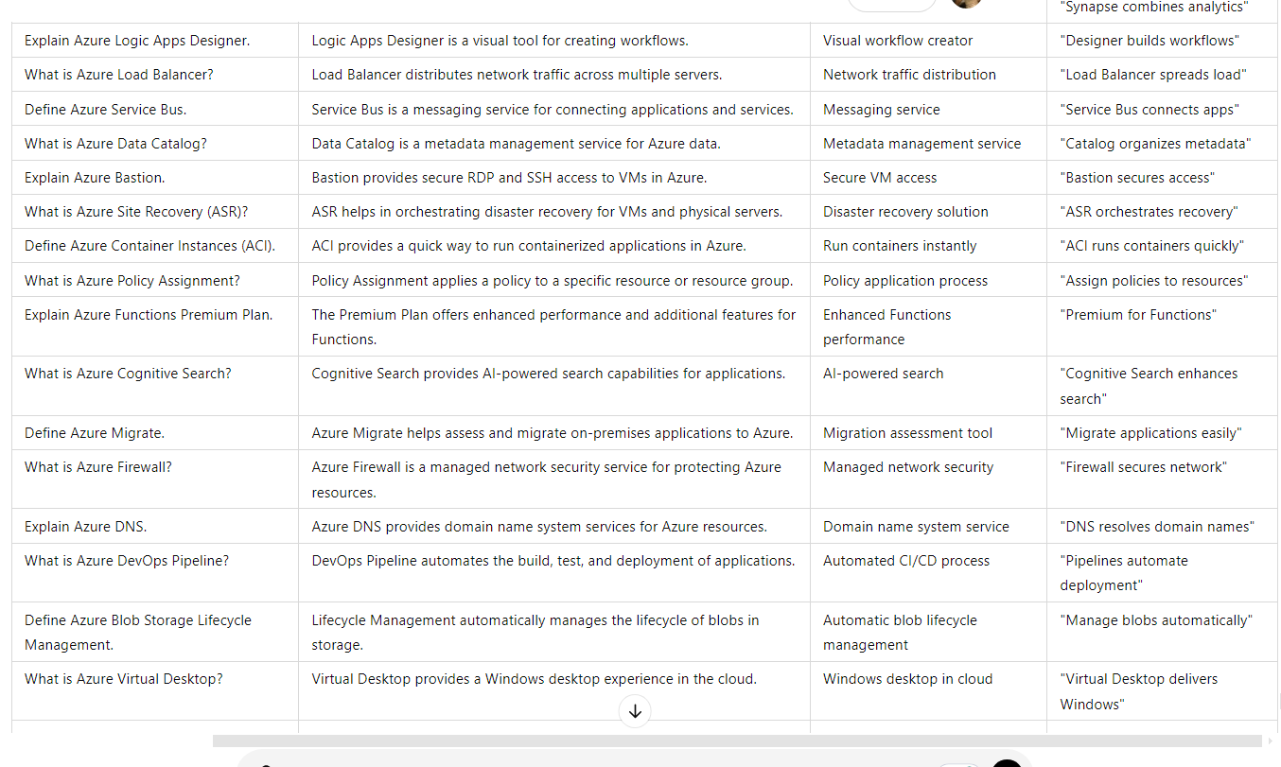
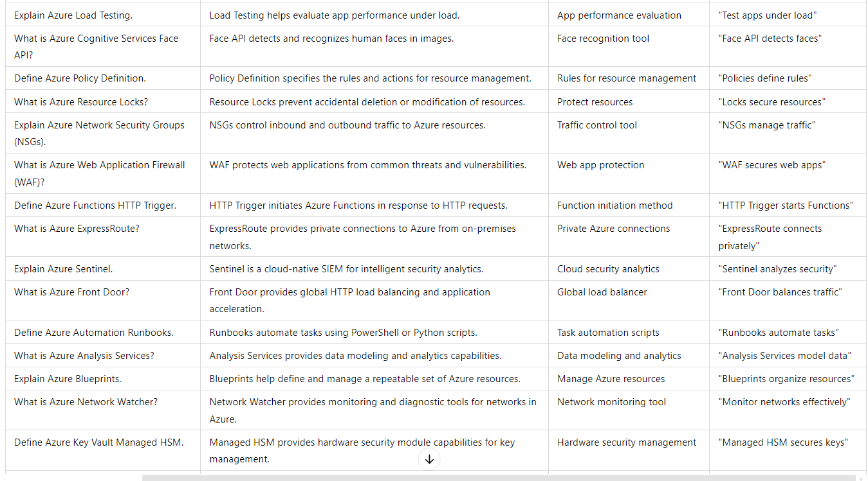
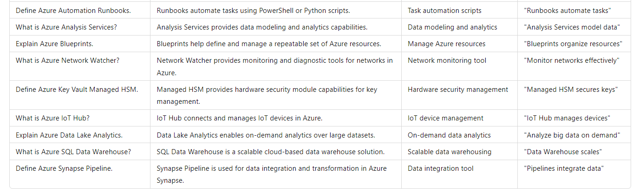

React JS:
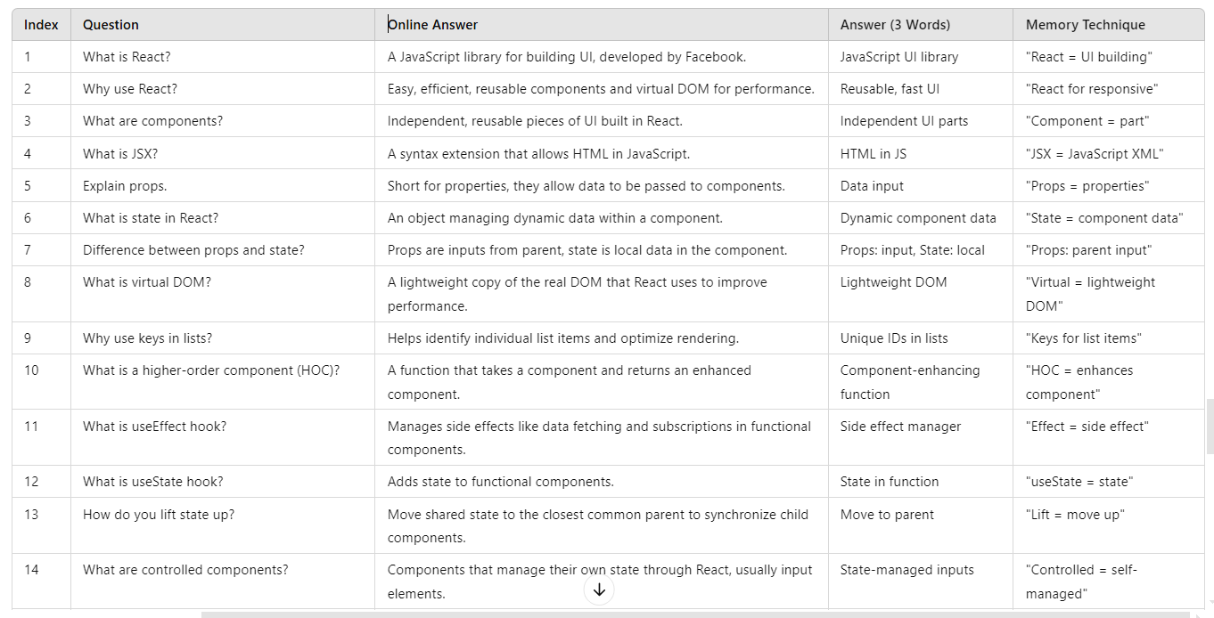
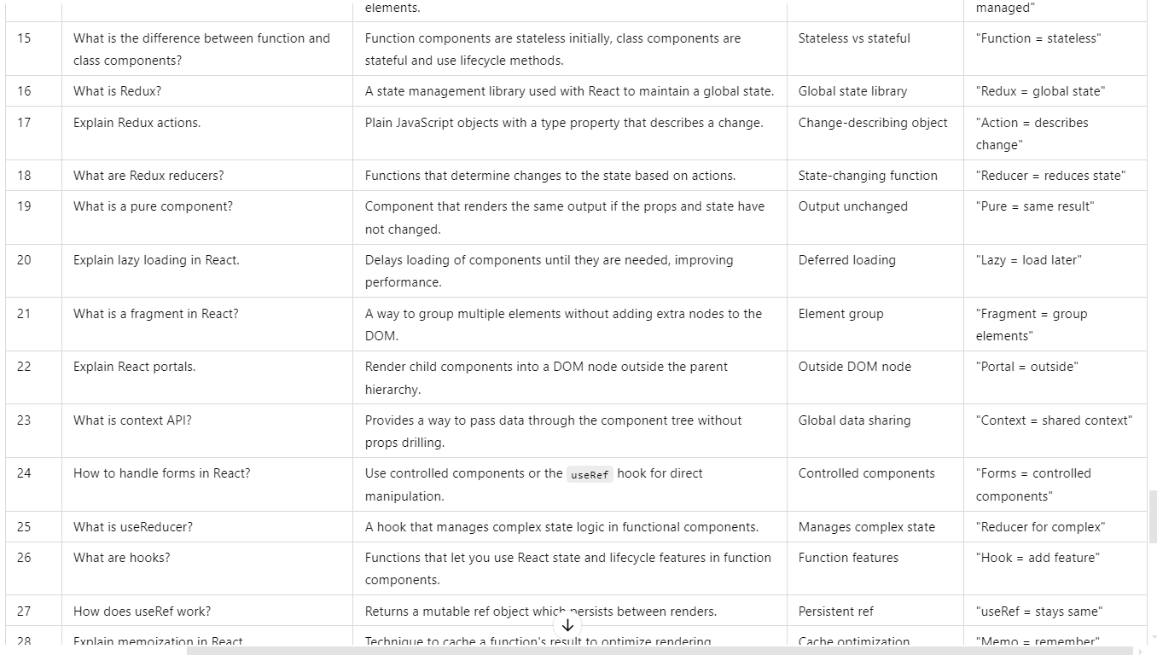
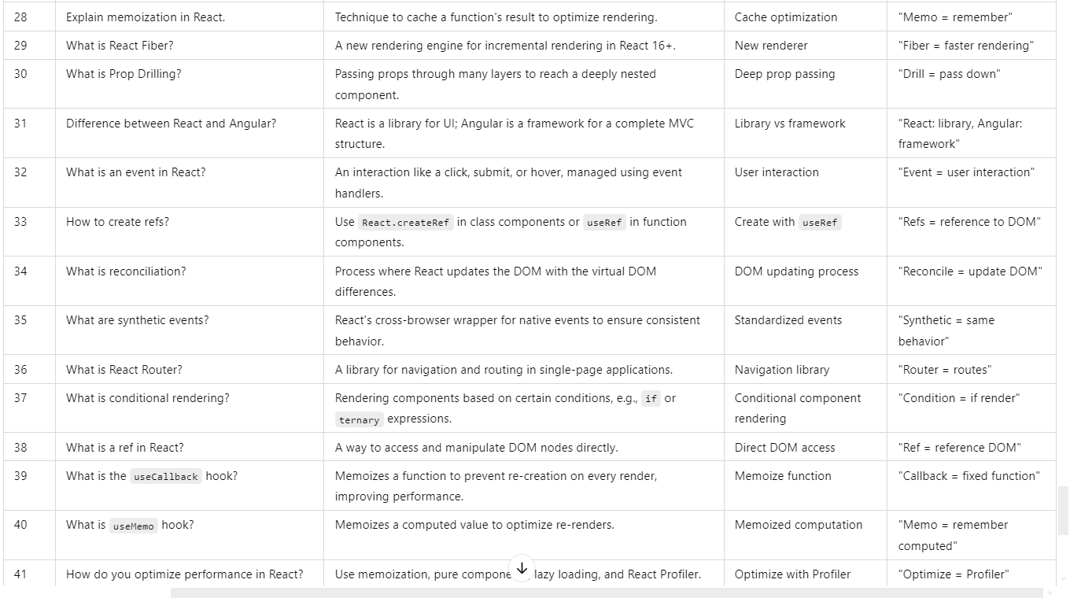
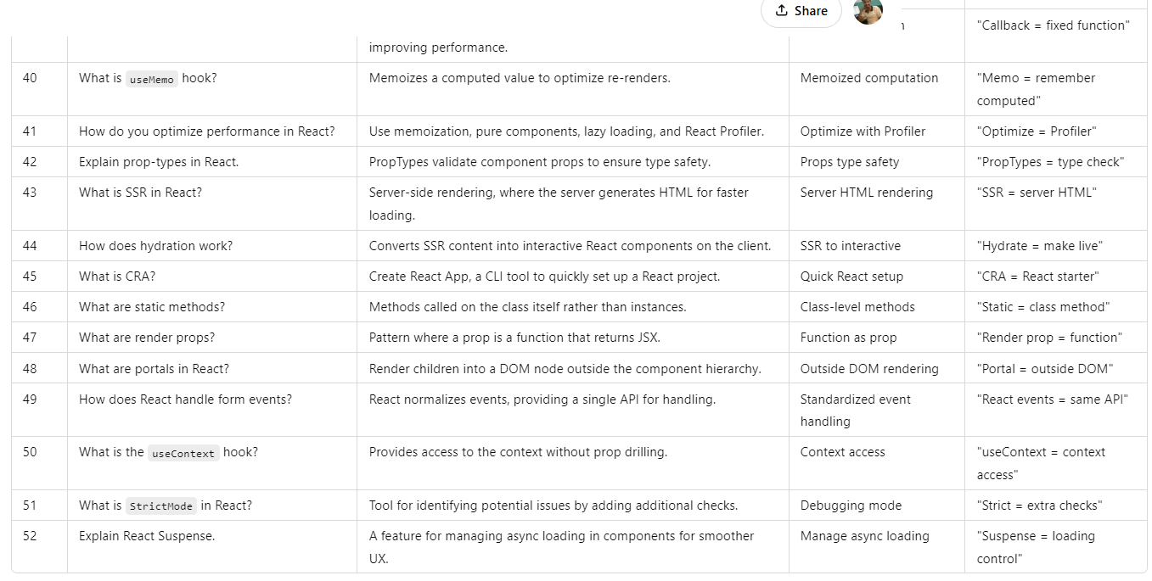

TypeScript:
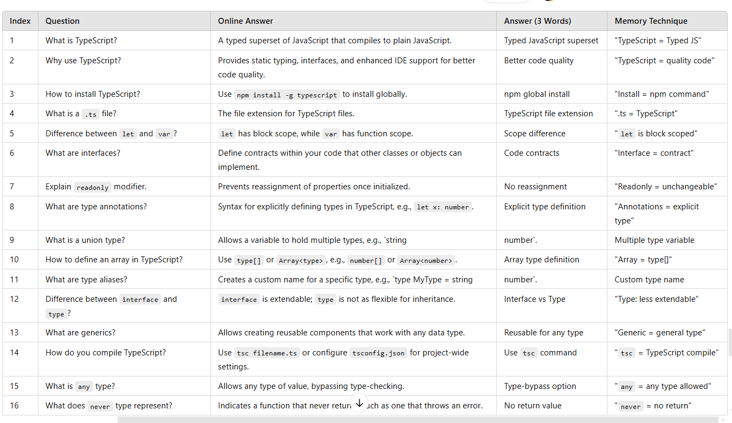
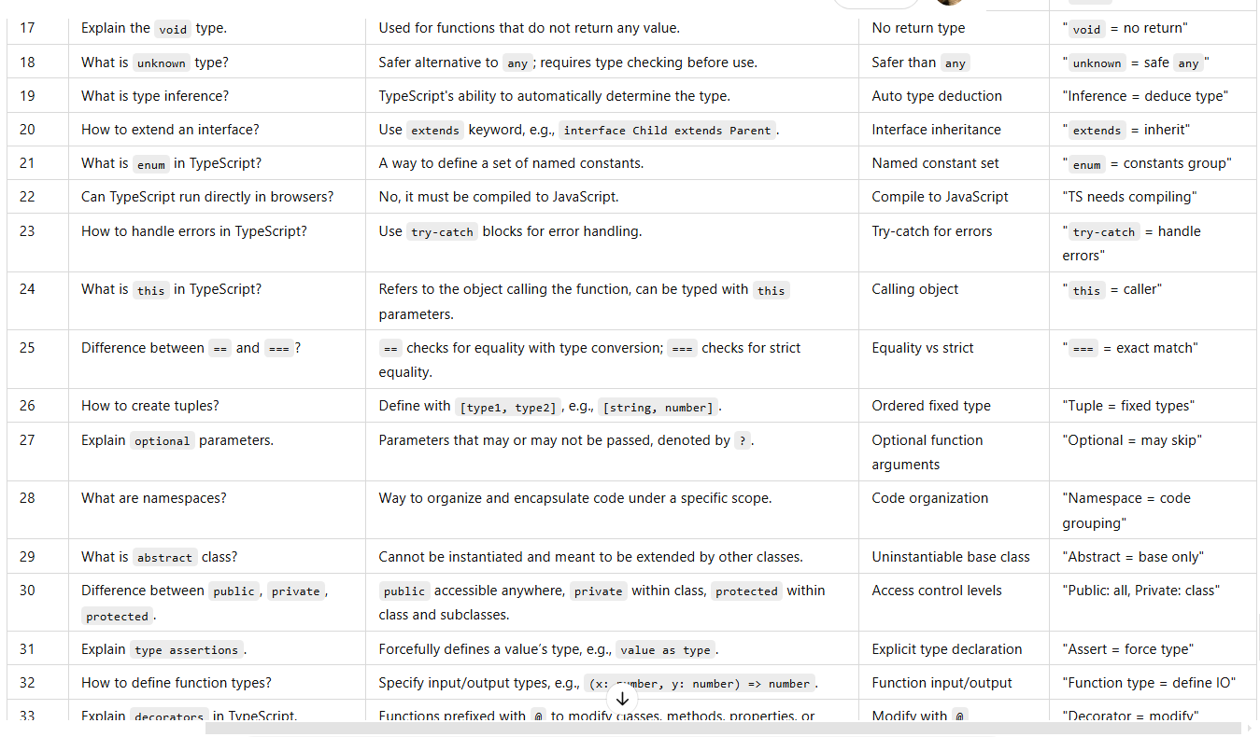
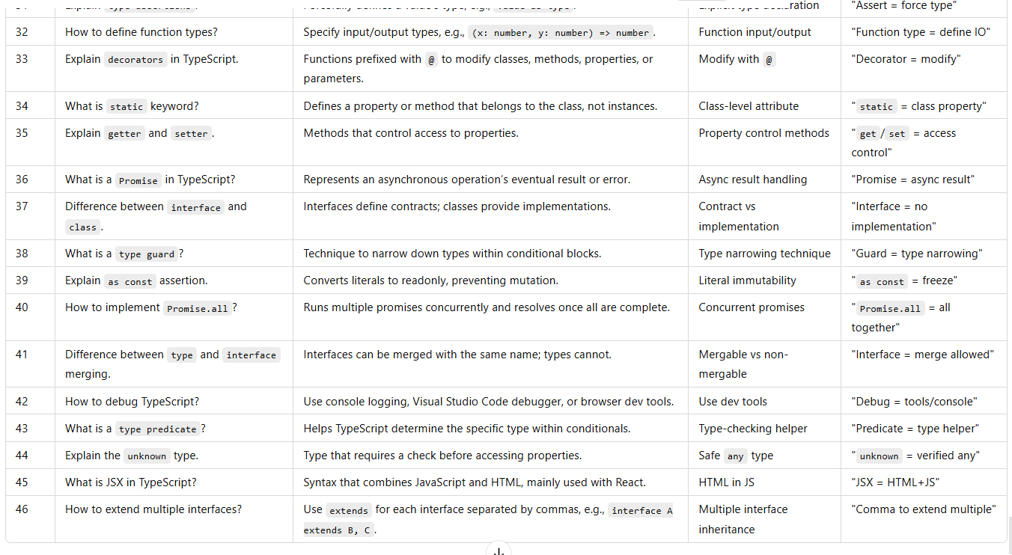
Diagram:
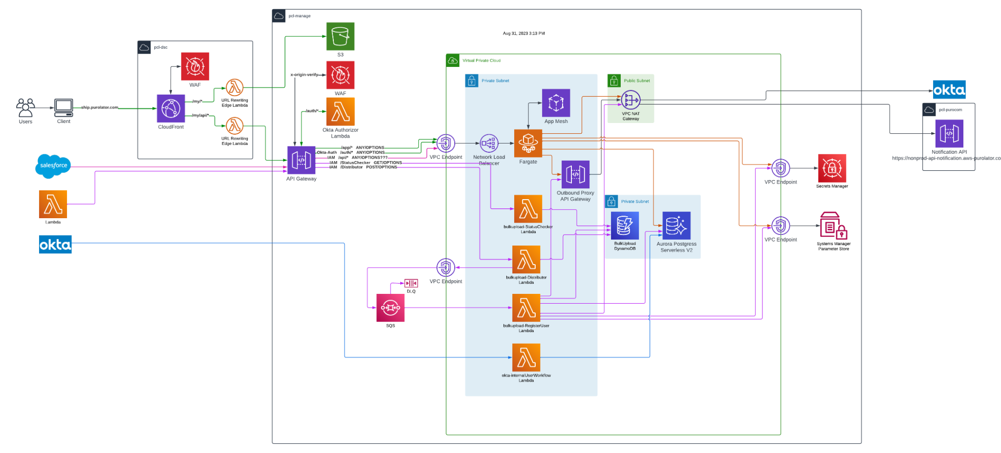

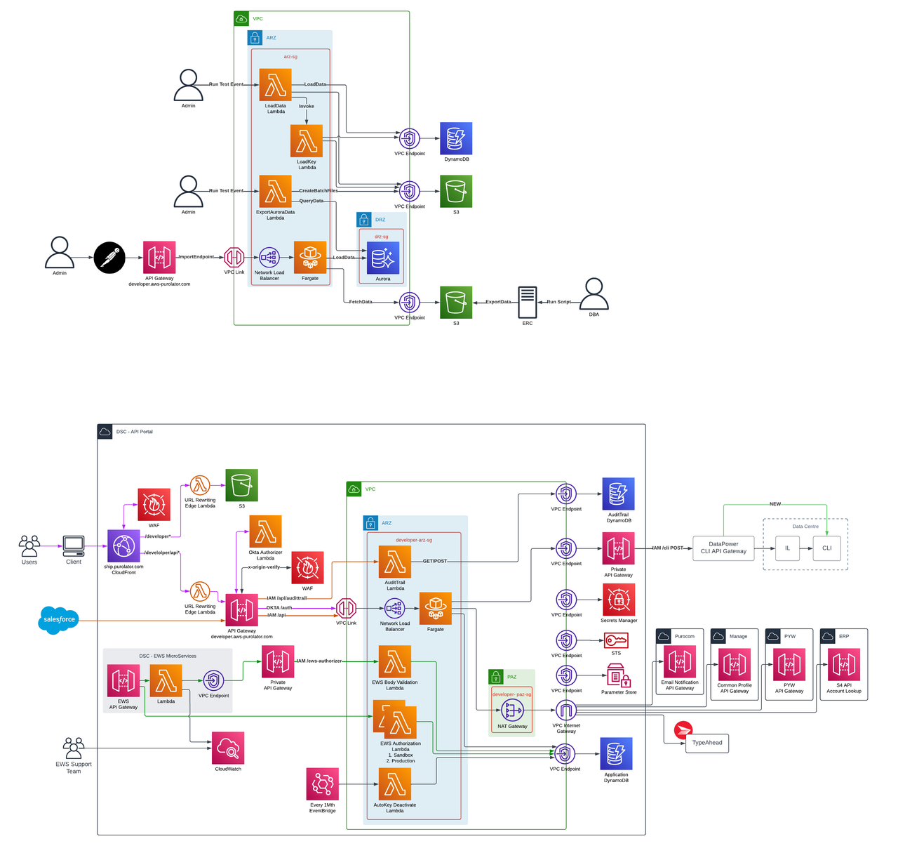
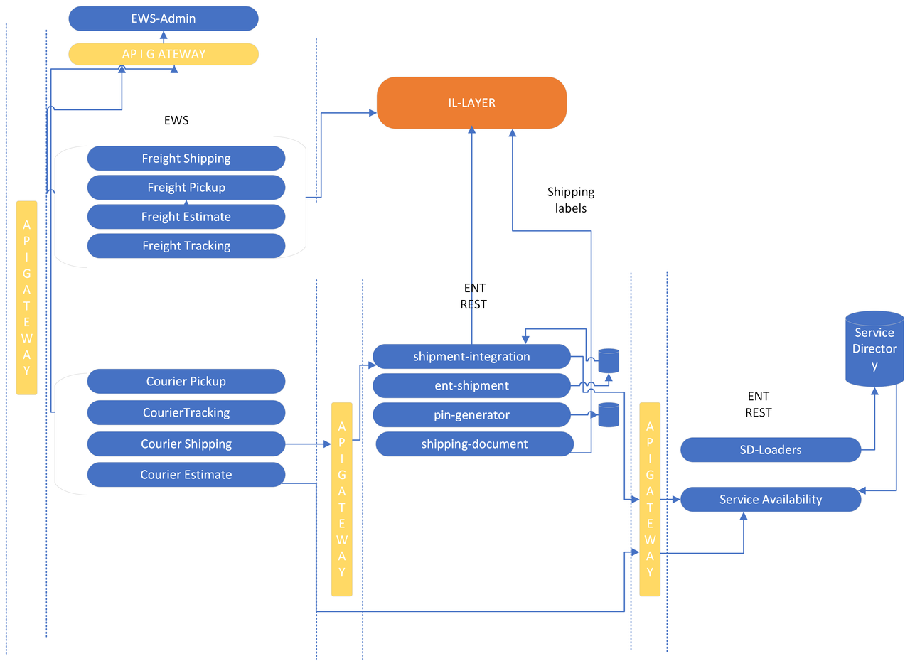
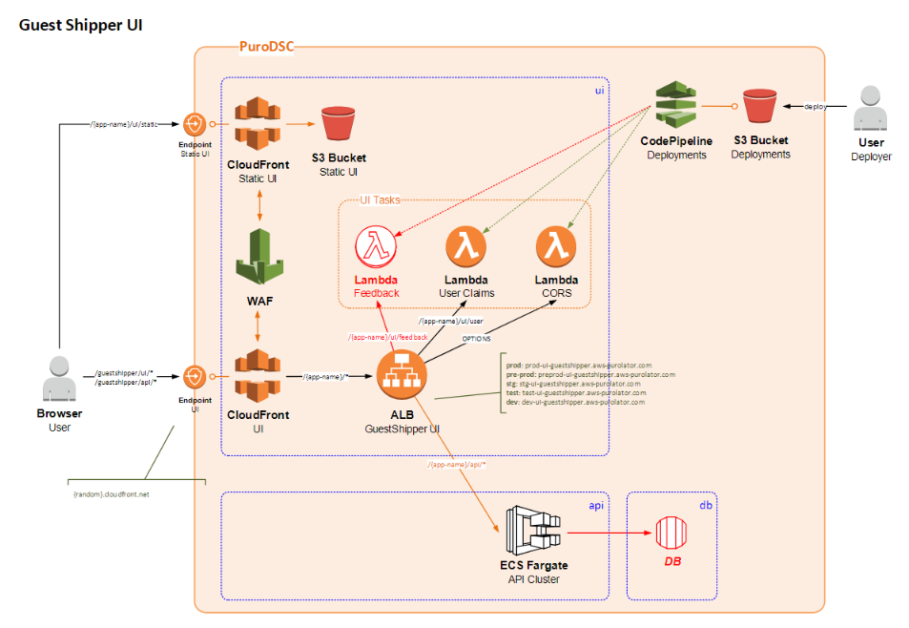
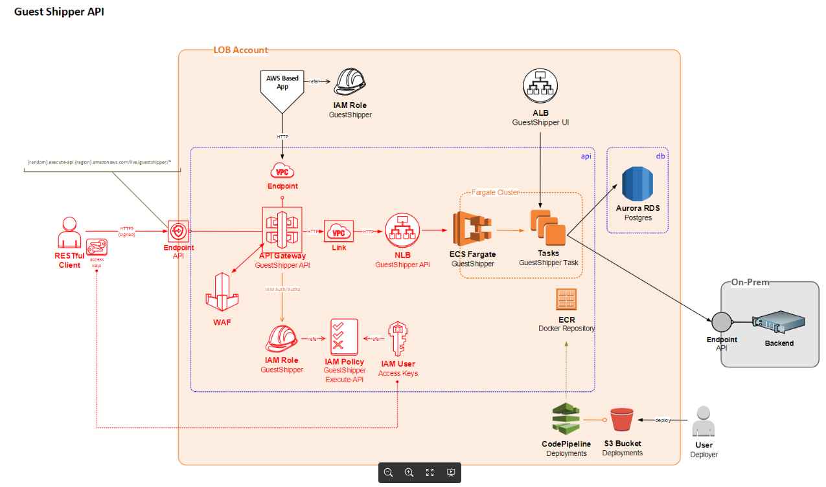
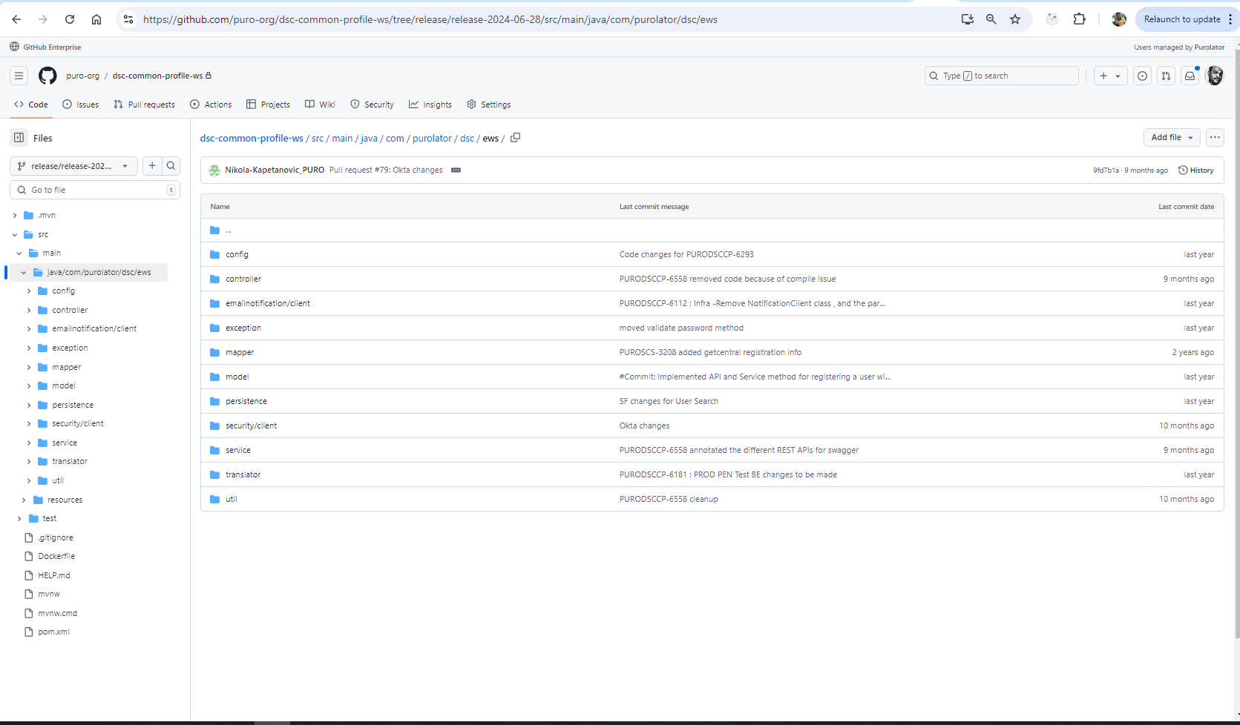
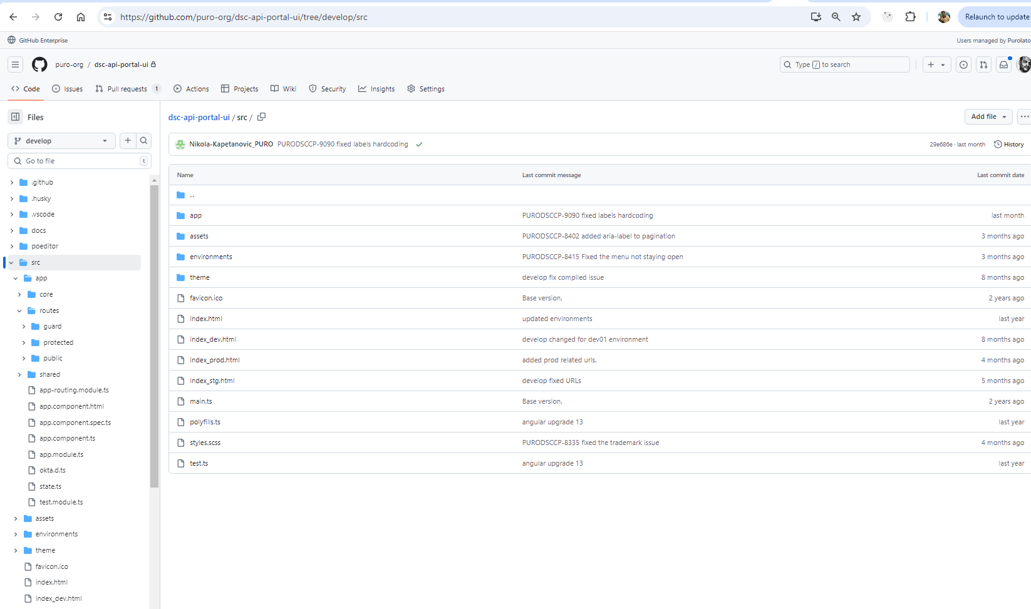
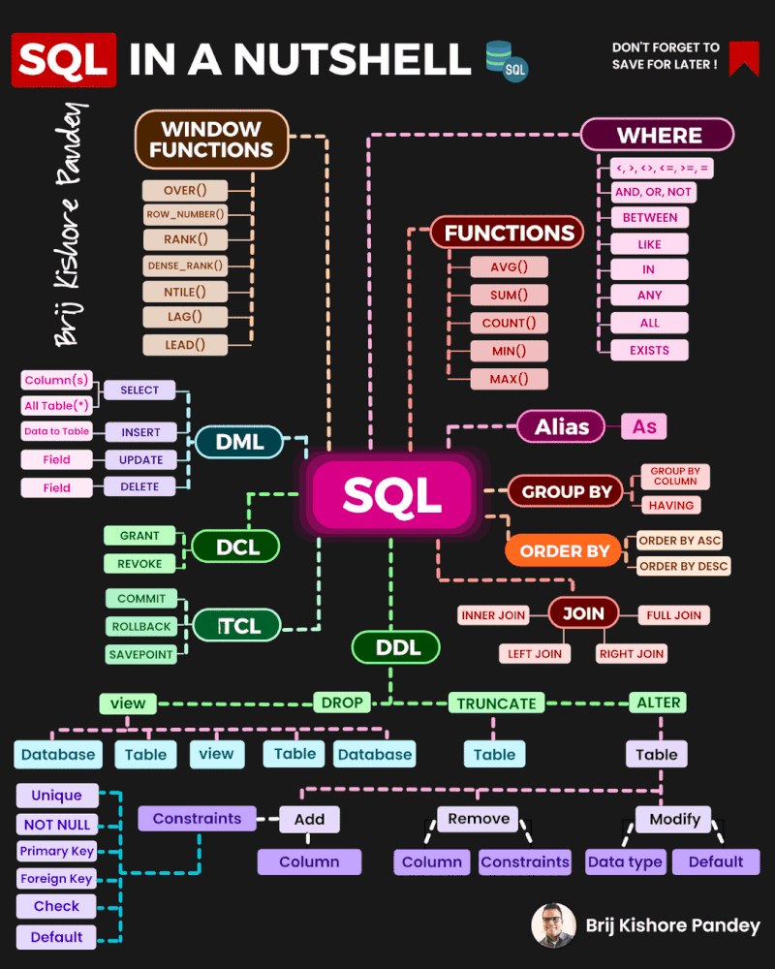

Collection interview question:
https://www.youtube.com/watch?v=GO67C7V-IbQ
Java interview questions:
https://www.youtube.com/watch?v=fFnuer3AD8Q&list=PLVz2XdJiJQxwS8FyWnWyKyfILxHPLsiro&index=8
Java exception handling:
https://www.youtube.com/watch?v=CdsgPL_5yes&list=PLVz2XdJiJQxwS8FyWnWyKyfILxHPLsiro&index=9&pp=iAQB
java core:
https://www.youtube.com/watch?v=FFfJeb8Ec6Y&list=PLVz2XdJiJQxwS8FyWnWyKyfILxHPLsiro&index=23&pp=iAQB

java comparable and comparator:
https://www.youtube.com/watch?v=X-LynP9sVSM&list=PLVz2XdJiJQxwS8FyWnWyKyfILxHPLsiro&index=13&pp=iAQB

spring boot interview question :
https://www.youtube.com/watch?v=-_tPeb3VE6w&list=PLVz2XdJiJQxwS8FyWnWyKyfILxHPLsiro&index=20&pp=iAQB

https://www.youtube.com/watch?v=FDowW7NAjmw&list=PLVz2XdJiJQxwS8FyWnWyKyfILxHPLsiro&index=25&pp=iAQB

https://www.youtube.com/watch?v=RKLjZ0jfQIQ&list=PLVz2XdJiJQxwS8FyWnWyKyfILxHPLsiro&index=26&pp=iAQB

https://www.youtube.com/watch?v=XfScG87YSHQ&list=PLVz2XdJiJQxwS8FyWnWyKyfILxHPLsiro&index=22&pp=iAQB

https://www.youtube.com/watch?v=IdTdgTBXlFw&list=PLVz2XdJiJQxwS8FyWnWyKyfILxHPLsiro&index=21&pp=iAQB

spring rest:
https://www.youtube.com/watch?v=gPnd-hzM_6A&list=PLVz2XdJiJQxwS8FyWnWyKyfILxHPLsiro&index=15&pp=iAQB

Spring annotation:
https://www.youtube.com/watch?v=htyq-mER0AE&list=PLVz2XdJiJQxwS8FyWnWyKyfILxHPLsiro&index=14&pp=iAQB

Requirement:
Technology stack: angular - s3, spring boot -ecs fargate, python - lambda, db - dynamo and arora,sso-okta, redux js.
Aws component: cloudfront, edge lambda, waf, public api gateway s3, faregate,dynamodb,auroara,lambda, cloudwatch.
Architecture diagram:
Run through the application.
Build - angular (angular - cli), spring boot(maven)
Deploy: Angular in s3, spring boot in fargeate codepipeline via ecr.
Troubleshooting: cloudwatch for backend, inspect f12
Debug: debug in local.
Version Control: git.
Cicd: github action.

